**FINAL YEAR PROJECT**

**ON**

**Comparative Study of Different Machine Learning Algorithms to Predict Heart Disease**



## Submitted By

MUHAMMAD RAHEEM ZADA Reg No. 2019/BIP/BSSE-042 SHOAIB AHMAD Reg No. 2019/BIP/BSSE-038

## Supervised By

MR NASIR SAYED

## Program

**BACHELOR OF SCIENCE IN SOFTWARE ENGINEERING**

# DEPARTMENT OF COMPUTER SCIENCE BRAINS INSTITUTE, PESHAWAR-PAKISTAN

## SESSION 2019-2023

**ACKNOWLEDGMENT**

How does a person say “thank u” when there are so many to thank? But we would specifically thank our Dads (who are not with us today), who are powerful role model ever for us, and to our Moms(Saeeda Begum And Shaheen Bibi )who taught us how to live with love and kindness. They made our lives.

**Regards**

Muhammad Raheem Zada

Shoaib Ahmad

BRAINS

Institute, Peshawar

## DEDICATION

We would like to thank our supervisor Mr. Nasir Sayed; he guided and helped us throughout this journey. We also dedicate this project to our loving parents and brothers; Osama Wazir, Malik Zarak Khan, Alamagir Khan, and Muhammad Idrees for their perseverance, support, and love that fascinated us, and appreciated our vision and goal throughout our project. We would like to thank our dearest friends; Shahab Wali, Zakria Khan, Dr.Jalal Khan, Shahabullah, Akhtar Nawaz, M. Shahab, and Raza Jan for their encouragement, guidance, and good remarks. We also thank to our cousins Engr Tariq Jan and Mufti Asad Gul for their unwavering support and encouragement throughout our project. Finally, we also dedicate this work to ourselves because without our inspiration, hard work, and efforts it would not have been possible.

# CERTIFICATE

# Dated: __________

**Final Approval**

It is certified that the project report titled ‘**Comparative Study of Different Machine Learning Algorithms to Predict Heart Disease’** submitted by **Muhammad Raheem Zada** & **Shoaib Ahmad** for the partial fulfillment of the requirement of **“BS Degree in Software Engineering”** is approved.



The committee certifies that this thesis forwarded by **Muhammad Raheem Zada & Shoaib Ahmad** is up to the standard and we here approve it for its acceptance as a partial fulfillment for the award of BS Degree in Software Engineering, from the department of Computer Science Brains Institute Peshawar

**COMMITTEE**

**Mr Nasir Sayed Signature:**

Project Supervisor:

**Dr Mia Imtiaz Ullah Signature:**

HOD Computer Science:

**ABSTRACT**

Nowadays, health disease is increasing day by day due to lifestyle, hereditary. Especially, heart disease has become more common these days, i.e., life of people is at risk. Each individual has different values for Blood pressure, cholesterol, and pulse rate. But according to medically proven results the normal values of Blood pressure is 120/90, Cholesterol is 100-129 mg/dL ,Pulse rate is 72, Fasting Blood Sugar level is 100 mg/dL ,Heart rate is 60-100 bpm, ECG is normal, Width of major vessels is 25 mm (1 inch) in the aorta to only 8 μm in the capillaries. This Project gives the survey about different classification techniques used for predicting the risk level of each person based on age, gender, Blood pressure, cholesterol, pulse rate.

“Disease Prediction” system based on predictive modeling predicts the disease of the user on the basis of the symptoms that user provides as an input to the system. The system analyzes the symptoms provided by the user as input and gives the probability of the disease as an output. Disease Prediction is done by implementing 5 techniques such as Naïve Bayes, KNN, Decision Tree, Linear Regression, and Random Forest Algorithms. These techniques calculate the probability of the disease. Therefore, average prediction accuracy probability 83% is obtained.

**TABLE OF CONTENTS**

[Acknowledgement](FINAL%20YEAR%20PROJECT%20REPORT.docx)………………………………………………………………………i

Dedication……………………………………………………………………………….ii

Abstract…………………………………………………………………………………iv

**CHAPTER NO.1** 1

**INTRODUCTION** 1

* 1. Introduction 1
  2. What Is Heart Disease………………………………………………………….3
  3. Attributes 4
     1. Age As A Cardiovascular Risk Factor 4
     2. Sex Differences In Coronary Heart Disease………………………6

1.4. Logistic Regression…………………………………………………………………7

1.5. Naïve Bayes…………………………………………………………………………8

1.6 K- Nearest Neighbour (Knn)…………………………………………………………9

1.7 Decesion Tree………………………………………………………………………..9

1.8 Random Forest……………………………………………………………………….10

1.9 Objectives Of The Project……………………………………………………………11

**CHAPTER NO. 2** 12

**LITERATURE REVIEW** 12

* 1. Prediction System For Heart Diseases Using Naïve Bayes And Particle Swarm….12
     1. Particle Swarm Optiization (Pso) 12
     2. Naive Bayes’ Classifier 12
  2. Predictive Data Mining For Medical Diagnosis: Heart Diseases Prediction….13
     1. Data Mining In The Heart Disease Prediction 14
     2. Data Mining And Artificial Neural Network 15
     3. Data Mining And Genetic Algorithm 16
     4. Association Rule Discovery…………………………………………17
     5. Issues And Challenges 18

**CHAPTER NO. 3 19**

**PROPOSED METHODOLOGY** 19

* 1. About Heart Disease 19
  2. Data Analysis Techniques 19
  3. Data Collection 19
     1. Dataset………………………………………………………………..19
     2. Attributes Used In Dataset……………………………………………20

**CHAPTER NO. 4** 22

**EXPERIMENTAL RESULTS** 22

* 1. Importing Libraries 22
  2. Load Data……………………………………………………………………..23
  3. Check Data Shape…………………………………………………………….23
  4. Checking Top Four Columns Of Dataset ……………………………………23
  5. Data Set Description …………………………………………………………25
  6. Types Of Features……………………………………………………………26
  7. Some Random Data Column…………………………………………………27
  8. Check For Missing Data ……………………………………………………..28
  9. Check The Co Realtion With Target Data …………………………………..29
  10. Exploratory Data Analysis (Eda) ……………………………………………29
  11. Percentage Of Patient With Or Without Heart Problem In The Given Dataset…30
  12. Uniquness Of Sex Columns …………………………………………………31
  13. Check The Percentage And Plot The Graph…………………………………31
  14. Heart Disease Frequency For Ages………………………………………….33
  15. Heart Disease Frequency For Sex……………………………………………35
  16. Making The Data Column Name Easily Recognizable………………………37
  17. Checking Out Male Anf Female Heart Disease According To Fasting Blood Sugar…….37
  18. Analyzing Chest Pain…………………………………………………………39
  19. Analyzing Resting Blood Pressure……………………………………………40
  20. Analyzing Resting Electrocardiographic Measurment ……………………….43
  21. Analyzing Exercise Induce Angina …………………………………………..44
  22. Slope Of The Peak Exercise St Segment……………………………………...45
  23. Analyzing Number Of Major Vessels Colored By Flouroscopy ……………..48
  24. Comparing With Target ………………………………………………………49
  25. Analyzing Thalassemia……………………………………………………….49
      1. Alpha Thalassemia 50
      2. Beta Thalassemia……………………………………………………50
  26. Thalassemia Vs Cholestrol…………………………………………………….53
  27. Thalassemia Vs Resting Blood Pressure………………………………………54
  28. Correlation Matrix……………………………………………………………..55
  29. Correlation Analysis……………………………………………………………56
  30. Data Preparation………………………………………………………………..57
  31. Modeling And Practicing With Machine Learning…………………………….57
  32. Logistic Regression…………………………………………………………….58
  33. Random Forest………………………………………………………………….64
  34. Naïve Bayes…………………………………………………………………….68
  35. K-Nearest Nieghbor(Knn) ……………………………………………………..72
  36. Decision Tree Pseudocode……………………………………………………..77
  37. Result…………………………………………………………………………..82

**CHAPTER NO. 5** 84

**CONCLUSION AND FUTURE ENHANCEMENT** 84

* 1. Conclusion 84
  2. Drwabacks…………………………………………………………………….85
  3. Future Scope…………………………………………………………………..86

**REFERENCES** 87

**TABLE OF FIGURES**

Figure 1 Annual number of adults having diagnosed heart attack or fatal coronary heart disease by age and sex. 7

Figure 2 The sample combinations of heart attack parameters for normal and risk level along with their values and weightages 15

Figure 3 Disease vs Non-Disease Analysis 28

Figure 4 Sex analysis 30

Figure 5 Heart Disease Frequency for ages 31

Figure 6 Heart Disease Frequency for sex 33

Figure 7 Heart Disease according to FBS 35

Figure 8 Chest Pain Analysis 37

Figure 9 Resting Blood Pressure Analysis 39

Figure 10 ECG analysis 41

Figure 11 Exercised Induced Angina Analysis 42

Figure 12 ST Slope Analysis 44

Figure 13 Analyzing no. of major vessels colored by fluoroscopy 45

Figure 14 Comparing with targets 46

Figure 15 Thalassemia distribution 48

Figure 16 Thalassemia against target 49

Figure 17 Thalassemia vs cholesterol 50

Figure 18 Thalassemia vs resting blood pressure 51

Figure 19 Correlation Matrix 52

Figure 20 sigmoid function 56

Figure 22 cost function 56

Figure 24 Vectorized cost function 57

Figure 25 logistic regression confusion matrix 58

Figure 26 Random forest confusion matrix 61

Figure 27 Naive Bayes confusion matrix 64

Figure 28 KNN confusion matrix 67

Figure 29 Decision tree visualization 70

Figure 30 Decision tree confusion matrix 71

Figure 31 Accuracy Scores of all Algorithms 72

Figure 32 Work flow diagram 75

Figure 33 work flow diagram 76

**CHAPTER NO. 1 INTRODUCTION**

**1.1 Introduction**

In day to day life many factors that affect a human heart. Many problems are occurring at a rapid pace and new heart diseases are rapidly being identified. In today’s world of stress Heart, being an essential organ in a human body which pumps blood through the body for the blood circulation is essential and its health is to be conserved for a healthy living. The health of a human heart is based on the experiences in a person’s life and is completely dependent on professional and personal behaviors of a person. There may also be several genetic factors through which a type of heart disease is passed down from generations. According to the World Health Organization, every year more than 12 million deaths are occurring worldwide due to the various types of heart diseases which is also known by the term cardiovascular disease. The term Heart disease includes many diseases that are diverse and specifically affect the heart and the arteries of a human being. Even young aged people around their 20-30 years of lifespan are getting affected by heart diseases. The increase in the possibility of heart disease among young may be due to the bad eating habits, lack of sleep, restless nature, depression and numerous other factors such as obesity, poor diet, family history, high blood pressure, high blood cholesterol, idle behavior, family history, smoking and hypertension.

The diagnosis of the heart diseases is a very important and is itself the most complicated task in the medical field. All the mentioned factors are taken into consideration when analyzing and understanding the patients by the doctor through manual check-ups at regular intervals of time.

The symptoms of heart disease greatly depend upon which of the discomfort felt by an individual. Some symptoms are not usually identified by the common people. However, common symptoms include chest pain, breathlessness, and heart palpitations. The chest pain common to many types of heart disease is known as angina, or angina pectoris, and occurs when a part of the heart does not receive enough oxygen. Angina may be triggered by stressful events or physical exertion and normally lasts under 10 minutes. Heart

attacks can also occur as a result of different types of heart disease. The signs of a heart attack are like angina except that they can occur during rest and tend to be more severe. The symptoms of a heart attack can sometimes resemble indigestion. Heartburn and a stomach ache can occur, as well as a heavy feeling in the chest. Other symptoms of a heart attack include pain that travels through the body, for example from the chest to the arms, neck, back, abdomen, or jaw, lightheadedness and dizzy sensations, profuse sweating, nausea and vomiting.

Heart failure is also an outcome of heart disease, and breathlessness can occur when the heart becomes too weak to circulate blood. Some heart conditions occur with no symptoms at all, especially in older adults and individuals with diabetes. The term 'congenital heart disease' covers a range of conditions, but the general symptoms include sweating, high levels of fatigue, fast heartbeat and breathing, breathlessness, chest pain. However, these symptoms might not develop until a person is older than 13 years. In these types of cases, the diagnosis becomes an intricate task requiring great experience and high skill. A risk of a heart attack or the possibility of the heart disease if identified early, can help the patients take precautions and take regulatory measures. Recently, the healthcare industry has been generating huge amounts of data about patients and their disease diagnosis reports are being especially taken for the prediction of heart attacks worldwide. When the data about heart disease is huge, the machine learning techniques can be implemented for the analysis.

Data Mining is a task of extracting the vital decision-making information from a collective of past records for future analysis or prediction. The information may be hidden and is not identifiable without the use of data mining. The classification is one data mining technique through which the future outcome or predictions can be made based on the historical data that is available. The medical data mining made a possible solution to integrate the classification techniques and provide computerized training on the dataset that further leads to exploring the hidden patterns in the medical data sets which is used for the prediction of the patient’s future state. Thus, by using medical data mining it is possible to provide insights on a patient’s history and is able to provide clinical support through the analysis. For clinical analysis of the patients, these patterns are very much essential. In simple English, the medical data mining uses classification algorithms that is a vital part for identifying the possibility of heart attack before the occurrence. The classification algorithms can be trained and tested to make the predictions that determine the person’s nature of being affected by heart disease[1].

In this research work, the supervised machine learning concept is utilized for making the predictions. A comparative analysis of the five data mining classification algorithms namely Random Forest, Decision Tree, k- Nearest neighbor, logistic regression, and Naïve Bayes are used to make predictions. The analysis is done at several levels of cross validation and several percentages of percentage split evaluation methods respectively. The Stat Log dataset from UCI machine learning repository is utilized for making heart disease predictions in this research work. The predictions are made using the classification model that is built from the classification algorithms when the heart disease dataset is used for training. This final model can be used for prediction of any types of heart diseases.[2][3]

Health-care is a field of the most needed service and an economically 2ndlargest industry in 21stcentury. While we talk about the affordability and quality assurance in health-care industry, several statistical analyses are carried on making health solutions more precise and flawless in this current era of increasing health problems and chronic diseases. Advancements on data driven intelligent technologies is disease diagnosis and detection, treatment and research are remarkable. Medical image analysis, symptom-based disease prediction is the part where the most sought-after brains are working. In this research we aim to present our proposed model on the prediction on diagnosis of cardio vascular disease with ECG analysis and symptom-based detection. The model aims to be researched and advance in further to become robust and end to end reliable research tool. We will discuss about the classical methods and algorithms implemented on CVD prediction, gradual advancements, draw comparison of performance among the existing systems and propose an enhanced multi-module system performing better in terms of accuracy and feasibility. Implementation, training, and testing of the modules have been done on datasets obtained from UCI and Physio net data repositories. Data format have been modified in the case of the ECG report data for betterment of action by the K-Nearest Neighbour used in our research and in the risk prediction module we have chosen attributes for training and implementing the multi-layered neural network developed by us. The further research and advancement possibilities are also mentioned in the research. [4]

**1.2 What is Heart Disease?**

Heart disease describes a range of conditions that affect your heart. Diseases under the heart disease umbrella include blood vessel diseases, such as coronary artery disease; heart rhythm problems (arrhythmias); and heart defects you're born with (congenital heart defects), among others. The term "heart disease" is often used interchangeably with the term "cardiovascular disease." Cardiovascular disease generally refers to conditions that involve narrowed or blocked blood vessels that can lead to a heart attack, chest pain (angina) or stroke. Other heart conditions, such as those that affect your heart's muscle, valves or rhythm, also are considered forms of heart disease. Heart failure is a serious condition with high prevalence (about2% in the adult population in developed countries, and or than8%inpatients olderthan75years). About 3 – 5%ofhospitaladmissions are linked with heart failure incidents. Heart failure is the first cause of admission by healthcare professionals in their clinical practice. The costs are very high, reaching up to 2% of the total health costs in the developed countries. Building an effective disease management strategy requires analysis of large amount of data, early detection of the disease, assessment of the severity and early prediction of adverse events. This will inhibit the progression of the disease, will improve the quality of life of the patients and will reduce the associated medical costs. Toward this direction machine learning techniques have been employed. The aim of this paper is to present the state-of-the-art of the machine learning methodologies applied for the assessment of heart failure. More specifically, models predicting the presence, estimating the subtype, assessing the severity of heart failure and predicting the presence of adverse events, such as destabilizations, re-hospitalizations, and mortality are presented. According to the authors' knowledge, it is the first time that such a comprehensive review, focusing on all aspects of the management of heart failure, is presented.

**1.3 Some of the attributes we used for Heart Disease Prediction and their correlation to CVD ( Cardiovascular Diseases )**

Below we have explained some of the key attributes we have taken in to consideration in our dataset for predicting whether the given data leads to conclude the presence of heart disease.

These key attributes are the very facts that has been used in determining a presence of heart disease. Thus, here we shall be getting into deeper in checking how these factors relate to or even cause Heart Diseases or CVD.

* + 1. **Age as a Cardiovascular Risk Factor**

According to the most recent estimates from United States, cardiovascular disease (CVD) death rates have declined but the disease burden still remains substantially high.[5] The risk of developing CVD is largely (75–90%) explained by the presence or absence of traditional CVD risk factors.Age is a well known traditional risk factor, which is generally considered to be non-modifiable for obvious reasons. In this review, we discuss the common use of an individual’s age in prediction of CVD incidence using different risk scores, examine whether age as a risk factor can be modified or not, discuss the methods used to evaluate long- and short-term CVD risk, appropriate communication of an individual’s risk based on their age group and CVD risk, and conclude by discussing the influence of age on cardiac and vascular risk factors.

**Age as a Cardiovascular Risk Factor**

Age is a key traditional risk factor for CVD, with risk prediction scores like the Framingham Risk Score incorporating it. Despite adjusting for other factors, age remains an independent predictor of CVD risk. However, this contribution could stem from exposure to other risk factors.

**Assessment of CVD Risk Using Age in Risk Scores**

Age's importance is showcased by its inclusion in various CVD risk prediction scores. The Framingham Risk Score, commonly used in the US, incorporates age, gender, smoking, cholesterol, and blood pressure. Other scores from Britain, Scotland, and other countries include family history and social factors. Age's influence on CVD risk is also explored using the Reynolds risk score and European models, which predict CVD death but omit non-fatal events.

**Age as an Independent Cardiovascular Risk Factor**

Age's role as a CVD risk factor persists even after accounting for other traditional factors. Studies suggest that modifying or eliminating other risk factors can mitigate age-related CVD risk. Notably, absence of risk factors not only prevents CVD but also reduces age-related comorbidities and mortality. This principle is confirmed in diverse populations, highlighting risk factor modification's universal importance.

**Relative Risk vs. Absolute Risk Assessment**

CVD risk assessment involves evaluating both short-term and long-term risk. Relative risk remains relatively stable over a person's lifespan, while absolute risk changes with age and other risk factors. Communicating risk to individuals of different ages is challenging, as overstating or understating risk factors can impact lifestyle changes. Guidelines stress the importance of both relative and absolute risk assessment for effective communication.

**Communicating CVD Risk to Young and Old**

Balancing risk communication to individuals of varying ages is crucial to ensure accurate understanding and motivation for risk reduction. Overemphasizing relative risk in younger individuals or underestimating absolute risk can lead to inappropriate reactions. Current guidelines recommend a comprehensive approach that considers both aspects for effective communication.

**Influence of Age on Other Individual Risk Factors**

While age contributes to CVD risk, the lifetime risk for CVD doesn't continuously rise with age due to factors like competing causes of death and genetic resistance. Initiating risk factor screening and modification early in life is pivotal for preventing CVD risk.

**Influence of Individual Risk Factors on Age-associated CVD Risk**

Age-associated CVD risk is partly attributed to the presence of other risk factors. Studies suggest that around 11.9% (men) to 40.3% (women) of this risk could be linked to the cumulative impact of other risk factors. This emphasizes the interconnectedness of various risk factors in contributing to age-related CVD risk.

* + 1. **sex differences in coronary heart disease**

Although CVD remains the leading killer of both women and men in the United States, there are substantial sex/gender differences in the prevalence and burden of different CVDs, as outlined. For both women and men, coronary heart disease (CHD) is the largest contributor to CVD morbidity and mortality. The absolute numbers of women living with and dying of CVD and stroke exceed those of men, as does the number of hospital discharges for heart failure and stroke.[67] In 2007, women accounted for 60.6% of US stroke deaths.[68] In contrast, more men are living with and dying of CHD than women and have more hospital discharges for CVD and CHD. As shown in Figure 3, the prevalence of CHD is higher in men within each age stratum until after 75 years of age, which may contribute to the perception that heart disease is a man’s disease. Sex differences in CVD and CHD mortality largely reflect sex differences in US demographics. Because female sex is associated with a longer life expectancy than male sex, women constitute a larger proportion of the elderly population in which the prevalence of CVD is greatest. Alarming statistics among younger women 35 to 44 years of age show that CHD mortality rates have increased an average of 1.3% annually between 1997 and 2002, a statistically significant trend.[6]

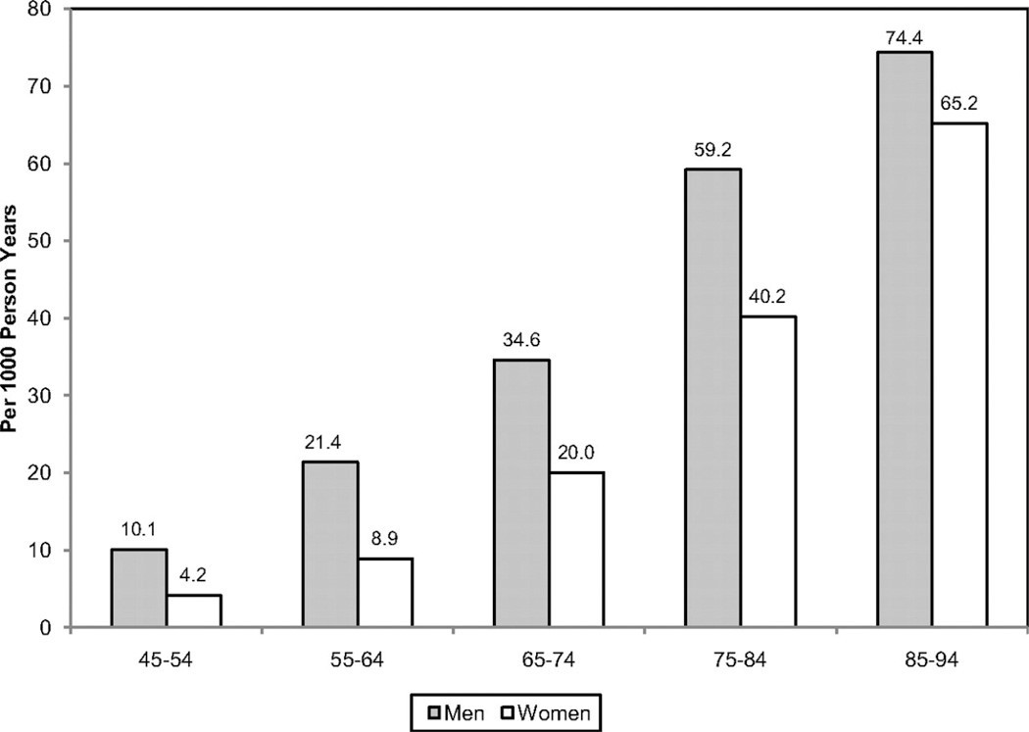

Figure 1 Annual number of adults having diagnosed heart attack or fatal coronary heart disease by age and sex.

As illustrated in Figure 3 the absolute number of annual CVD deaths among the female sex has exceeded that of the male sex since 1984. These data are often confused with CVD mortality rates, which, when adjusted for differences in age distribution, reveal that the CVD mortality rate is substantially higher in men than women. In 2007, the age-adjusted CVD death rate in men was 300 per 100 000 compared with 212 per 100 000 women. The 2007 CVD mortality rate in women represents a 43% reduction from the rate in 1997. From 1980 to 2000, the age-adjusted death rate for CHD fell from 263 to 134 per 100 000 women; during the same time period, the rate fell from 543 to 267 per 100 000 men.[7]

**1.4 Logistic regression**

Logistic regression is a statistical method used for modeling the relationship between a binary dependent variable (also called the outcome or response variable) and one or more independent variables (predictors or features). Unlike linear regression, which is used for continuous outcomes, logistic regression is specifically designed for binary outcomes, where the dependent variable takes on two possible values, often representing categories like yes/no, 1/0, true/false, etc.

The logistic regression model uses the logistic function (also called the sigmoid function) to transform a linear combination of the independent variables into a value between 0 and 1. This transformed value represents the probability of the binary outcome being a particular category. The logistic function ensures that the probabilities remain within this range, even when the linear combination of predictors extends beyond that range.

Mathematically, the logistic regression model can be expressed as:

�(�=1∣�)=11+�−(�0+�1�1+�2�2+…+����)*P*(*Y*=1∣*X*)=1+*e*−(*β*0​+*β*1​*X*1​+*β*2​*X*2​+…+*βp*​*Xp*​)1​

Where:

* �(�=1∣�)*P*(*Y*=1∣*X*) is the probability of the dependent variable being 1 given the values of the independent variables �1,�2,…,��*X*1​,*X*2​,…,*Xp*​.
* �*e* is the base of the natural logarithm.
* �0,�1,�2,…,��*β*0​,*β*1​,*β*2​,…,*βp*​ are the coefficients associated with each independent variable.
* �1,�2,…,��*X*1​,*X*2​,…,*Xp*​ are the values of the independent variables.

The coefficients �0,�1,…,��*β*0​,*β*1​,…,*βp*​ are estimated using various optimization techniques, with the goal of maximizing the likelihood of the observed outcomes given the predictors. The researcher has used this algorithm for prediction of heart disease.

**1.5 Naïve bayes**

Naive Bayes is a probabilistic machine learning algorithm commonly used for classification tasks. It's based on Bayes' theorem, which is a fundamental concept in probability theory. The "naive" in Naive Bayes comes from the assumption that features (attributes or variables) used to describe instances are independent of each other, which is often a simplification but can work well in practice for many applications. Naïve bayes works through Bayes’ theorem, assumption of independence, classification, and choosing highest probability.

Naive Bayes is particularly useful for text classification tasks, such as spam detection or sentiment analysis, where each feature represents a word's presence or absence in a document. Despite its "naive" assumption of independence, Naive Bayes often performs surprisingly well in practice and can be computationally efficient.

**1.6 K-Nearest Neighbors (KNN)**

K-Nearest Neighbors (KNN) is a simple and intuitive machine learning algorithm used for both classification and regression tasks. It's a non-parametric and instance-based learning method, which means it makes predictions based on the data points (instances) in its training set.

Here's how KNN works:

1. **Training**: During the training phase, KNN simply stores the available data points and their corresponding labels (in classification) or target values (in regression). It doesn't construct an explicit model like many other algorithms.
2. **Prediction for Classification**: When you want to classify a new data point, KNN looks at the "k" nearest neighbors in the training data based on some distance metric (usually Euclidean distance). "k" is a user-defined parameter representing the number of neighbors to consider. KNN then counts the number of neighbors belonging to each class and assigns the new data point to the class with the highest count among its neighbors.
3. **Prediction for Regression**: In regression tasks, instead of counting classes, KNN calculates the average or weighted average of the target values of its "k" nearest neighbors and assigns this average as the prediction for the new data point.

**1.7 Decision tree**

A decision tree is a versatile and widely used machine learning algorithm that can be applied to both classification and regression tasks. It's a graphical representation of a series of decisions based on features to arrive at a predicted outcome. The tree structure is composed of nodes and branches, with each node representing a feature and each branch representing a decision or outcome.

Here's how a decision tree works:

1. **Root Node**: At the top, there's a root node representing the entire dataset. The decision tree starts by evaluating a feature (or features) at this node based on some criterion, often aiming to split the data into subsets that are more homogenous in terms of the target variable (for classification) or the predicted value (for regression).
2. **Internal Nodes**: As the tree grows, it forms internal nodes that represent decisions made based on features. Each internal node is associated with a feature and a decision threshold.
3. **Branches**: From each internal node, branches lead to child nodes based on the possible outcomes of the decision. The data is split into subsets based on the decision made at the parent node.
4. **Leaf Nodes**: The tree continues to branch until it reaches leaf nodes. These are the terminal nodes where predictions are made. For classification, the majority class in the leaf node's subset is assigned as the predicted class. For regression, the predicted value is often the mean or median of the target values in the subset.

The key advantages of decision trees include their interpretability, as the graphical representation is easy to understand and visualize. They can handle both numerical and categorical data, require minimal data preprocessing, and can capture complex relationships between features and outcomes.

**1.8 Random Forest**

Random Forest is an ensemble learning technique based on decision trees, and it's widely used for classification and regression tasks. Ensemble methods combine multiple models to improve overall predictive performance and reduce overfitting. Random Forest creates a "forest" of decision trees, and the predictions from multiple trees are combined to make a final prediction.

Here's how Random Forest works:

1. **Bootstrapped Samples**: The algorithm randomly selects multiple subsets (with replacement) from the training data. Each subset is used to train an individual decision tree.
2. **Feature Randomness**: At each node of every decision tree, a random subset of features is considered for making a split. This introduces randomness and diversity among the trees.
3. **Growing Trees**: Each decision tree is grown as far as possible (usually without pruning) to capture the complexity of the data.
4. **Voting/Averaging**: For classification tasks, the predictions from all the trees are combined by majority voting (the class that most trees predict). For regression tasks, predictions are averaged.

## 1.9 Objectives of the project

The main motivation of doing this research is to present a heart disease prediction model for the prediction of occurrence of heart disease. Further, this research work is aimed towards identifying the best classification algorithm for identifying the possibility of heart disease in a patient. This work is justified by performing a comparative study and analysis using three classification algorithms namely Naïve Bayes, Decision Tree, KNN, Logistic Regression and Random Forest are used at different levels of evaluations. Although these are commonly used machine learning algorithms, the heart disease prediction is a vital task involving highest possible accuracy. Hence, the five algorithms are evaluated at numerous levels and types of evaluation strategies. This will provide researchers and medical practitioners to establish a better understanding and help them identify a solution to identify the best method for predicting the heart diseases[8][9].

A key challenge confronting healthcare organization (hospitals, medical centers) is the

facility of quality services at reasonable prices. Quality amenities suggest diagnosing patients

accurately and regulating medications that are effective. Poor clinical choices can prompt

deplorable results, which are in this manner unsatisfactory. Hospitals should limit the cost

of clinical tests. They can accomplish these outcomes by utilizing fitting PC based data and

additionally choice emotionally supportive networks. The heart is the essential piece of our

body. Life is itself reliant on effective working of the heart. If task of the heart isn't legitimate,

it will influence the other body parts of human, for example, cerebrum, kidney and so on.

Coronary illness is a sickness that effects on the activity of the heart.

**CHAPTER NO. 2 LITERATURE REVIEW**

In recent years, several experiments and researches have been conducted in the area of medical science and machine learning, resulting in the publication of important publications**.**

* 1. **Prediction system for heart disease using Naive Bayes and particle swarm**

This section provides the basic concepts of classifier as Naive Bayes and feature subset selection method as PSO.

* + 1. **Particle swarm optimization (PSO)**

PSO is an Evolutionary Computation technique is proposed by Kennedy et al. in 1995[11]. PSO is motivated by social behaviors such as bird flocking and fish schooling. In PSO population swarm consists of “n” particles, and the position of each particle stands for the potential solution in D-dimensional space. The particles change its condition based on three aspects: To keep its inertia; To change the condition according to its most optimist position; To change the condition according to the swarm’s most optimist position[30]. In PSO, a population are encoded as particles in the search space dimensionality D.PSO starts with the random initialization of a population of particles. Based on the best experience of one particle (pbest) and its neighboring particles (gbest), PSO searches for the optimal solution by updating the velocity and the position of each particle.

* + 1. **Naïve Bayes’ Classifier**

Naive Bayes classifiers are a family of simple probabilistic classifiers based by using Bayes theorem with s t r o n g (Naive) independence assumptions between the features. Naive Bayes classifiers are highly scalable by requiring several parameters linear for the number of features or predictors as variable in a learning problem.[12] It is the simplest and the fastest probabilistic classifier especially for the training phase.

**Feature selection -** It is a process of removing the irrelevant and redundant features from dataset based on evaluation criterion which is used to improve accuracy. There are two approaches as individual evaluation and other one is subset evaluation. The process of feature selection is classified into three broad classes. One is filter and another one is wrapper and third one is embedded method based on how the feature selection is deployed by supervised learning algorithm. In this paper, they proposed a model which uses Naive Bayes as classifier and PSO as Feature subset selection measure for prediction of heart disease.[13]

**Proposed system -** In this section, we propose a methodology to improve the performance of Bayesian classifier for prediction of heart disease. Algorithm for our proposed model is shown below:

**Algorithm 1:** Heart disease prediction by using Bayes classifier and PSO. Input: Heart disease dataset.

Output: Classify patient dataset into heart disease or not (normal). Step 1: Read the dataset.

Step 2: Apply particle swarm optimization for f e a t u r e selection. Step 3: Remove the features with low value of PSO.

Step 4: Apply Naive Bayes classifier on relevant features. Step 5: Evaluate the performance of NB+PSO model.

The above algorithm divided into two sections, section 1 (step 2 and step 3) performs processing and feature subset selection. In section 2 (step 4 and step 5) Naive Bayes is applied on relevant features data and evaluate the performance in terms of accuracy.[14]

Accuracy= (No. of objects correctly classified/Total no. of objects in test set) Cross validation technique used to split into training and testing data.

**2.2 Predictive Data Mining for Medical Diagnosis: Heart Disease Prediction**

The successful application of data mining in highly visible fields like e-business, marketing and retail has led to its application in other industries and sectors However, there is a lack of effective analysis tools to discover hidden relationships and trends in data. Number of experiment has been conducted to compare the performance of predictive data mining technique on the same dataset and the outcome reveals that Decision Tree outperforms and sometime Bayesian classification is having similar accuracy as of decision tree but other predictive methods like KNN, Neural Networks, Classification based on clustering are not performing well. The second conclusion is that the accuracy of the Decision Tree and Bayesian Classification further improves after applying genetic algorithm to reduce the actual data size to get the optimal subset of attribute enough for heart disease prediction.[15][16]

* + 1. **Data Mining and Artificial Neural network**

Intelligent Heart Disease Prediction System (IHDPS) using data mining techniques, namely, Decision Trees, Naïve Bayes and Neural Network. is implemented in using .NET platform. IHDPS i s Web-based, user-friendly, scalable, reliable and expandable system. It can also answer complex “what if” queries which traditional decision support systems cannot. Using medical profiles such as age, sex, blood pressure and blood sugar it can predict the likelihood of patients getting a heart disease. It enables significant knowledge, e.g. patterns, relationships between medical factors related to heart disease. As a **Data source** a total of 909 records with 15 medical attributes (factors) were obtained from the Cleveland Heart Disease database. Figure 1 lists the attributes. The records were split equally into two datasets: training dataset (455 records) and testing dataset (454 records). Initially, the data warehouse is pre- processed in order to make it suitable for the mining process. Once the preprocessing gets over, the heart disease warehouse is clustered with the aid of the K-means clustering algorithm, which will extract the data appropriate to heart attack from the warehouse. Consequently, the frequent patterns applicable to heart disease are mined with the aid of the MAFIA algorithm from the data extracted. In addition, the patterns vital to heart attack prediction are selected on basis of the computed significant weightage. The neural network is trained with the selected significant patterns for the effective prediction of heart attack. Multi-layer Perceptron Neural Network with Back-propagation is being used as the training algorithm. In feed-forward neural networks the neurons of the first layer forward their output to the neurons of the second layer, in a unidirectional fashion, which explains that the neurons are not received from the reverse direction.[17][1]

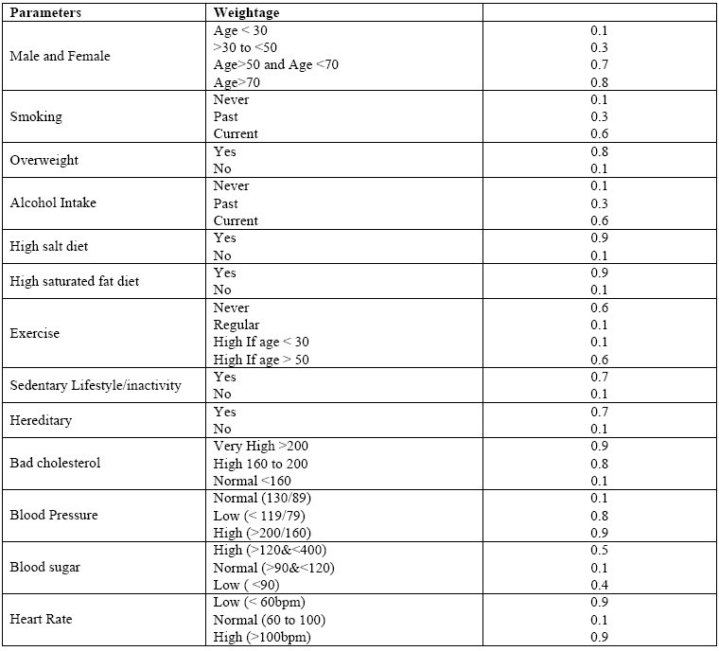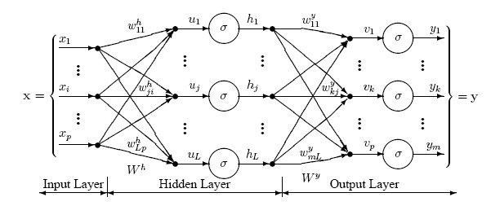

Figure 2 The sample combinations of heart attack parameters for normal and risk level along with their values and weightages

**2.2.3 Data Mining and Genetic Algorithm**

Genetic algorithm has been used in, to reduce the actual data size to get the optimal subset of attributed sufficient for heart disease prediction. Classification is a supervised learning method to extract models describing important data classes or to predict future trends. Three classifiers e.g. Decision Tree, Naïve Bayes and Classification via clustering have been used to diagnose the presence of heart disease in patients. **Classification via clustering:** Clustering is the process of grouping similar elements. This technique may be used as a preprocessing step before feeding the data to the classifying model. The attribute values need to be normalized before clustering to avoid high value attributes dominating the low value attributes. Further, classification is performed based on clustering. Experiments were conducted with Weka 3.6.0 tool. Data set of 909 records with 13 attributes. All attributes are made categorical and inconsistencies are resolved for simplicity. To enhance the prediction of classifiers, genetic search is incorporated. Observations exhibit that the Decision Tree data mining technique outperforms other two data mining techniques after incorporating feature subset selection but with high model construction time. Naïve Bayes performs consistently before and after reduction of attributes with the same model construction time.[19]

* + 1. **Association Rule Discovery**

Association rules represent a promising technique to improve heart disease prediction. Unfortunately, when association rules are applied on a medical data set, they produce an extremely large number of rules. Most of such rules are medically irrelevant and the time required to find them can be impractical. In, four constraints were proposed to reduce the number of rules: item filtering, attribute grouping, maximum itemset size, and antecedent/consequent rule filtering. When association rules are applied on a medical data set, they produce an extremely large number of rules. Most of such rules are medically irrelevant and the time required to find them can be impractical. A more important issue is that, in general, association rules are mined on the entire data set without validation on an independent sample. To solve these limitations, the author has introduced an algorithm that uses search constraints to reduce the number of rules, searches for association rules on a training set, and finally validates them on an independent test set. Instead of using only Support and confidence, one more parameter i.e. lift have been used as the metrics to evaluate the medical significance and reliability of association rules. Medical doctors use sensitivity and specificity as two basic statistics to validate results. Sensitivity is defined as the probability of correctly identifying sick patients, whereas specificity is defined as the probability of correctly identifying healthy individuals. Lift was used together with confidence to understand sensitivity and specificity. To find predictive association rules in a medical data set the algorithm has three major steps. First, a medical data set with categorical and numeric attributes is transformed into a transaction data set. Second, four constraints mentioned above are incorporated into the search process to find predictive association rules with medically relevant attribute combinations. Third, a train and test approach are used to validate association rules.[20][21]

* + 1. **Issues and Challenges**

Medical diagnosis is considered as a significant yet intricate task that needs to be carried out precisely and efficiently. The automation of the same would be highly beneficial. Clinical decisions are often made based on doctor’s intuition and experience rather than on the knowledge rich data hidden in the database. This practice leads to unwanted biases, errors and excessive medical costs which affects the quality of service provided to patients. Data mining have the potential to generate a knowledge-rich environment which can help to significantly improve the quality of clinical decisions.

Purushottam ,et Hill climbing and decision tree algorithms were proposed in a study by. are used in the System for Effective Heart Disease Prediction. The outcomes of algorithms like SVM and KNN are based on split conditions that can be vertical or horizontal depending on the dependent variables. Yet, a decision tree is a structure that resembles a tree with a root node, leaves, and branches, and it is based on the decisions made in each tree. The value of the attributes in the dataset is also explained by the decision tree. Also, they used the Cleveland data set. Using some techniques, the data set is divided into 70% training and 30% testing. The accuracy of this method is 91%. Naive Bayes, the second algorithm, is used for categorization. Since it can handle complex, nonlinear, dependent data, the heart disease dataset—which is similarly complex, dependent, and nonlinear in nature—is seen to be a good fit. This program gives 87% accuracy.

## CHAPTER NO. 3 PROPOSED METHODOLOGY

* 1. **About Heart Disease**

Heart Diseases affect a large population in today’s world, where the lifestyle is moved from active to comfort-oriented. We live in era of fast foods. Which build up cholesterol, diabetes and many more factors which in turn affects the heart in some way or the other. According to the World Health Organization Cardiovascular Diseases (CVD) or Heart Diseases cause more death than any other diseases globally[22]. The amount of data in medical sectors is quite large and computerized as well. They are not utilized or put to any use. This data if studied and analyzed could be put to good use like prediction of diseases or even prevent them. Diseases such as cancer can be detected, and the stage can also be predicted by training dataset with pictures of cancer cells. Similarly, heart disease can be predicted based on aspects like cholesterol, diabetes, heart rate etc. The prediction of heart diseases is a challenge and very risky. We observed that in some cases solutions of problems does not rely on a single method. It varies from situation to situation. It is also a challenge as most of the data are sparse or missing as they were not stored in the motive of analyzing.

**3.2 Data analysis technique**

The prediction of heart diseases is a challenge and very risky. We observed that in some cases solutions of problems does not rely on a single method. It varies from situation to situation. It is also a challenge as most of the data are sparse or missing as they were not stored in the motive of analyzing. We therefore set out goal to finding which method would be best for predicting the diseases using data of four different hospitals from four different places. This is a comparative study on the efficiency of different data mining techniques such as Logical Regression, Random forest, Naïve bayes, K-Nearest Neighbors, and Decision Tree in predicting heart diseases. The Data Mining techniques are analyzed, and the accuracy of prediction is noted for each method used.

**3.3 Data collection**

**3.3.1 Data set**

The main objective of this study is to build a model that can predict the heart disease occurrence, based on a combination of features (risk factors) describing the disease. Different machine learning techniques will be implemented and compared upon standard performance metric such as accuracy. The dataset used for this study was taken from UCI machine learning repository[23]. This database contains 76 attributes, but all published experiments refer to using a subset of 14 of them. In particular, the Cleveland database is the only one that has been used by ML researchers to this date. The "goal" field refers to the presence of heart disease in the patient. It is integer valued from 0 (no presence) to 4. Experiments with the Cleveland database have concentrated on simply attempting to distinguish presence (values 1,2,3,4) from absence (value 0).In this project we used 5 algorithms to find out the reasons of heart disease and create a model to get the maximum accuracy possible. For this we have used UCI dataset[24] where 4 databases: Cleveland, Hungary, Switzerland, and the VA Long Beach are already stored and the Creators are:

1. Hungarian Institute of Cardiology. Budapest: Andras Janosi, M.D.
2. University Hospital, Zurich, Switzerland: William Steinbrunn, M.D.
3. University Hospital, Basel, Switzerland: Matthias Pfisterer, M.D.
4. V.A. Medical Center, Long Beach and Cleveland Clinic Foundation: Robert Detrano, M.D., Ph.D.

**3.3.2 Attributes used in dataset**

1. age: The person's age in years
2. sex: The person's sex (1 = male, 0 = female)
3. cp: The chest pain experienced (Value 1: typical angina, Value 2: atypical angina, Value 3: non-anginal pain, Value 4: asymptomatic)
4. trestbps: The person's resting blood pressure (mm Hg on admission to the hospital)
5. chol: The person's cholesterol measurement in mg/dl
6. fbs: The person's fasting blood sugar (> 120 mg/dl, 1 = true; 0 = false)
7. restecg: Resting electrocardiographic measurement (0 = normal, 1 = having ST-T wave abnormality, 2 = showing probable or definite left ventricular hypertrophy by Estes' criteria)
8. thalach: The person's maximum heart rate achieved
9. exang: Exercise-induced angina (1 = yes; 0 = no)
10. old peak: ST depression induced by exercise relative to rest ('ST' relates to positions on the ECG plot. See more here)
11. slope: the slope of the peak exercise ST segment (Value 1: upsloping, Value 2: flat, Value 3: downsloping)
12. ca: The number of major vessels (0-3)
13. thal: A blood disorder called thalassemia (3 = normal; 6 = fixed defect; 7 = reversible defect)
14. target: Heart disease (0 = no, 1 = ye

**CHAPTER No. 4 EXPERIMENTAL RESULTS**

* 1. 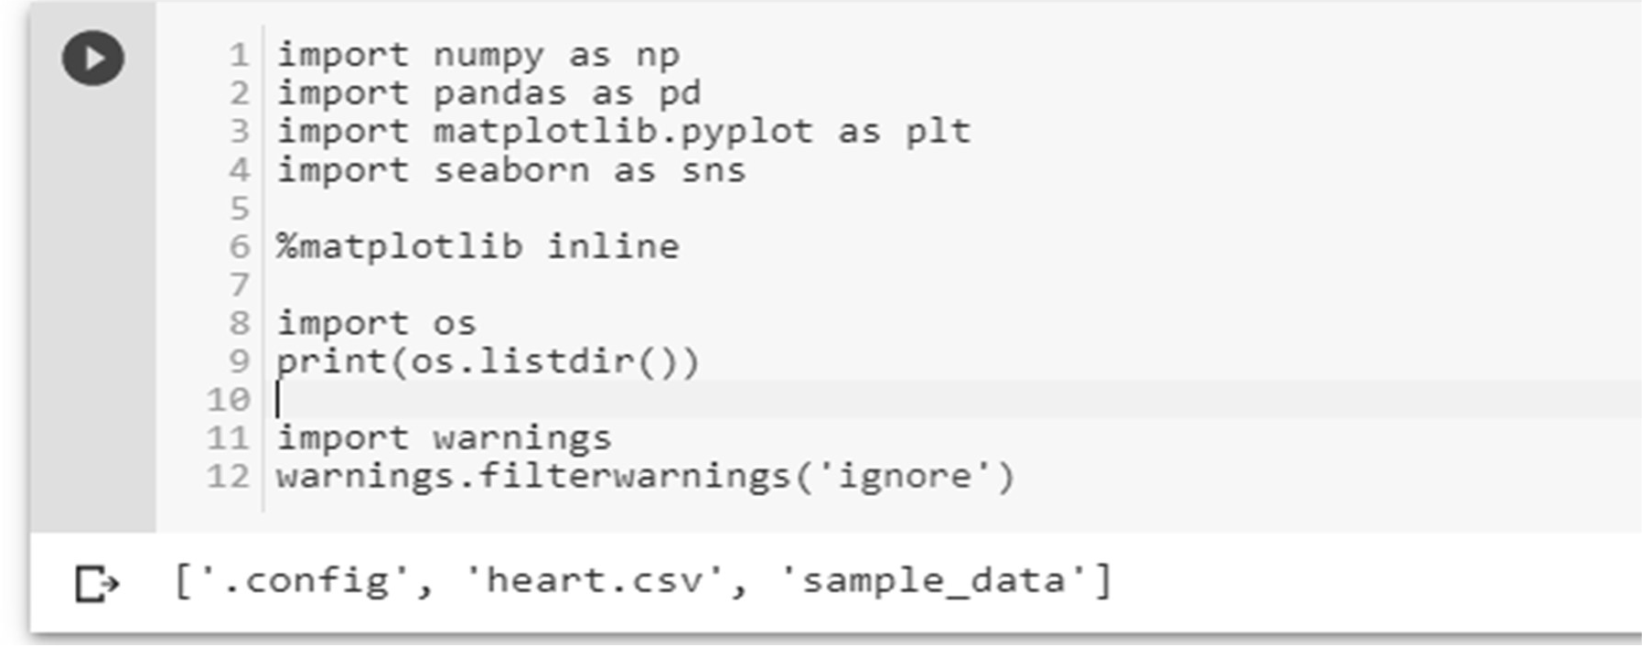 **Importing libraries**
  2. **Load data**

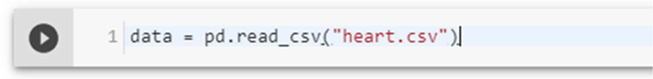

* 1. **Check the type of the dataset**

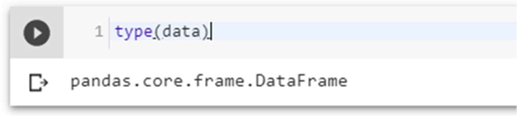

* 1. **Check the Shape of the data**

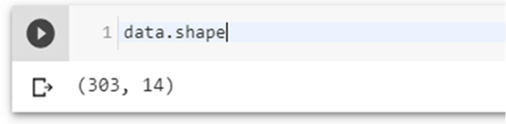

* 1. 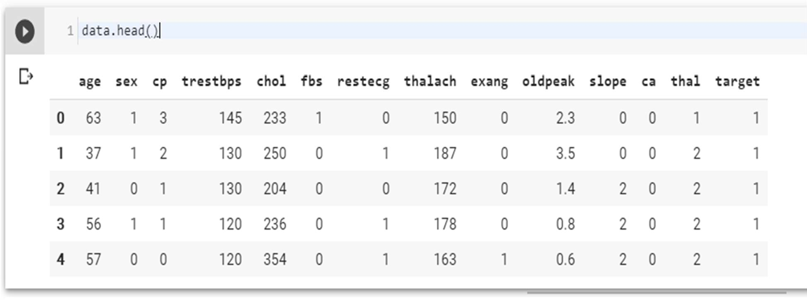**Check the top four columns of the dataset**

**4.5 Dataset description**

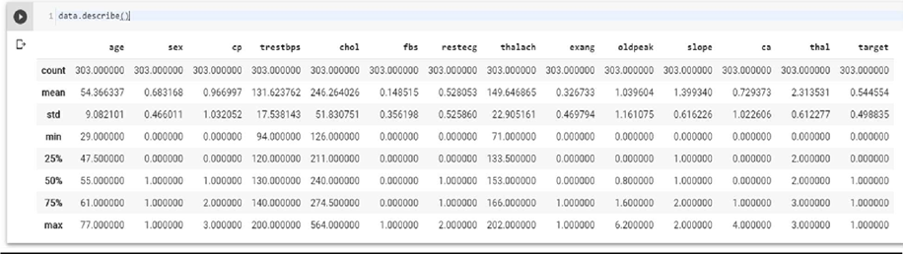

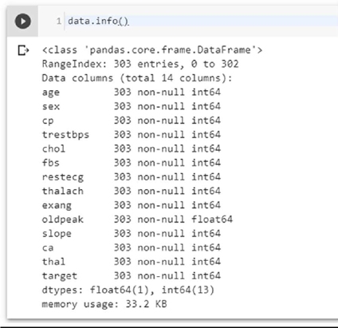

The dataset used in this project contains 14 variables. The independent variable that needs to be predicted, 'diagnosis', determines whether a person is healthy or suffer from heart disease. Experiments with the Cleveland database have concentrated on endeavors to distinguish disease presence (values 1, 2, 3, 4) from absence (value 0). There are several missing attribute values, distinguished with symbol '?'. The header row is missing in this dataset, so the column names have to be inserted manually.[124]

Features information:

age - age in years

sex - sex (1 = male; 0 = female)

chest pain - chest pain type (1 = typical angina; 2 = atypical angina; 3 = non- anginal pain; 4 = asymptomatic)

blood pressure - resting blood pressure (in mm Hg on admission to the hospital)

serum cholesterol - serum cholesterol in mg/dl

fasting blood sugar - fasting blood sugar > 120 mg/dl (1 = true; 0 = false)

electrocardiographic - resting electrocardiographic results (0 = normal; 1 = having ST-T; 2 = hypertrophy)

max heart rate - maximum heart rate achieved

induced angina – exercise-induced angina (1 = yes; 0 = no)

ST depression - ST depression induced by exercise relative to rest

slope - the slope of the peak exercise ST segment (1 = upsloping; 2 = flat; 3 = down sloping)

no of vessels - number of major vessels (0-3) colored by fluoroscopy

thalassemia - 3 = normal; 6 = fixed defect; 7 = reversible defect

diagnosis - the predicted attribute - diagnosis of heart disease (angiographic disease status) (Value 0 = < 50% diameter narrowing; Value 1 = > 50% diameter narrowing)

**4.6 Types of feature**

**Categorical features** (Has two or more categories and each value in that feature can be categorized by em): **sex, chest pain**

**Ordinal features** (Variable having relative ordering or sorting between the values): **fasting blood sugar, electrocardiographic, induced angina, slope, no of vessels, thalassemia, diagnosis**

**Continuous features** (Variable taking values between any two points or between the minimum or maximum values in the feature column): **age, blood pressure, serum cholesterol, max heart rate, ST depression**

* 1. **Some Random data columns**

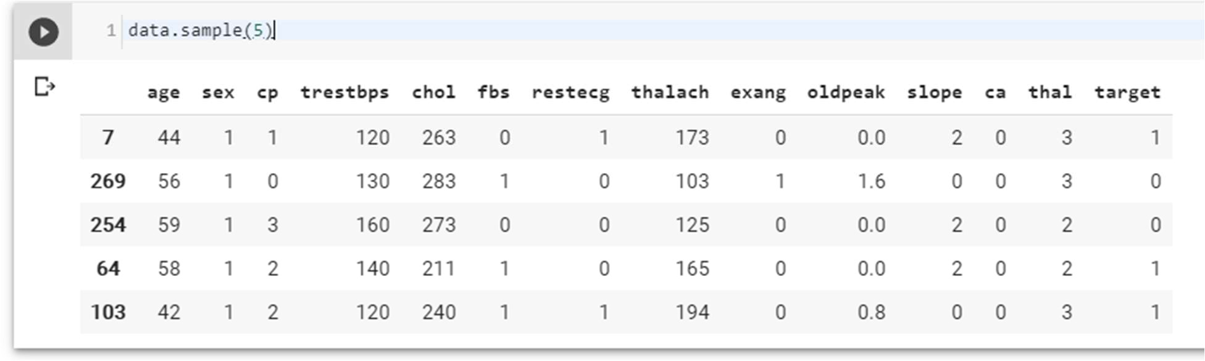

**4.8 Check for missing Data**

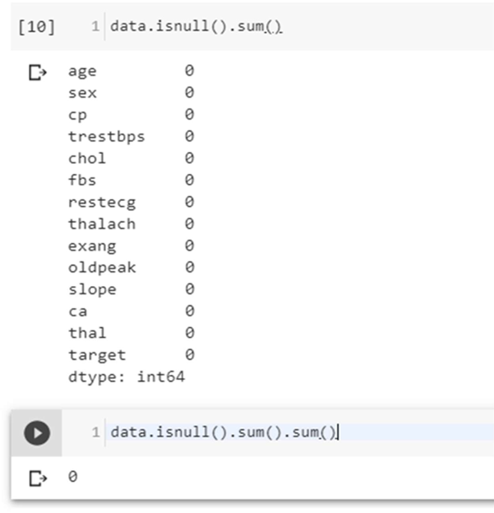

No Data is missing, which is good.

* 1. **Check the correlation with target data**

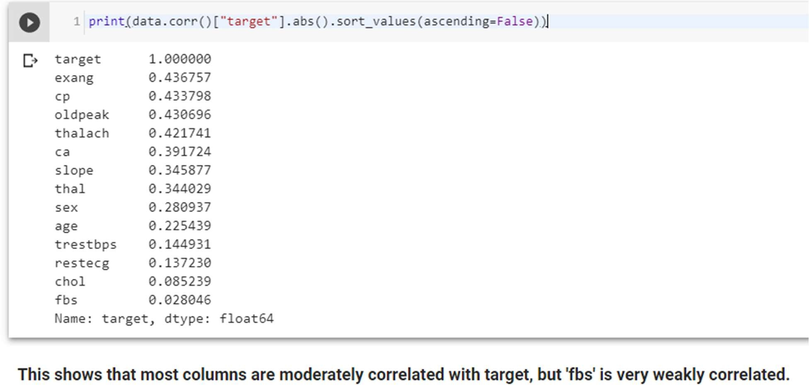

* 1. **Exploratory Data Analysis (EDA)**

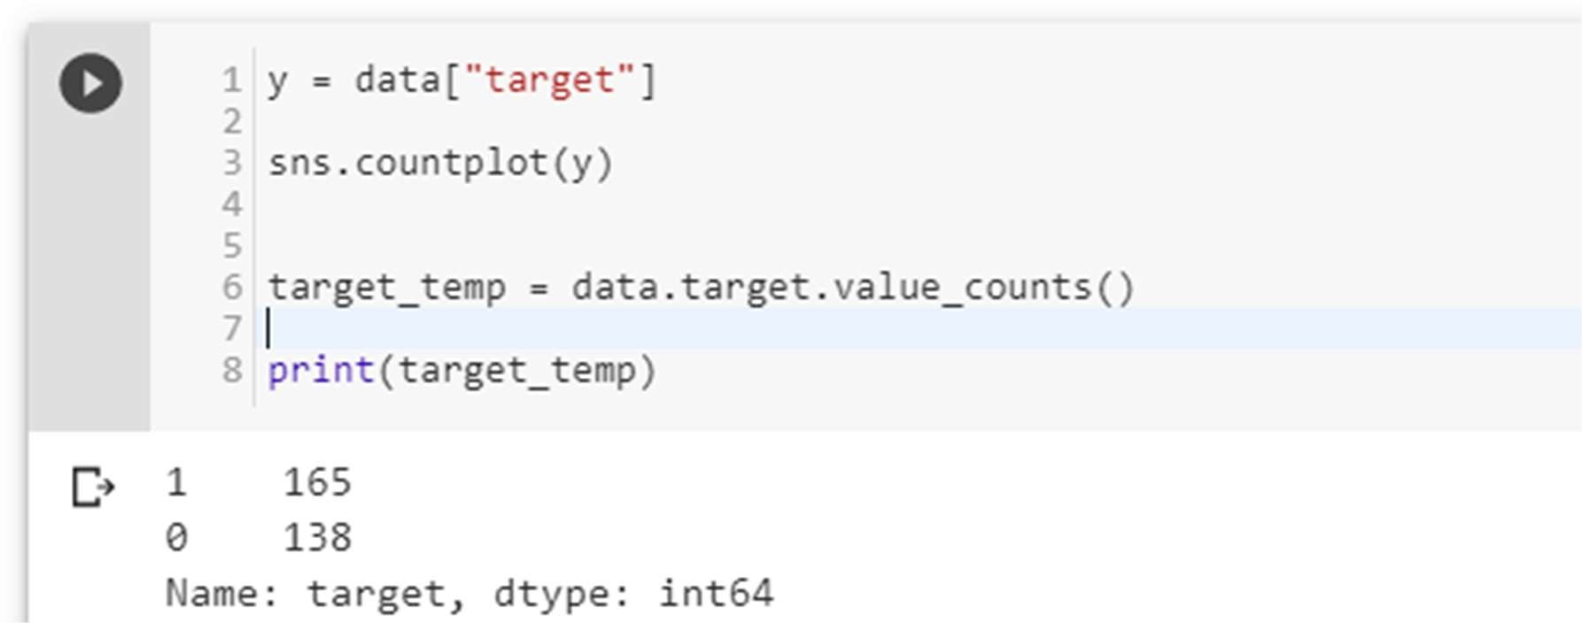

(1 is who have Heart Disease and 0 is who don’t have Heart Disease)

No. of Heart Disease patients is 165. No. of patients who don’t have a heart disease is 138. [Which is a good balance of target data.]

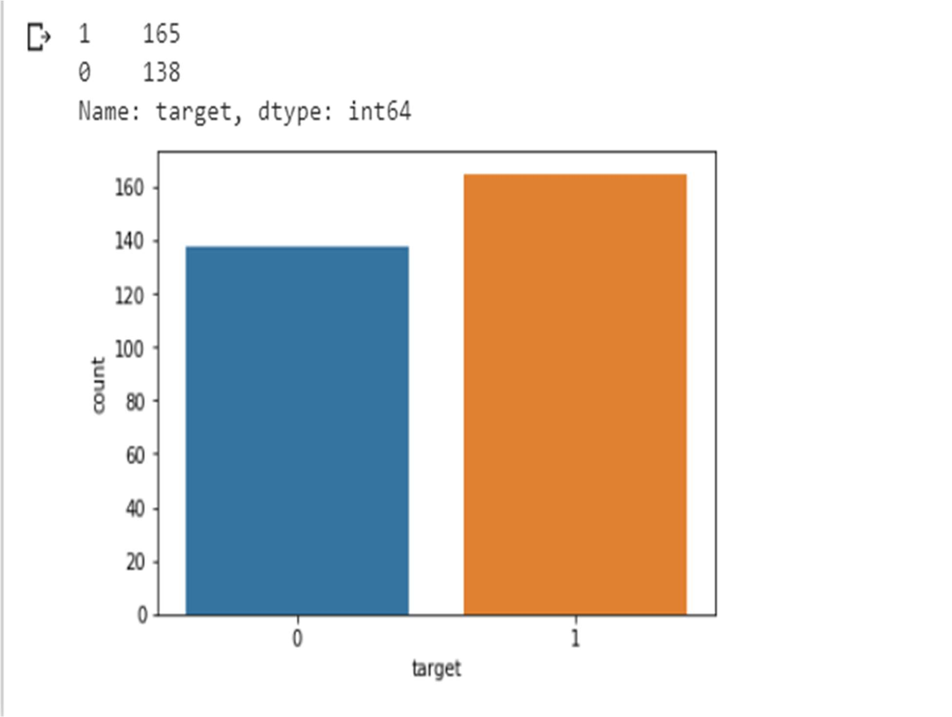

Figure 3 Disease vs Non-Disease Analysis

**4.11 Percentage of patient with or without heart problems in the given dataset**

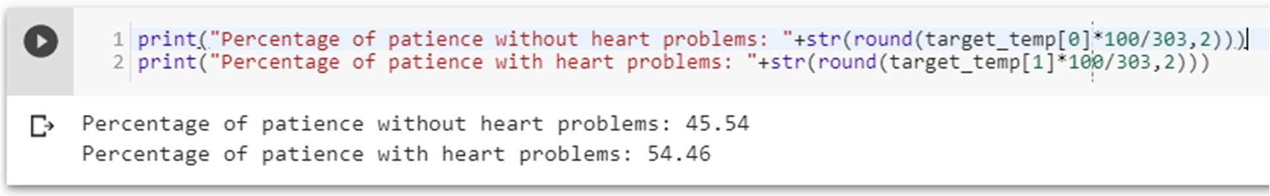

which is a good data distribution

* 1. **Uniqueness of sex column**

Two sex types: 1 is male and 0 is female

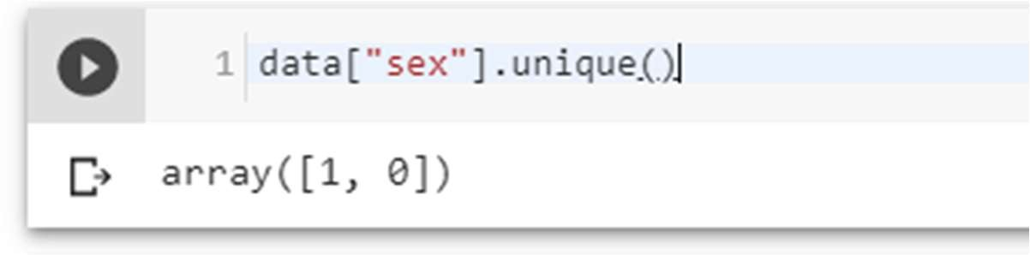

* 1. **Check the percentage and plot the graph**

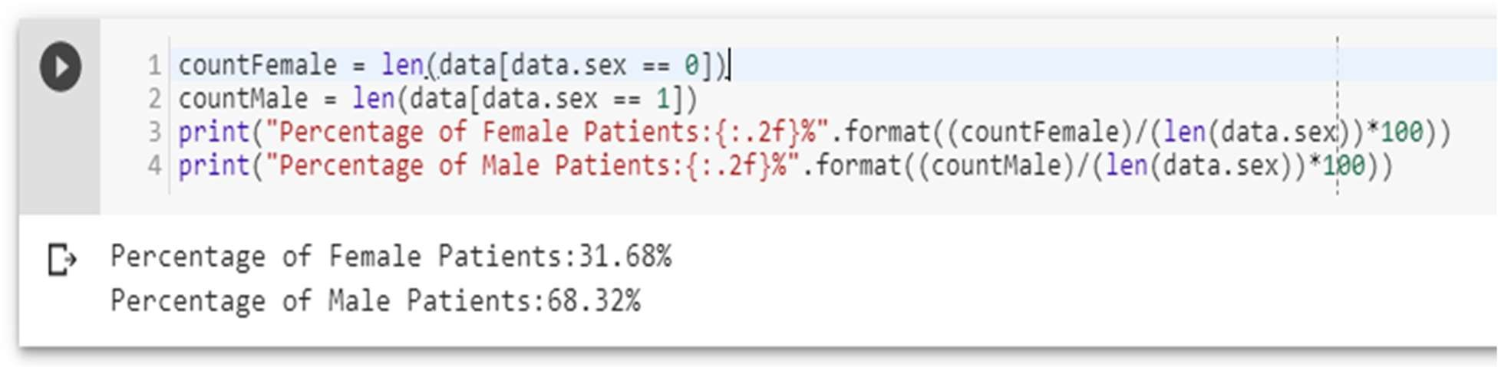

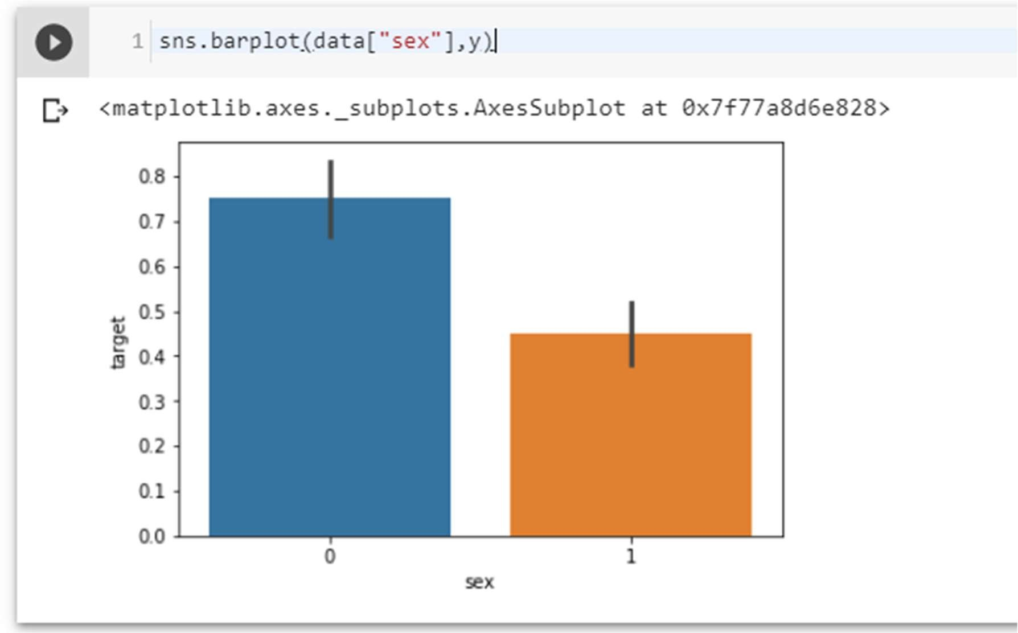

Figure 4 Sex analysis

* 1. **Heart Disease Frequency for Ages**

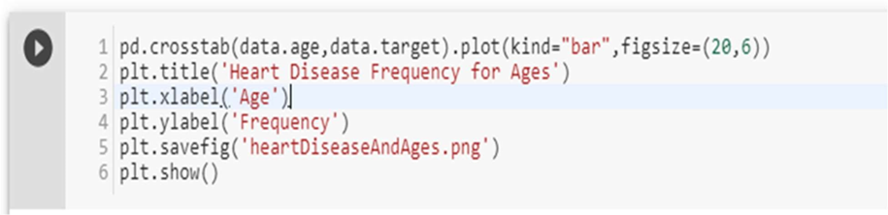

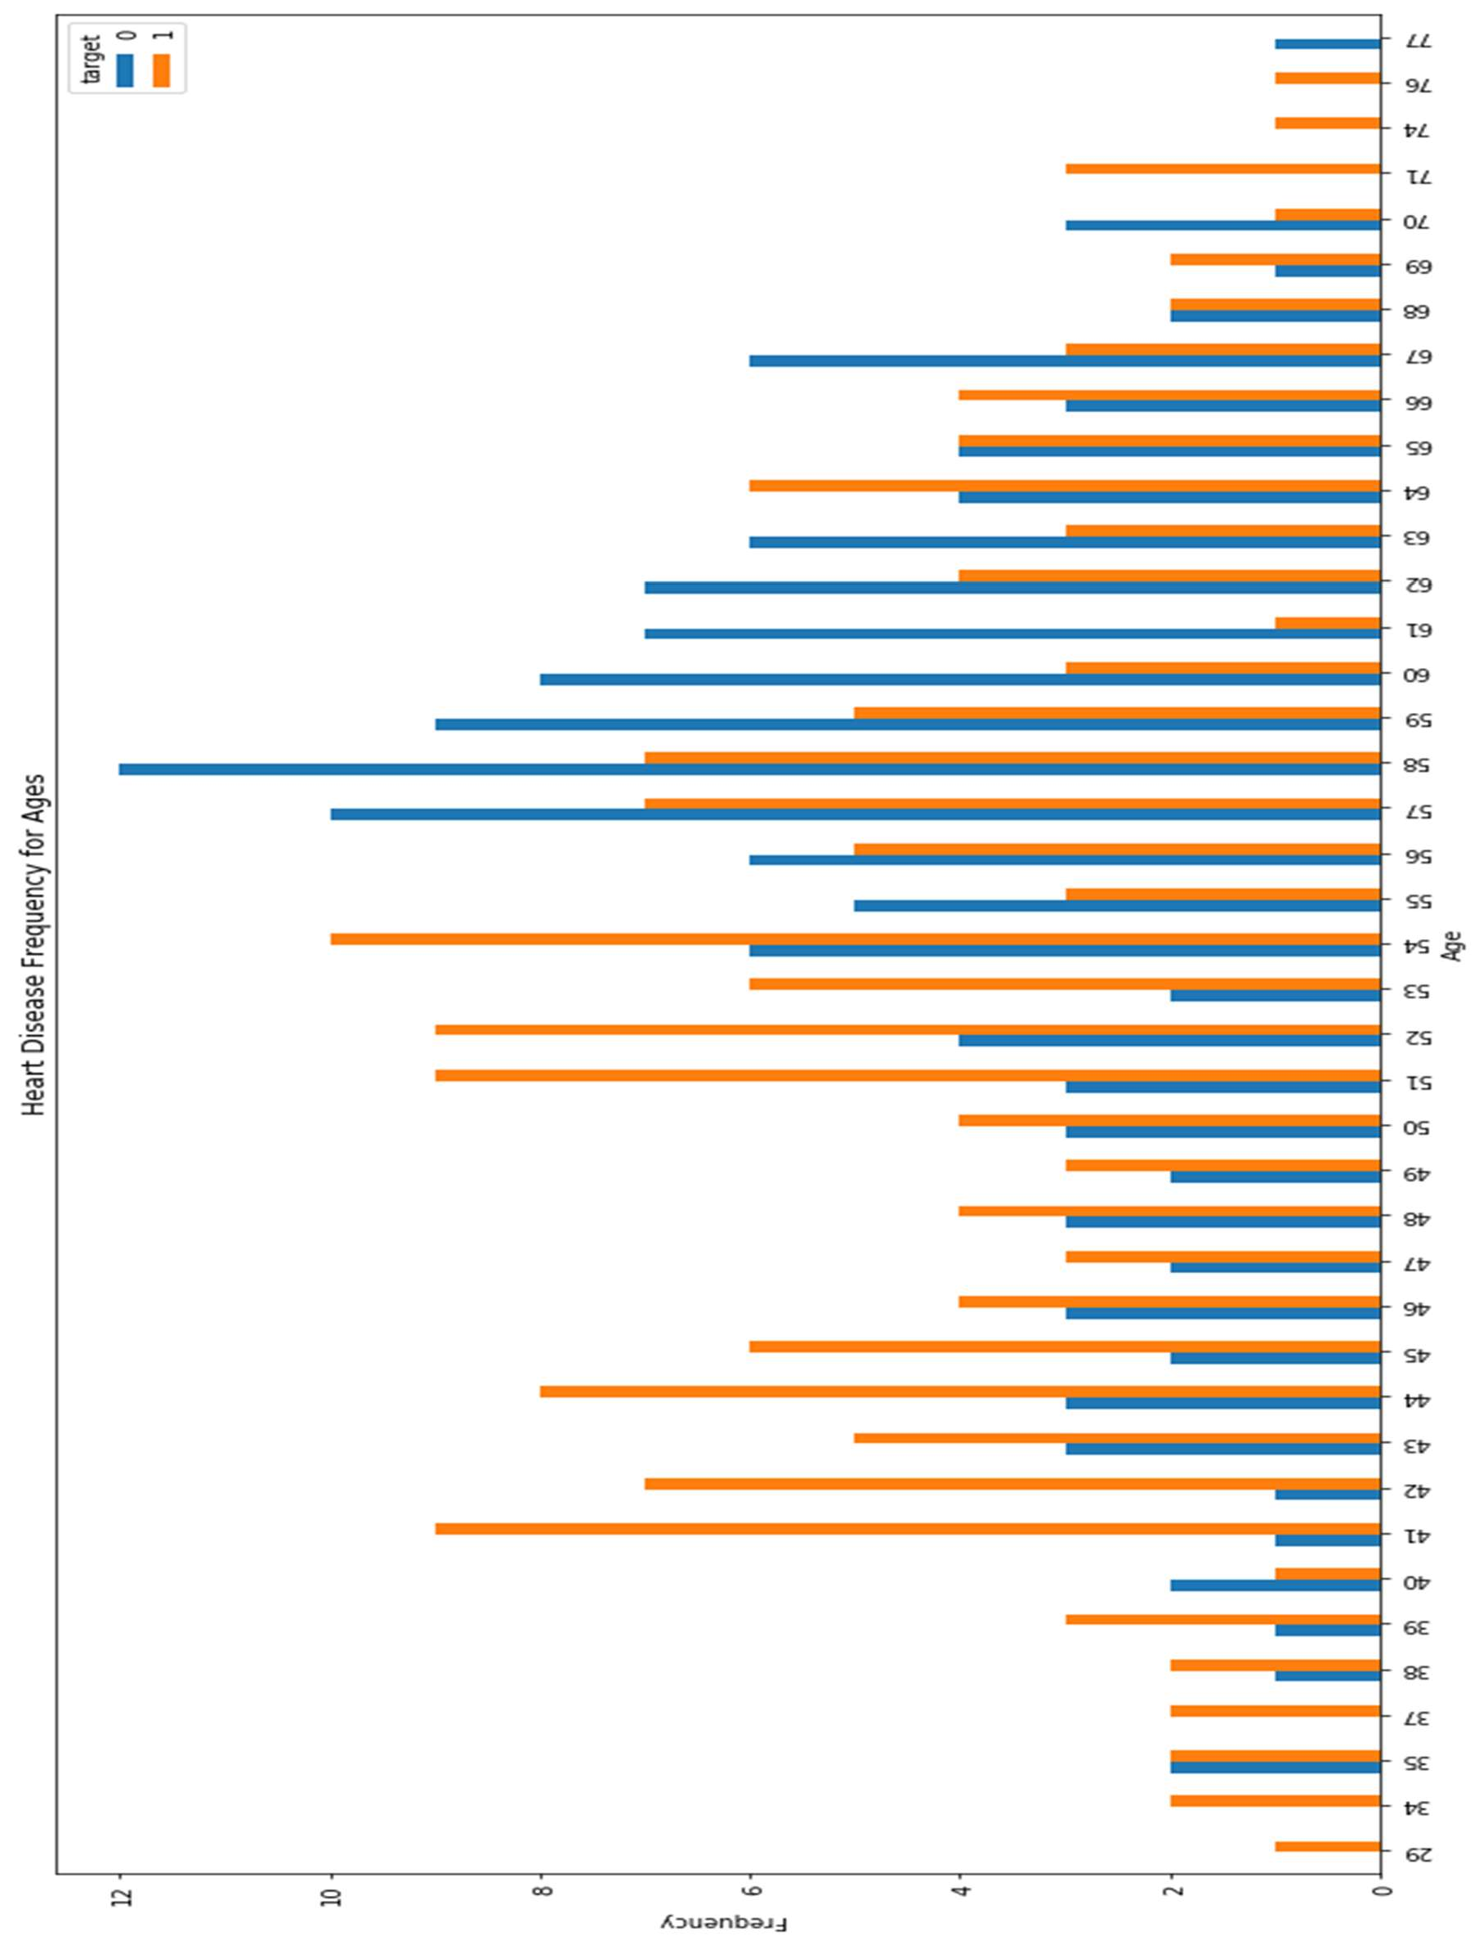

Figure 5 Heart Disease Frequency for ages

* 1. **Heart Disease Frequency for sex**

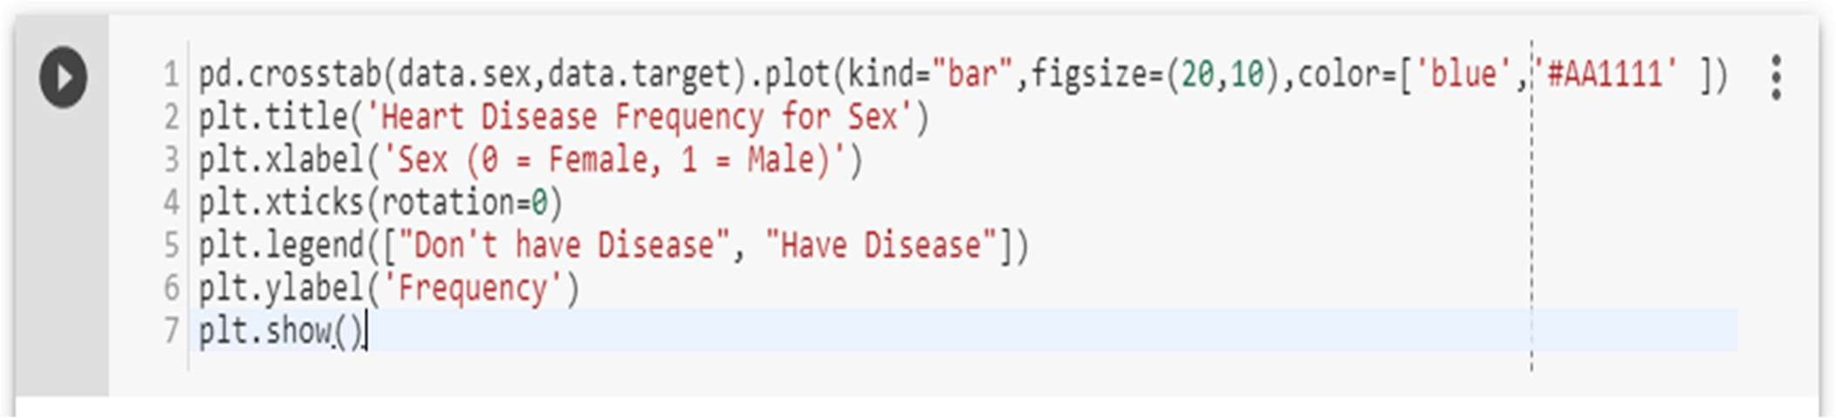

**Where 1 is “male”, 0 is “female”.**

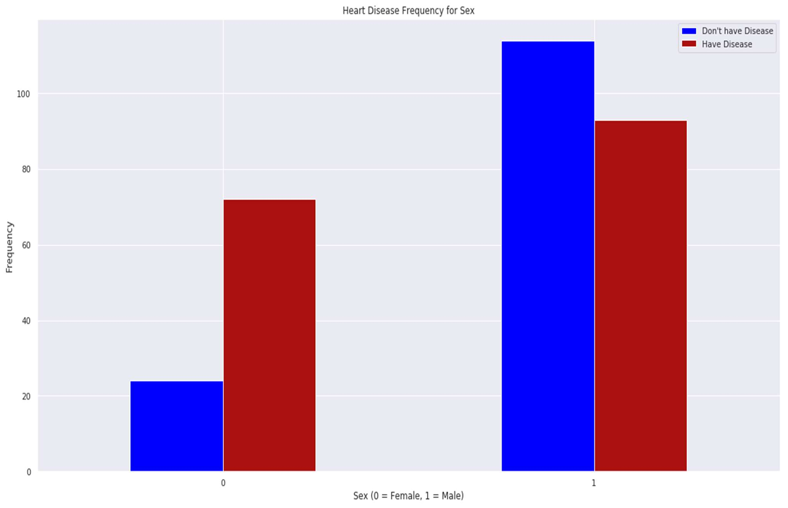

Figure 6 Heart Disease Frequency for sex

**4.16 Making the data column names easily recognizable**

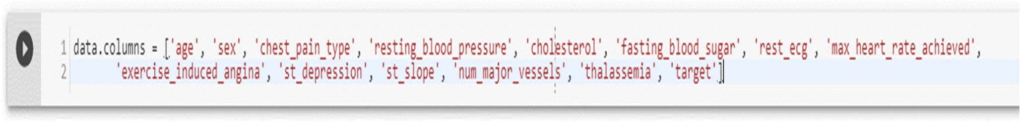

* 1. **Checking out Male/Female Heart disease according to Fasting Blood Sugar**

**Fasting blood sugar test:** A blood sample will be taken after an overnight fast. A fasting blood sugar level less than 100 mg/dL (5.6 mmol/L) is normal. A fasting blood sugar level from 100 to 125 mg/dL (5.6 to 6.9 mmol/L) is considered prediabetes. If it's 126 mg/dL (7 mmol/L) or higher on two separate tests, you have diabetes[125].

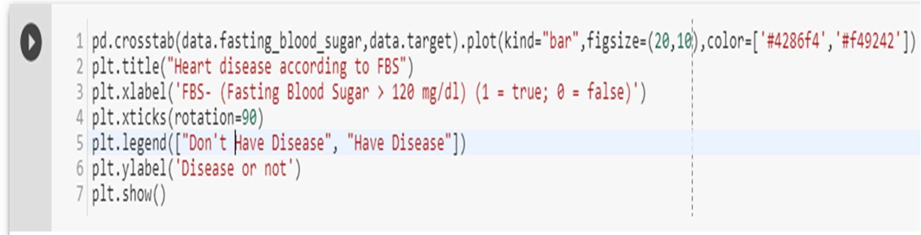

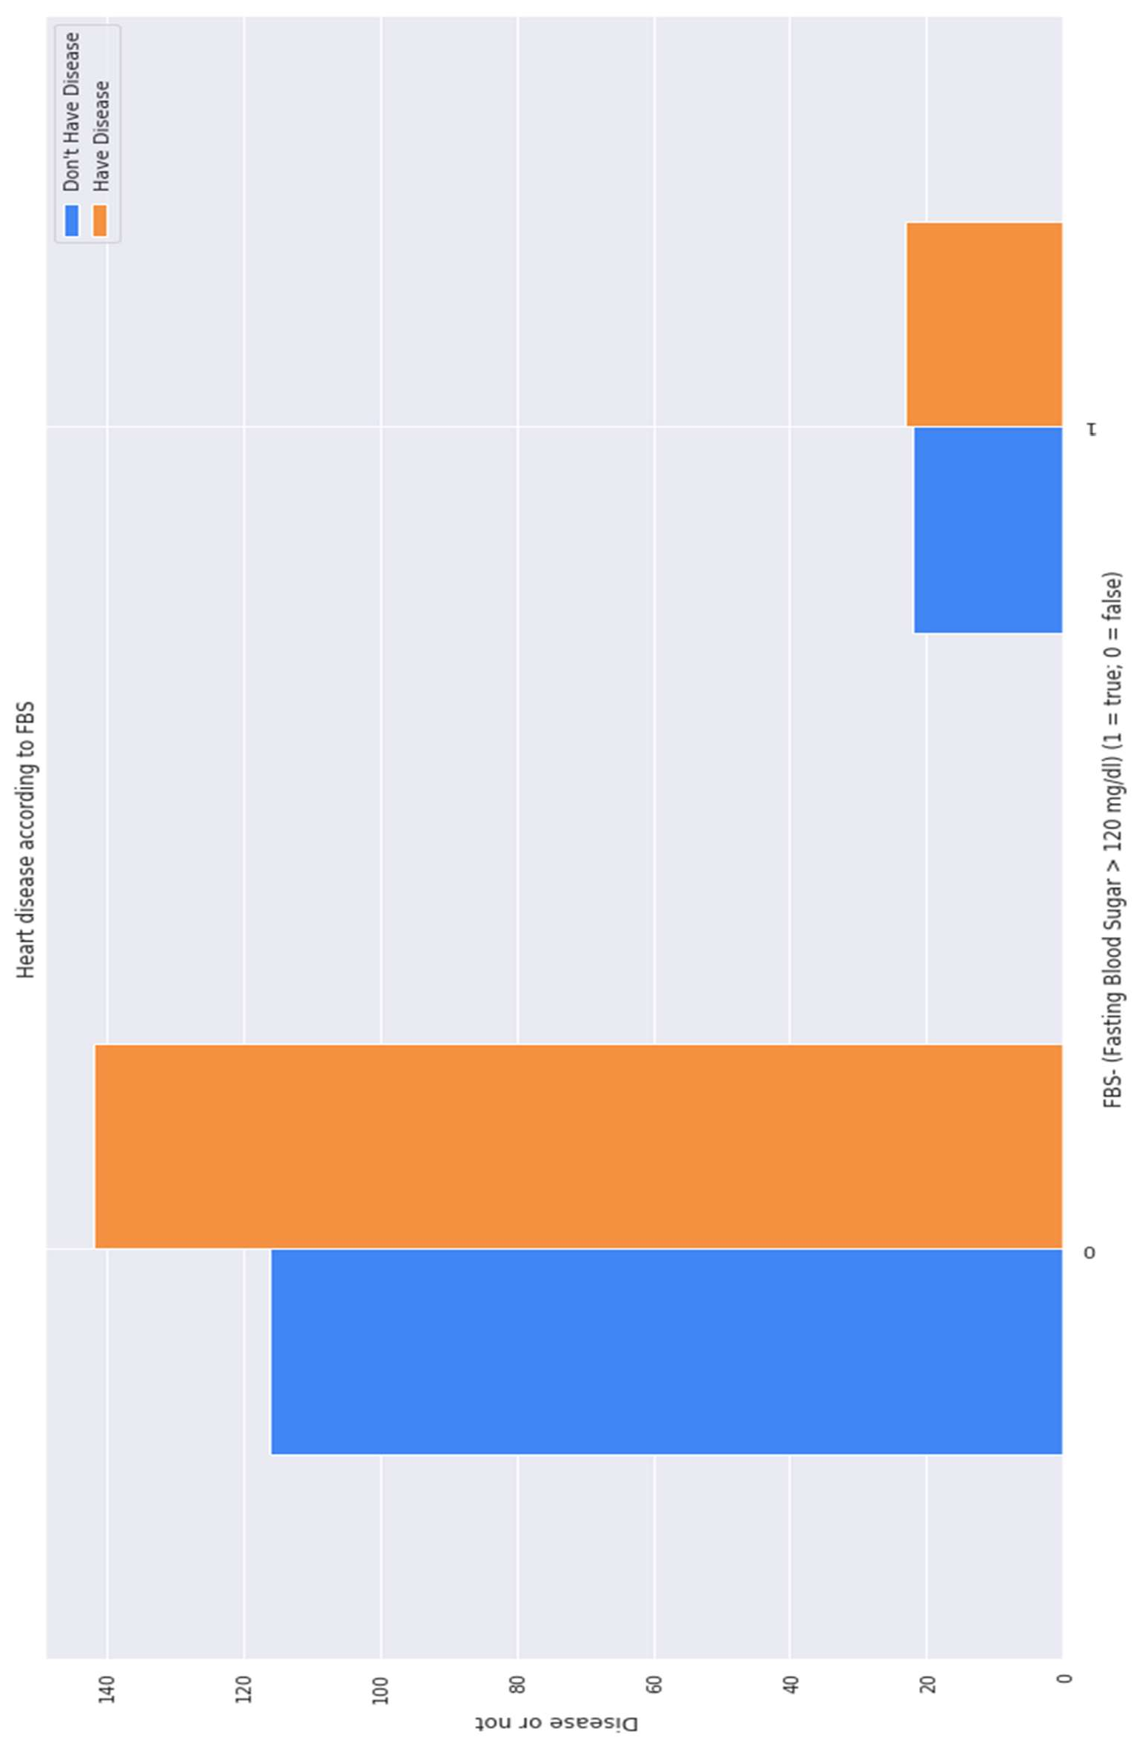

Figure 7 Heart Disease according to FBS

**4.18 Analyzing the chest pain**

There are four types of Angina(chest pain)[126].

[Value 1: typical angina[122], Value 2: atypical angina[127], Value 3: non-anginal pain[123], Value 4: asymptomatic[128] ].

**Let’s check how many types of chest pain (Angina) is present in our dataset**

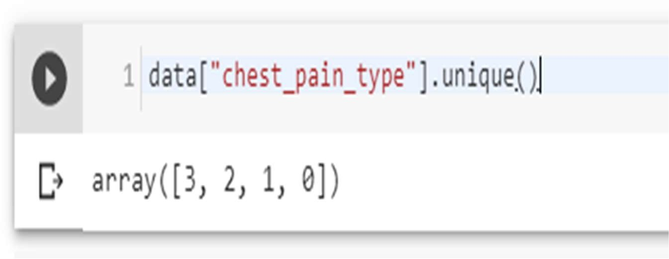

4 types are present, 0, 1, 2, 3

**Let’s plot chest pain types against target**

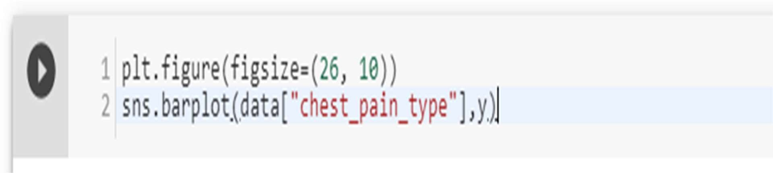

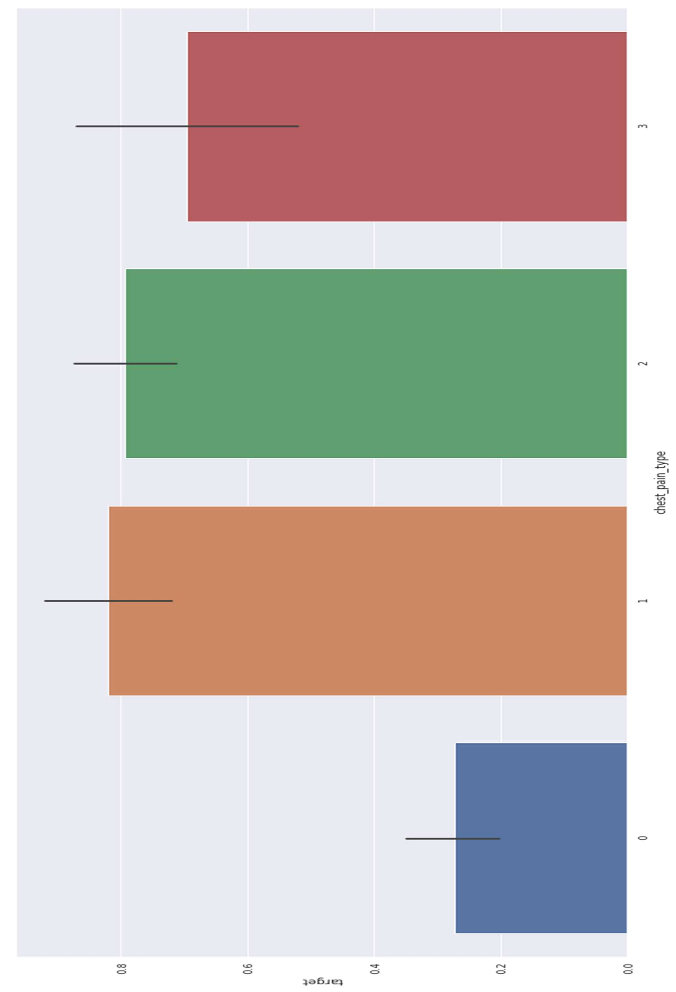

Figure 8 Chest Pain Analysis

**4.19 Analyzing the resting blood pressure**

Resting blood pressure in mm Hg on admission to the hospital [129][124].

**Let’s check out the unique resting blood pressures in our dataset**

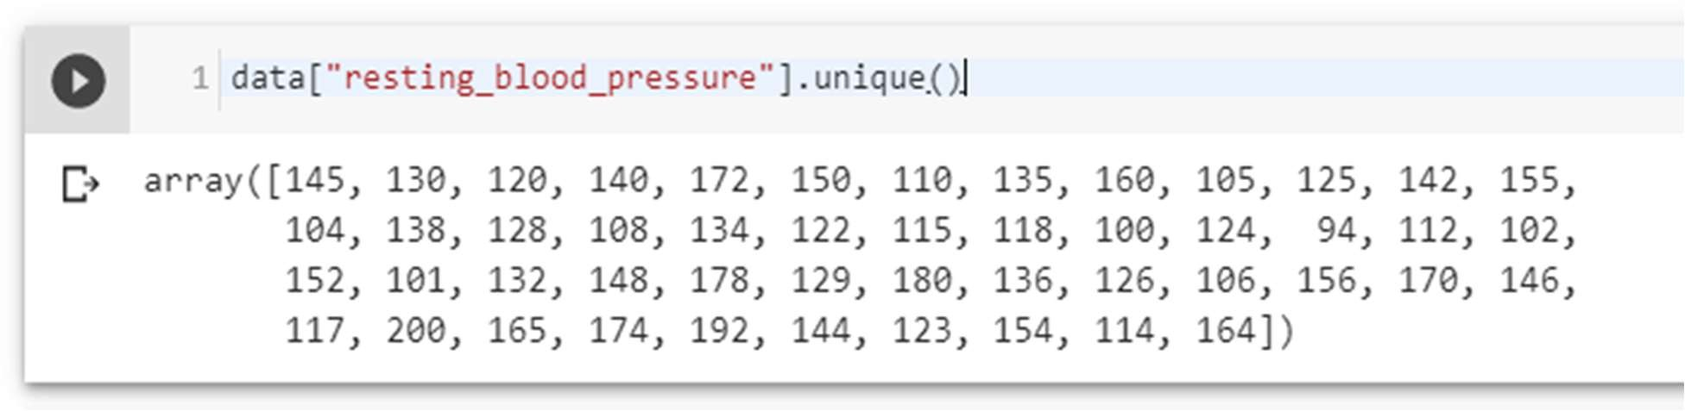

**Let’s plot the resting blood pressure of our dataset against target**

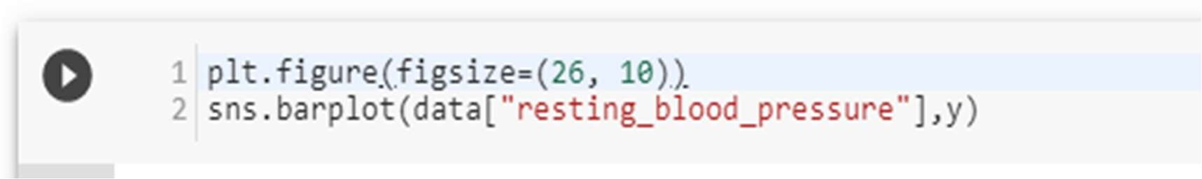

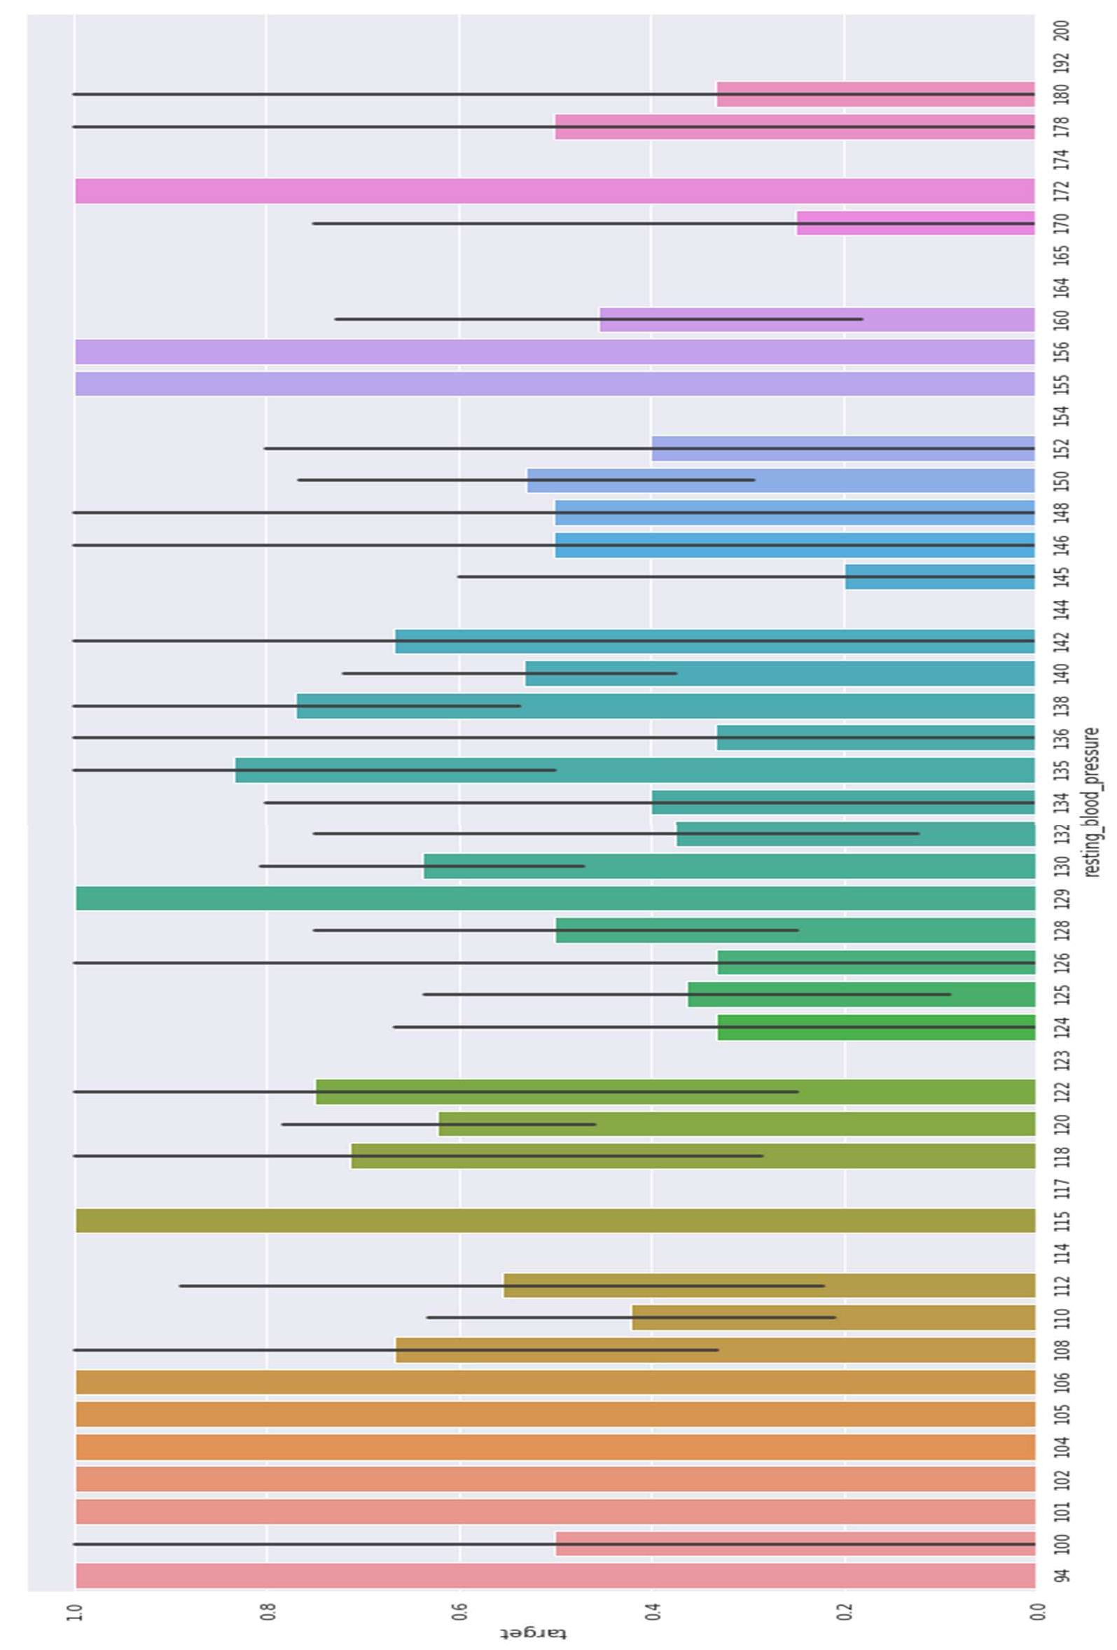

Figure 9 Resting Blood Pressure Analysis

**4.20 Analyzing the resting electrocardiographic measurement**

0 = normal, 1 = having ST-T wave abnormality, 2 = showing probable or definite left ventricular hypertrophy by Estes' criteria[130][131][132].

**Let’s check uniqueness of our dataset**

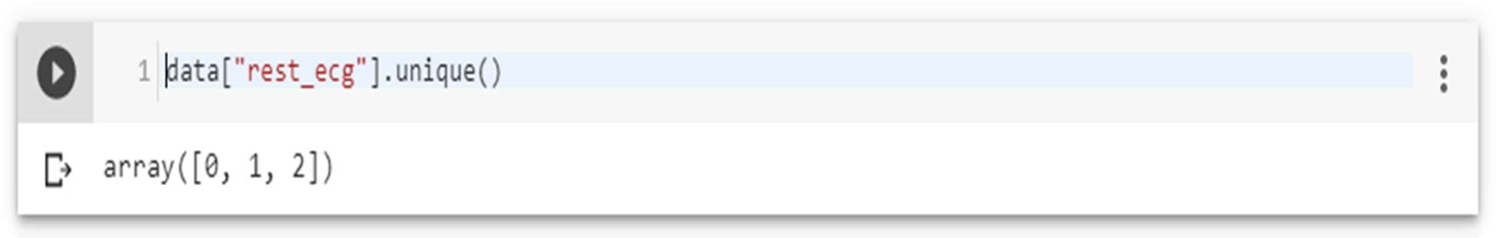

There are 3 types of resting ECG values are present: 0, 1, 2.

**Let’s then plot the ECG values against target column**

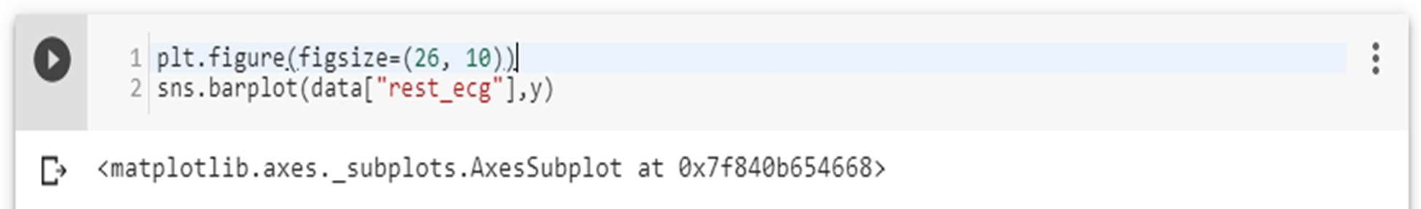

**People with resting ECG value: 1 and 0 are much likely to have a heart disease than with the value 2 of resting ECG.**

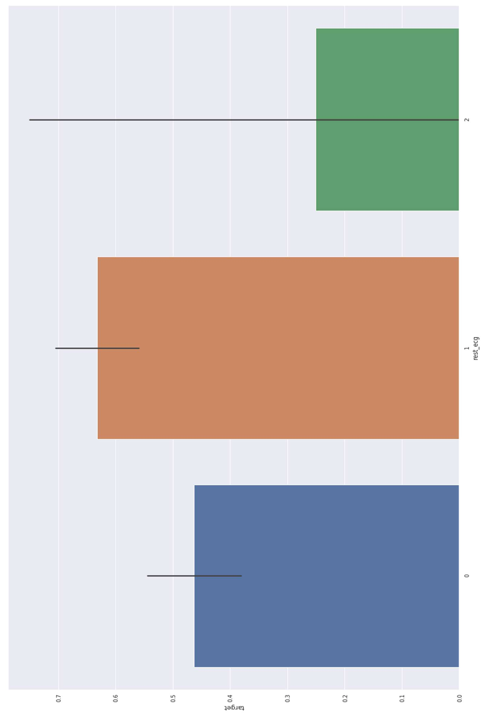

Figure 10 ECG analysis

**4.21 Analyzing Exercise Induced angina**

1 means yes, and 0 means no.

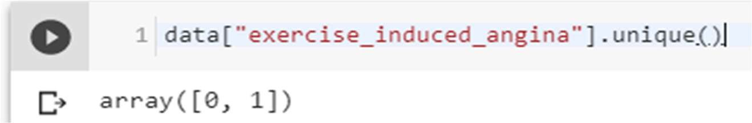

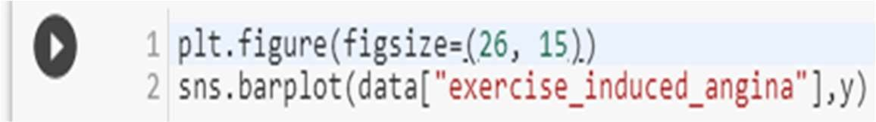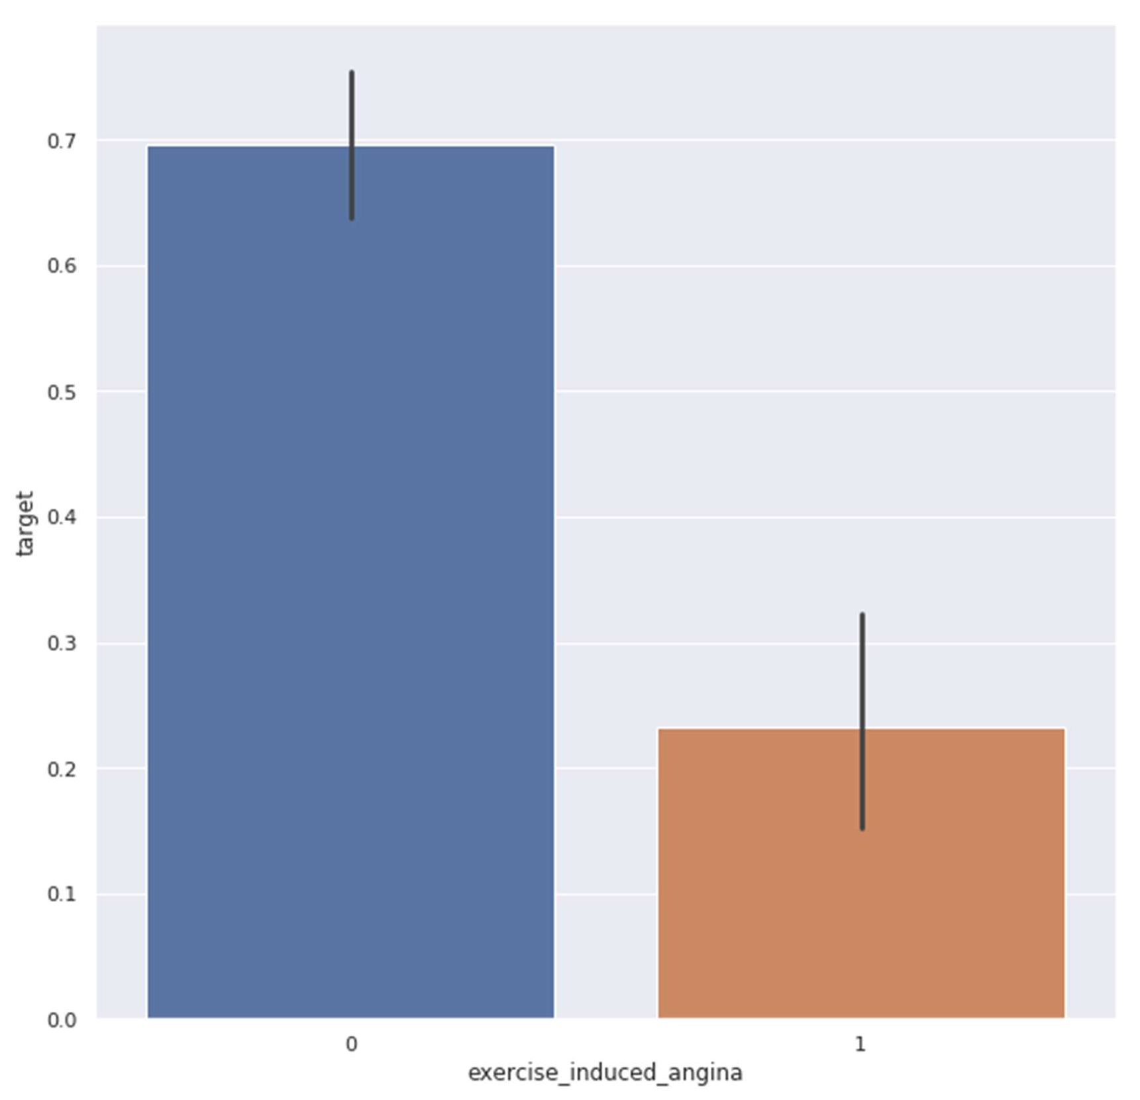

Figure 11 Exercised Induced Angina Analysis

**4.22 Slope of the peak exercise ST segment**

The treadmill electrocardiogram (ECG) stress test is widely used to screen for obstructive coronary artery disease (CAD). The presence of ST segment changes, either depression or elevation, on the ECG during

the treadmill test often suggests presence of CAD and warrants further management. We herein present three cases, with evidence of ischemia on the

treadmill ECG stress test. In addition, we discuss the use of the treadmill ECG stress test, including its indications, contraindications, reasons for termination and interpretation of the ST-segment changes, heart rate, as well as blood pressure responses to exercise[133].

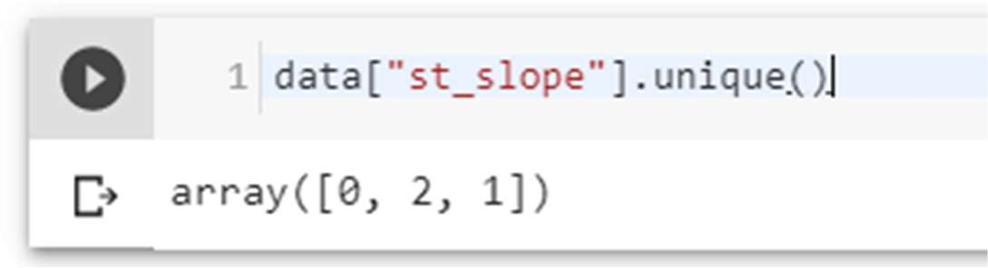

Value 1: upsloping, Value 2: flat, Value 3: down sloping.

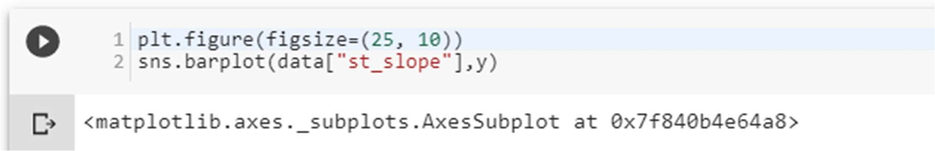

Slope '2' causes heart pain much more than Slope '0' and '1'**.**

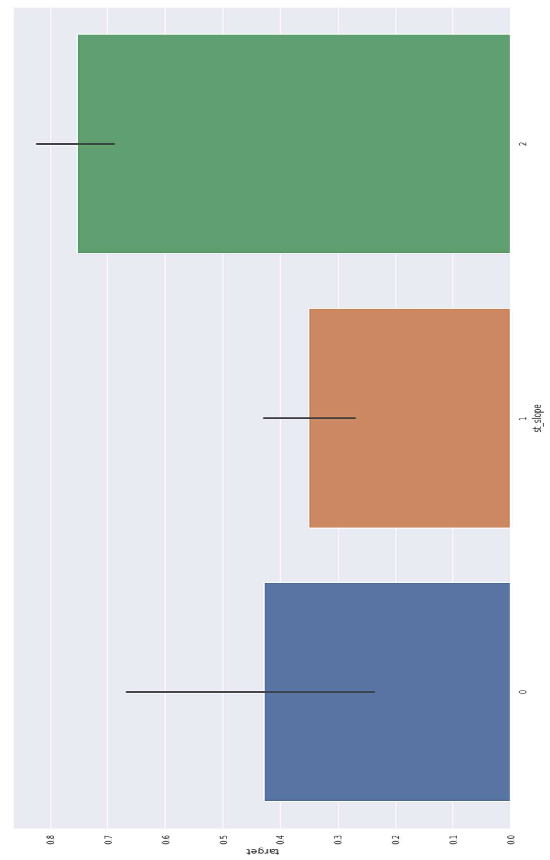

Figure 12 ST Slope Analysis

**4.23 Analyzing no. of major vessels colored by fluoroscopy**

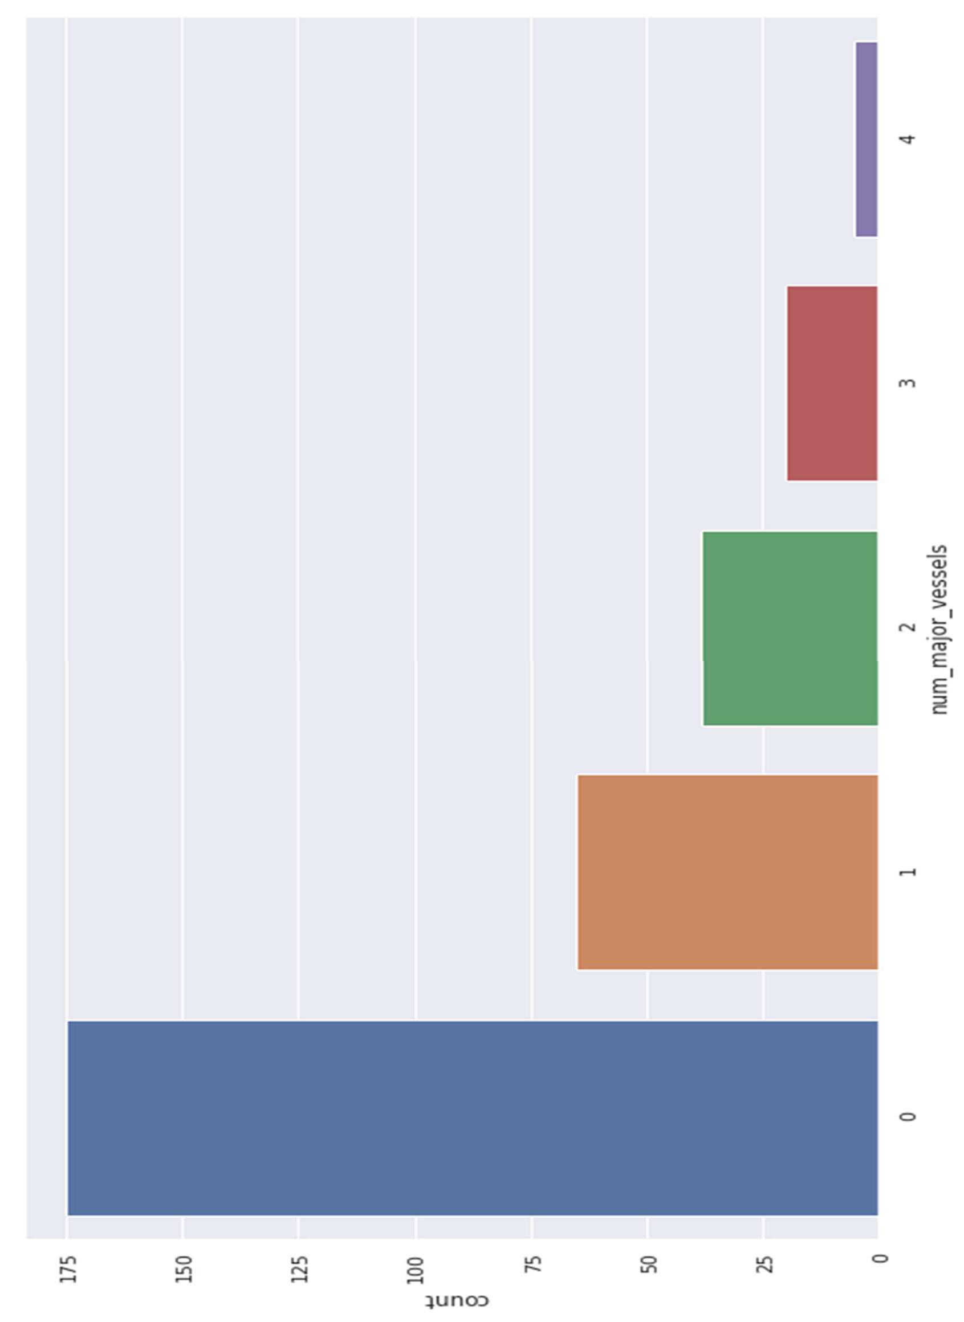

Figure 13 Analyzing no. of major vessels colored by fluoroscopy

**4.24 Comparing with target:**

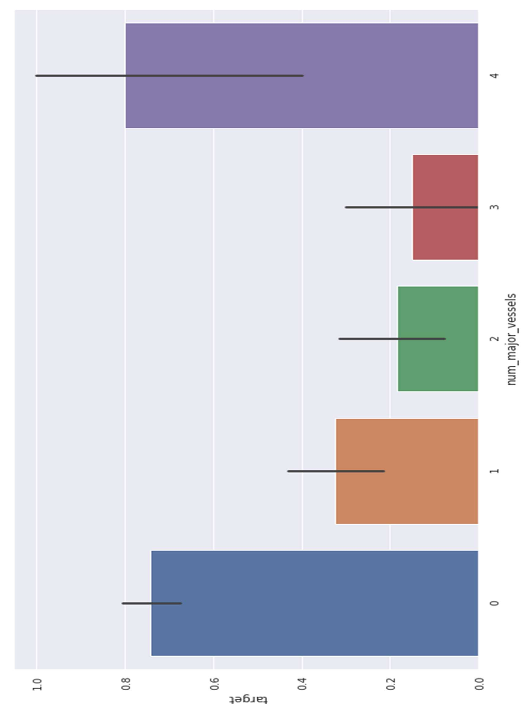

Figure 14 Comparing with targets

Four alpha-globin and two beta-globin protein chains make up hemoglobin. The two main types of thalassemia are alpha and beta.

**4.25.1 Alpha thalassemia -** In alpha thalassemia, the hemoglobin does not produce enough alpha protein. To make alpha-globin protein chains we need four genes, two on each chromosome

We get two from each parent. If one or more of these genes is missing, alpha thalassemia will result. The severity of thalassemia depends on how many genes are faulty, or mutated.

**One faulty gene**: The patient has no symptoms. A healthy person who has a child with symptoms of thalassemia is a carrier. This type is known as alpha thalassemia minima.

**Two faulty genes**: The patient has mild anemia. It is known as alpha thalassemia minor.

**Three faulty genes**: The patient has hemoglobin H disease, a type of chronic anemia. They will need regular blood transfusions throughout their life.

**Four faulty genes**: Alpha thalassemia major is the most severe form of alpha thalassemia. It is known to cause hydrops fetalis, a serious condition in which fluid accumulates in parts of the fetus' body. A fetus with four mutated genes cannot produce normal hemoglobin and is unlikely to survive, even with blood transfusions. Alpha thalassemia is common in southern China, Southeast Asia, India, the Middle East, and Africa.

**4.25.2 Beta Thalassemia -** We need two globin genes to make beta-globin chains, one from each parent. If one or both genes are faulty, beta thalassemia will occur.

Severity depends on how many genes are mutated.

* + **One faulty gene**: This is called beta thalassemia minor.
  + **Two faulty genes**: There may be moderate or severe symptoms. This is known as thalassemia major. It used to be called Colley's anemia.

Beta thalassemia is more common among people of Mediterranean ancestry. Prevalence is higher in North Africa, West Asia, and the Maldives Islands. So, we’ll mainly work with

Alpha Thalassemia, And value 0 is one faulty gene, Value 1 is Two faulty genes, Value 2 is Three faulty genes, Value 3 is Four faulty genes.

**Thalassemia distribution**

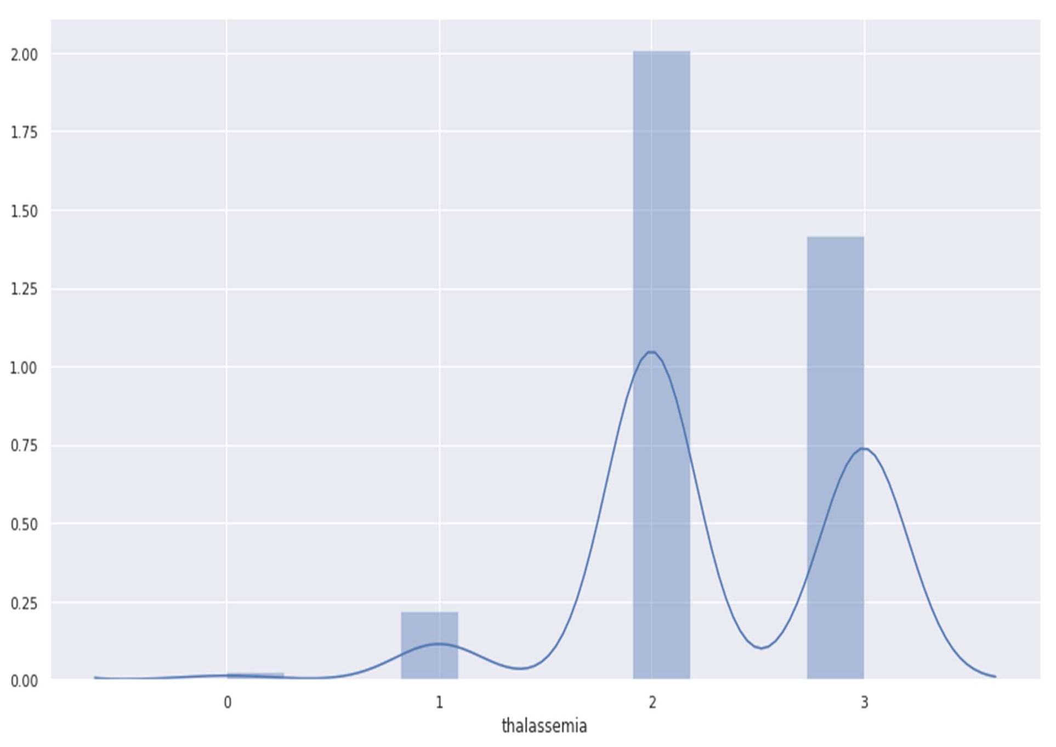

Figure 15 Thalassemia distribution

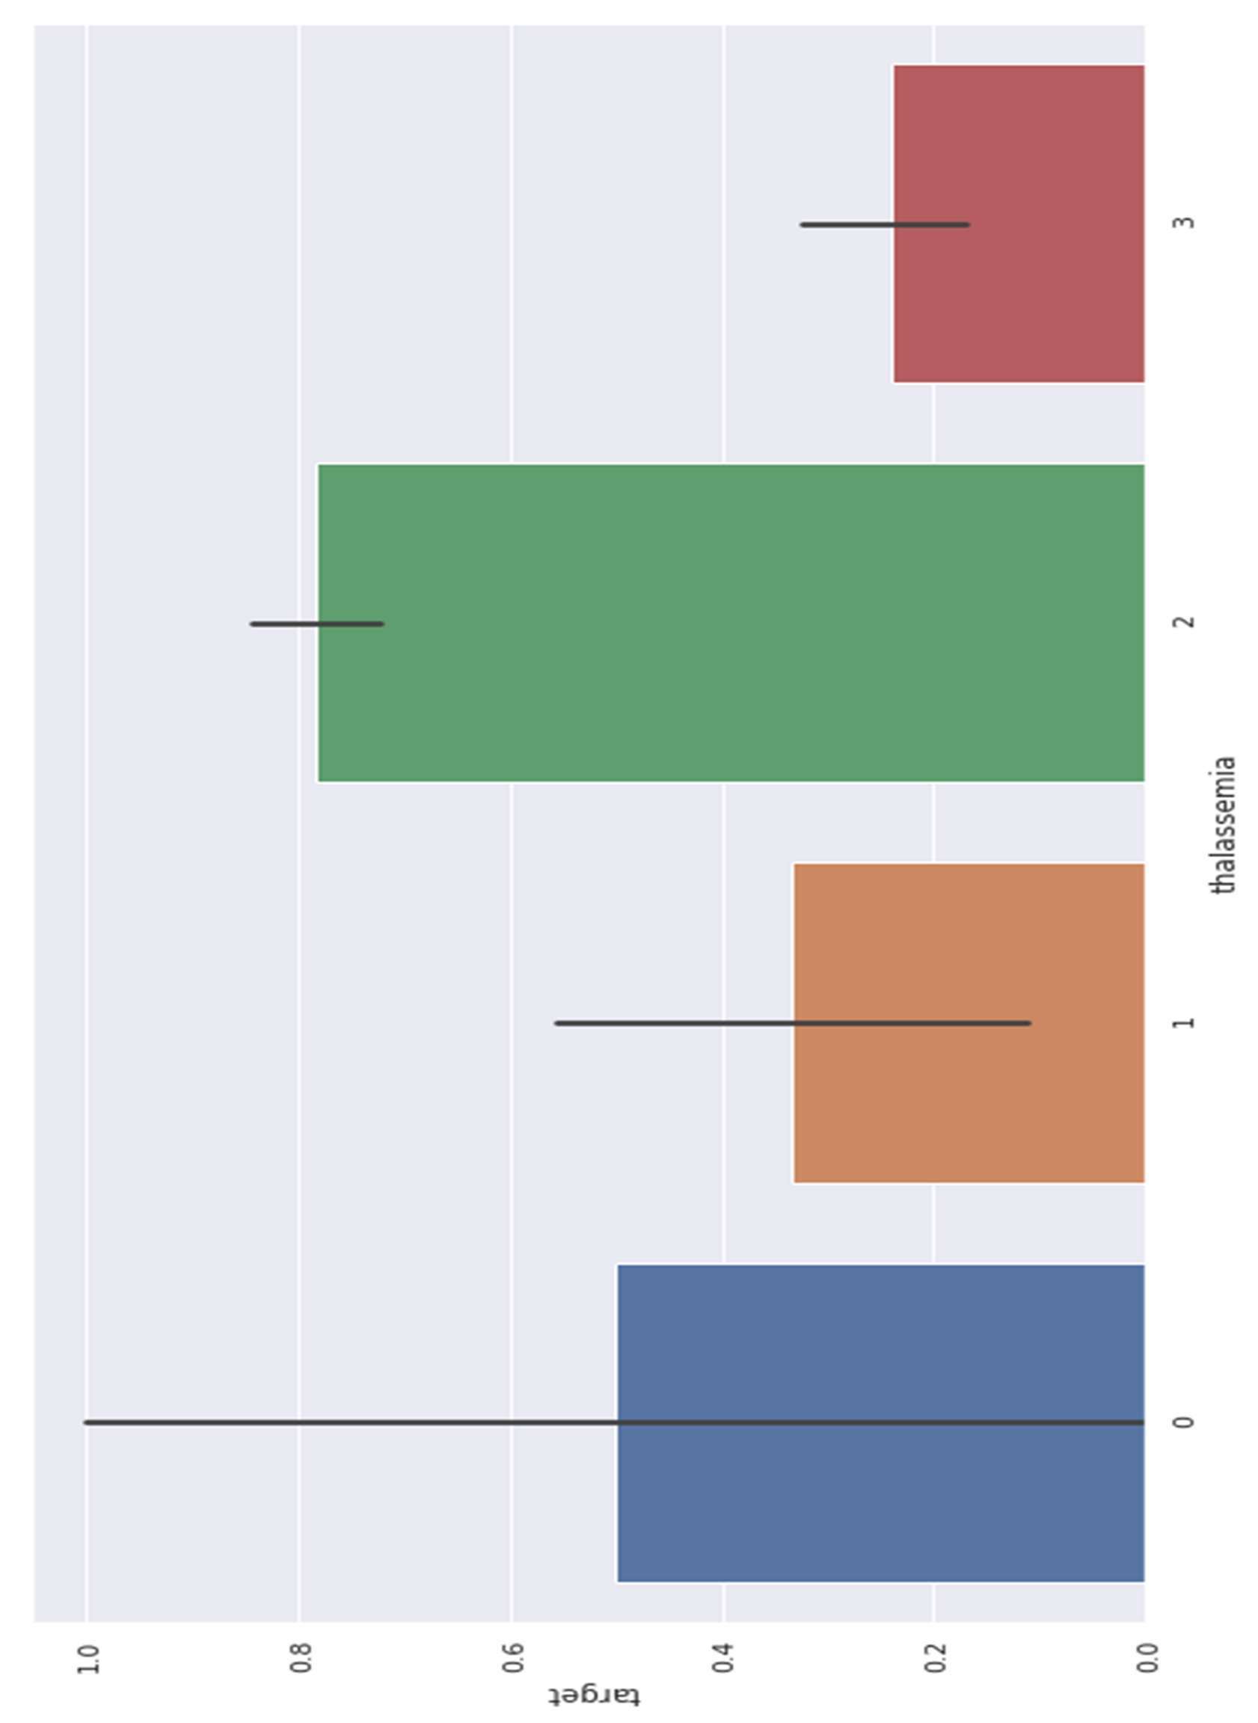**Against target:**

Figure 16 Thalassemia against target

**4.26 Thalassemia vs cholesterol**

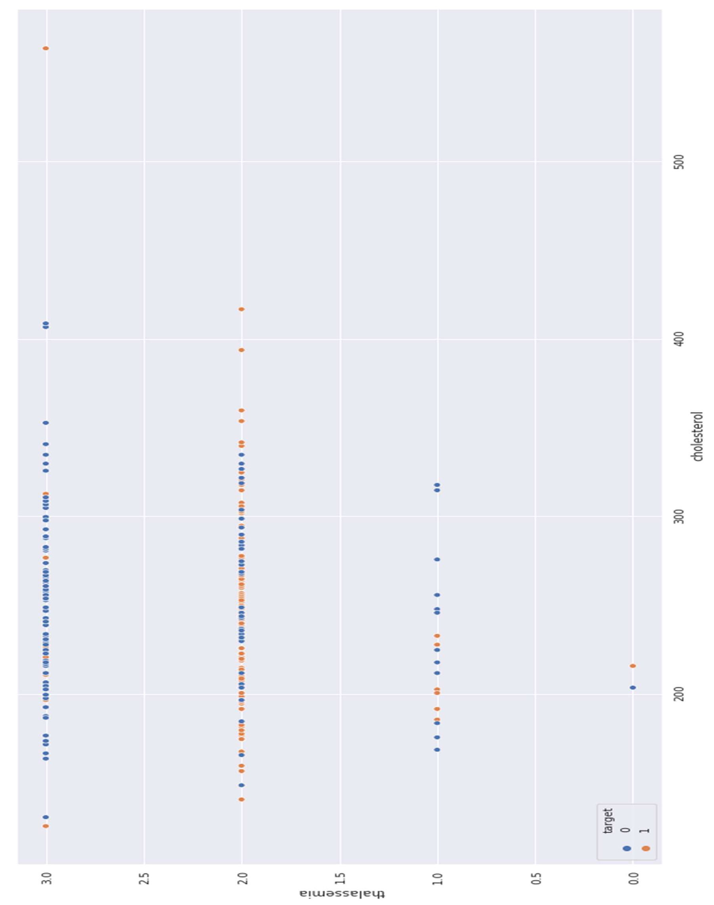

Figure 17 Thalassemia vs cholesterol

**4.27 Thalassemia vs resting blood pressure**

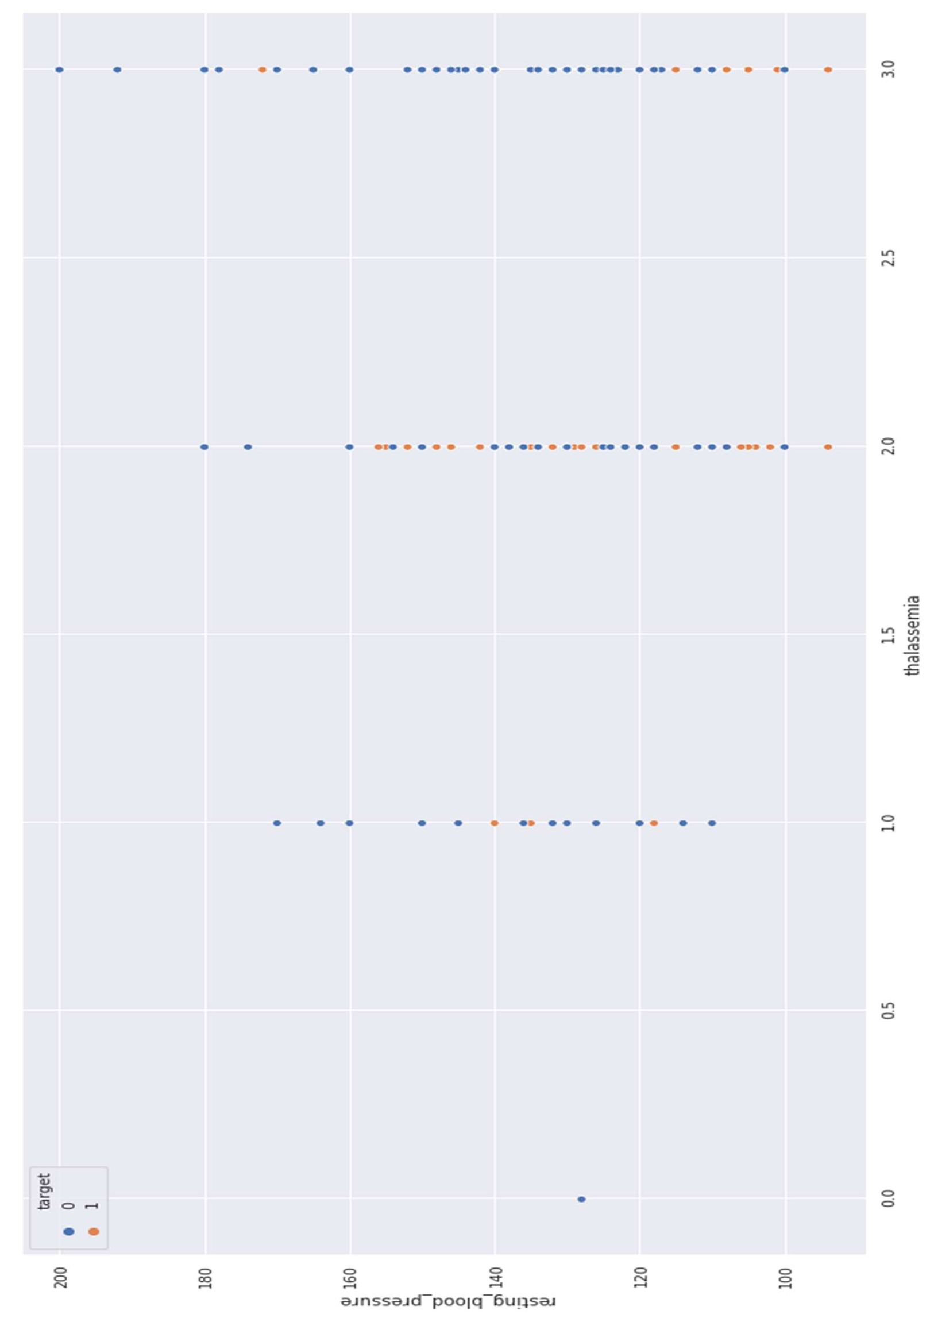

Figure 18 Thalassemia vs resting blood pressure

**4.28 Correlation Matrix**

Correlation analysis is a method of statistical evaluation used to study the strength of a relationship between two, numerically measured, continuous variables (e.g. height and weight)

Store numeric variables in cname variable

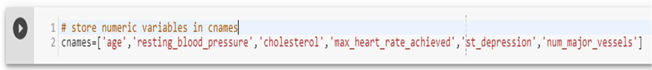

**Let’s plot the Correlation plot**

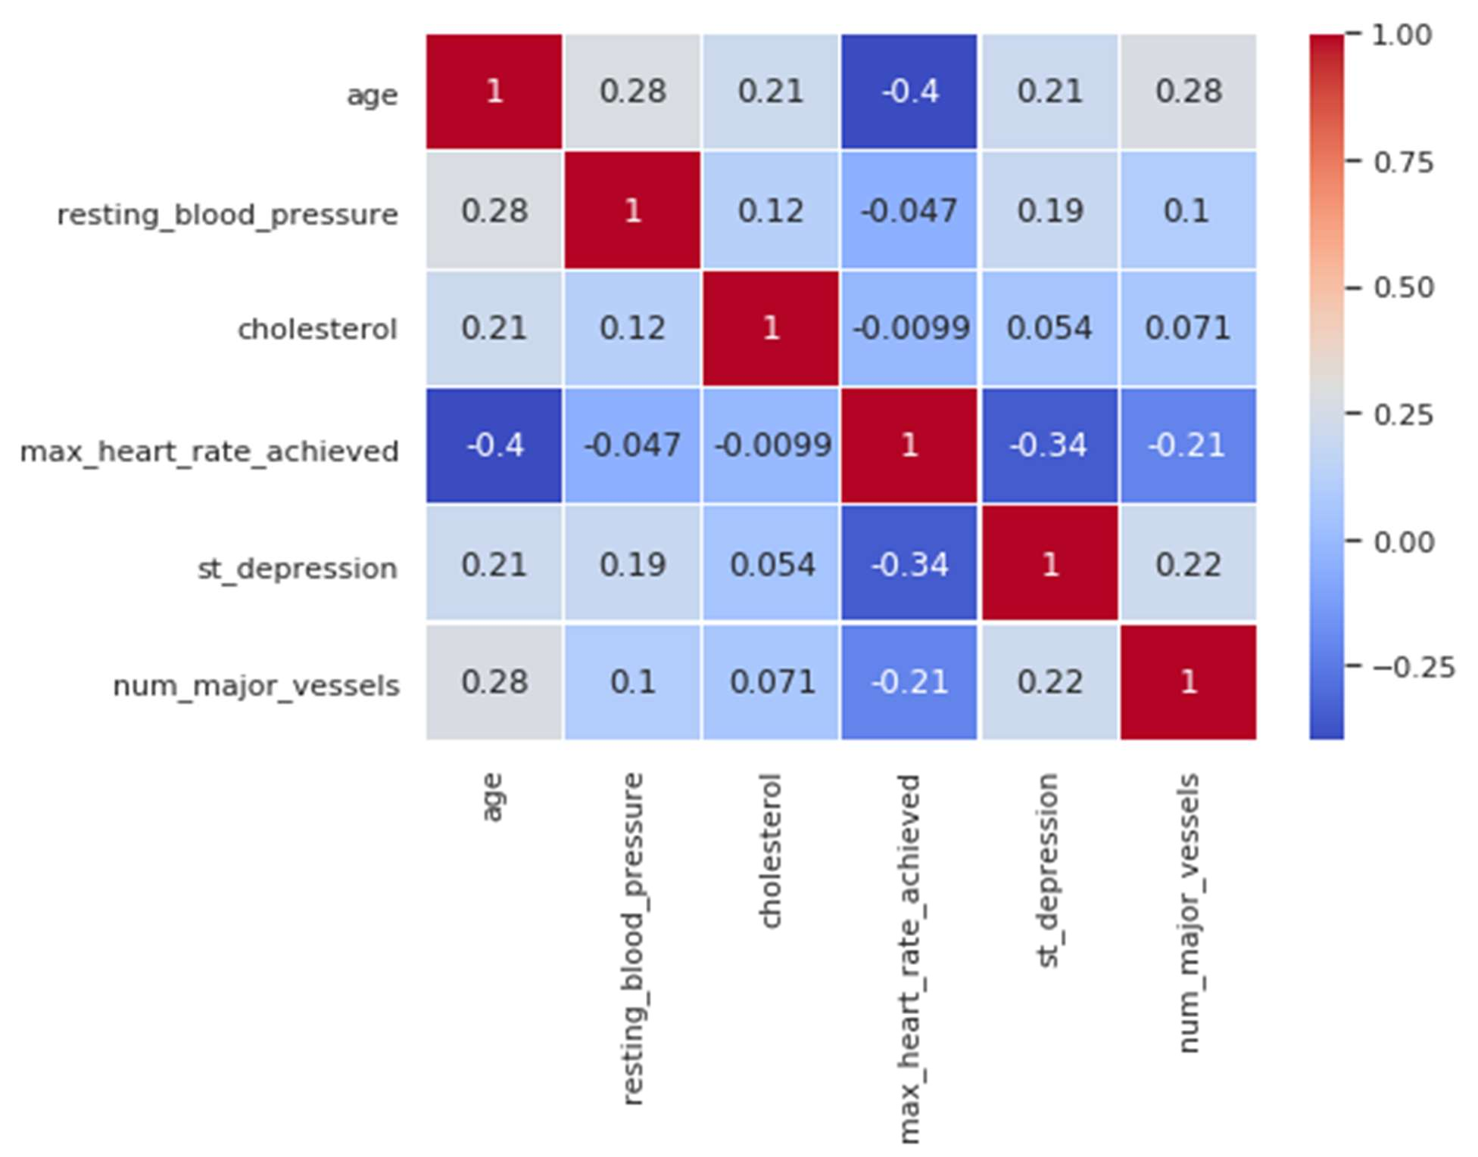

Figure 19 Correlation Matrix

**4.29 Correlation Analysis:**

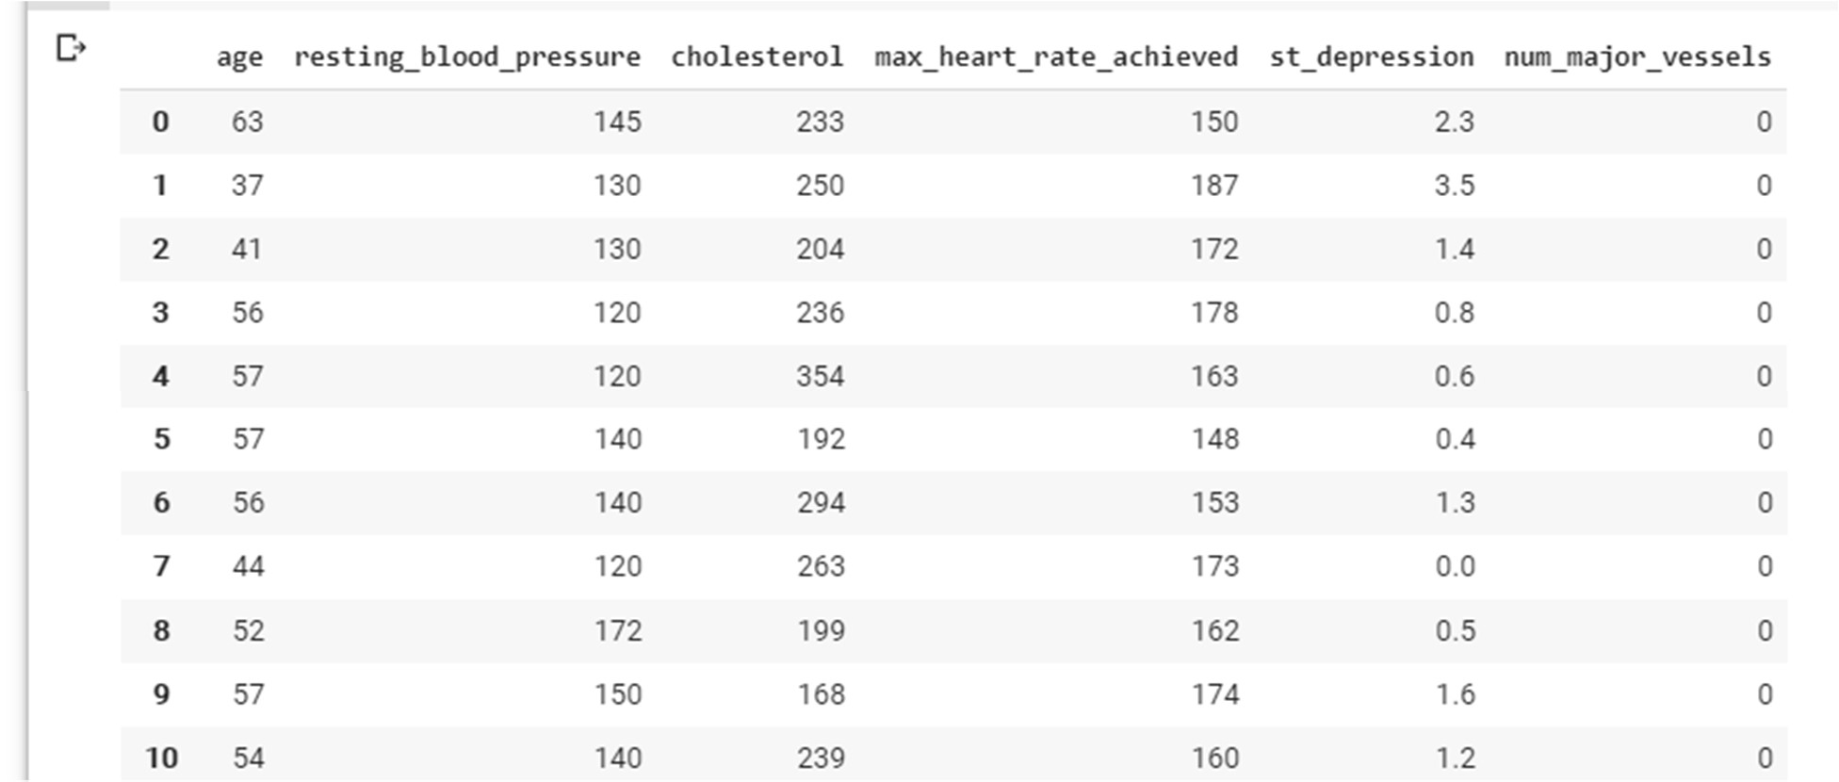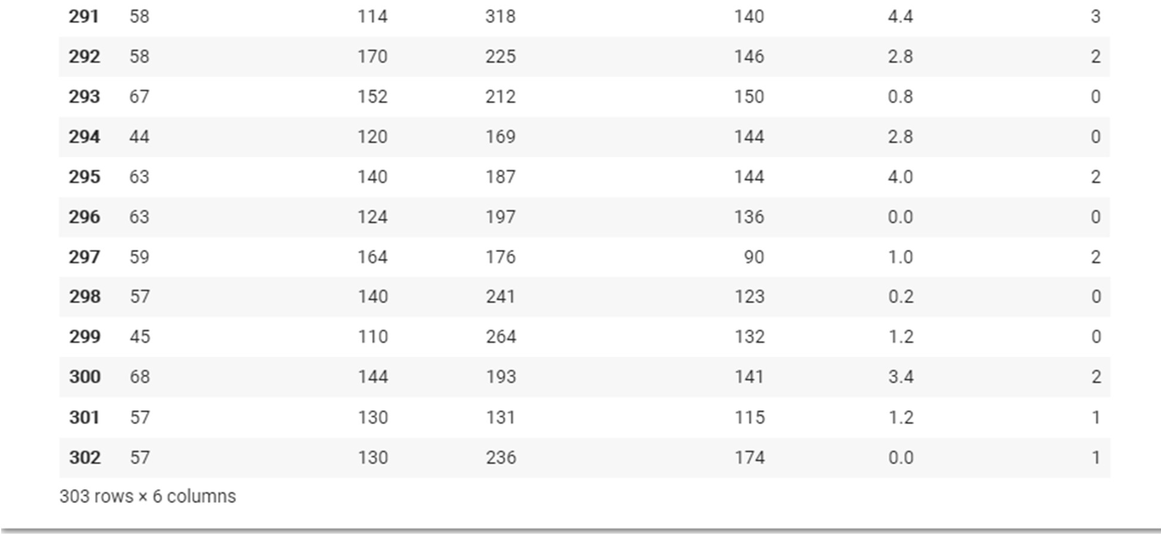

There is no single feature that has a very high correlation with our target value. Also, some of the features have a negative correlation with the target value and some have positive.

**4.30 Data Preparation**

Total Among 303 data’s randomly 242 are chosen for Training and 61 are chosen for Testing**.**

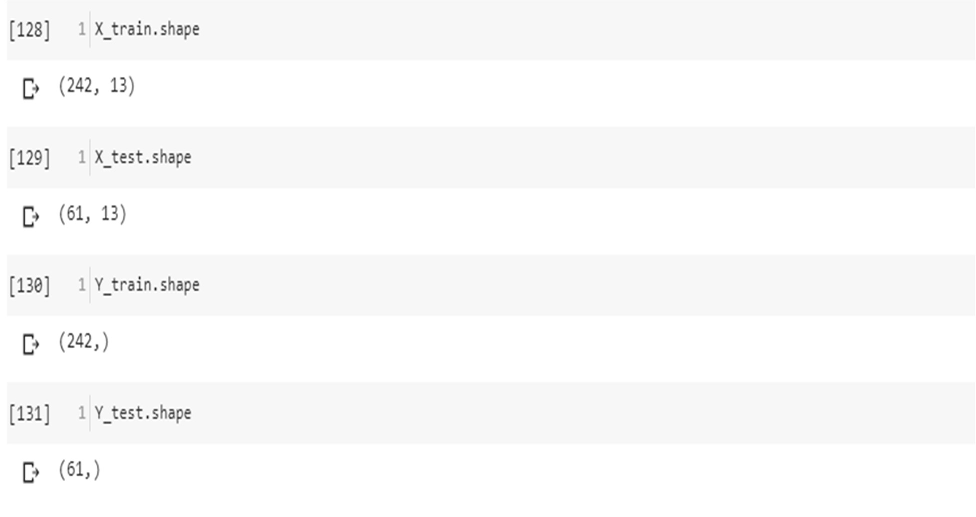

* 1. **Modelling and predicting with Machine Learning**

The main goal of the entire project is to predict heart disease occurrence with the highest accuracy. In order to achieve this, we will test several classification algorithms. This section includes all results obtained from the study and introduces the best performer according to accuracy metric. We have chosen several algorithms typical for solving supervised learning problems throughout classification methods.

Modelling and predicting with Machine Learning

The main goal of the entire project is to predict heart disease occurrence with the highest accuracy. In order to achieve this, we will test several classification algorithms. This section includes all results obtained from the study and introduces the best performer according to accuracy metric. We have chosen several algorithms typical for solving supervised learning problems throughout classification methods.

First of all, let's equip ourselves with a handy tool that benefits from the cohesion of SciKit Learn library and formulate a general function for training our models. The reason for displaying accuracy on both, train and test sets, is to allow us to evaluate whether the model overfits or underfits the data (so-called bias/variance tradeoff).

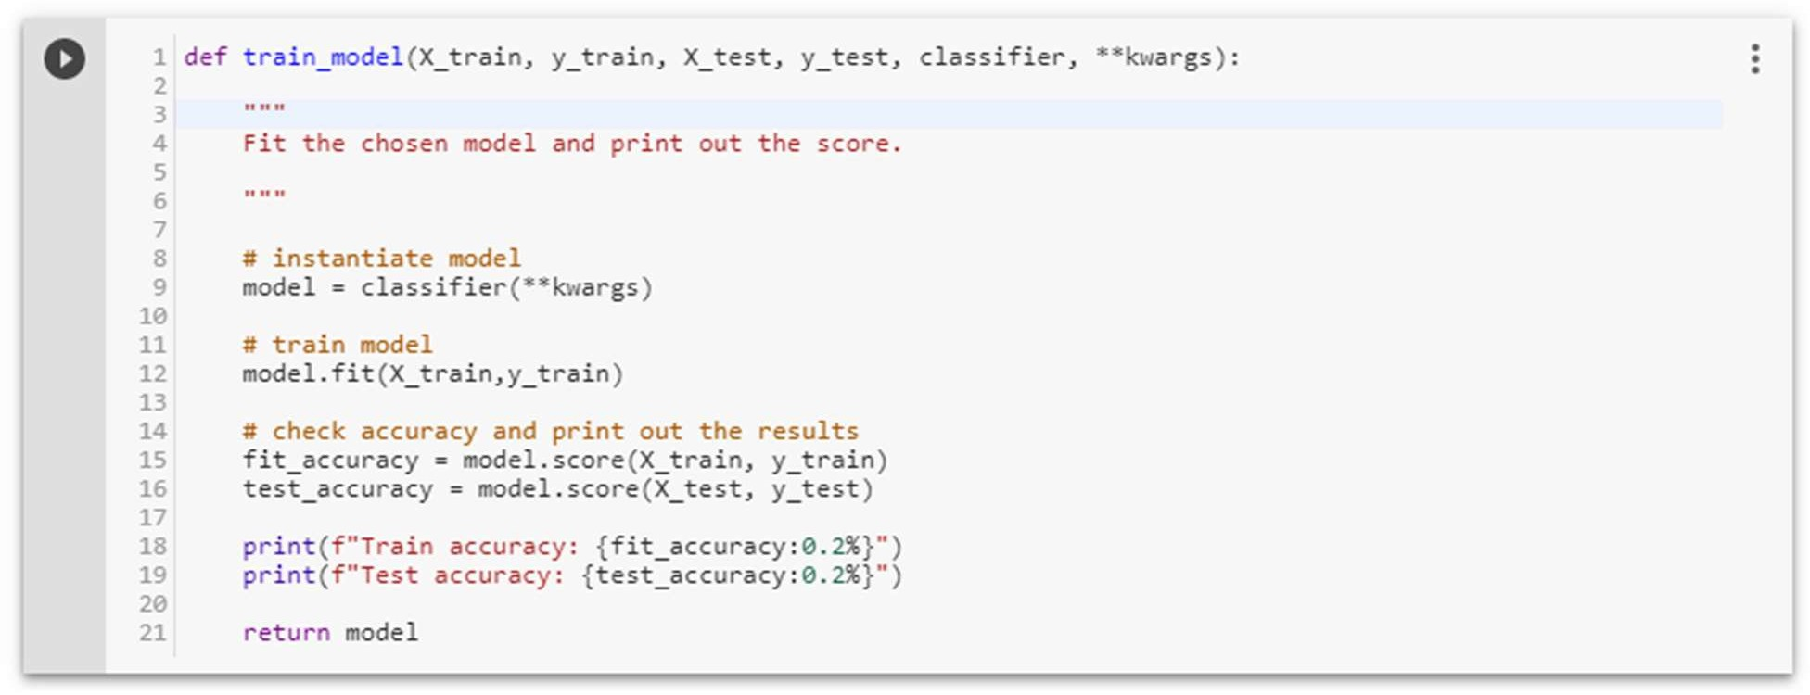

* 1. **Logistic Regression**

Logistic regression is a classification algorithm used to assign observations to a discrete set of classes. Unlike linear regression which outputs continuous number values, logistic regression transforms its output using the logistic sigmoid function to return a probability value which can then be mapped to two or more discrete classes.

**Types of logical regression:**

* Binary (Pass/Fail)
* Multi (Cats, Dogs, Sheep)

**Sigmoid function**

S(z)=1/1+e^−z

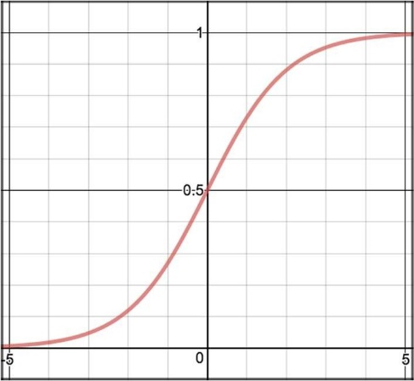

Figure 20 sigmoid function

**Decision Boundary**

**Decision Boundary**

**Cost Function**

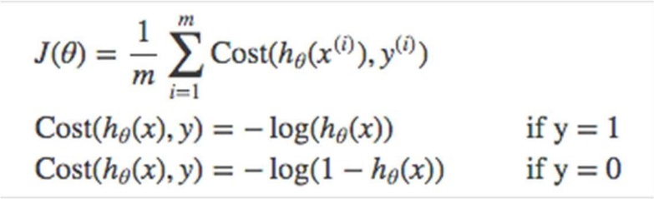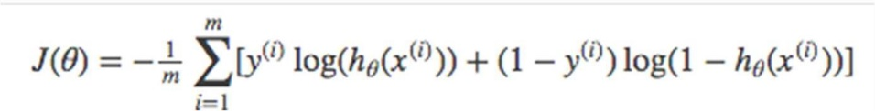

Figure 21 cost function

**Vectorized cost function**

Figure 22 Vectorized cost function

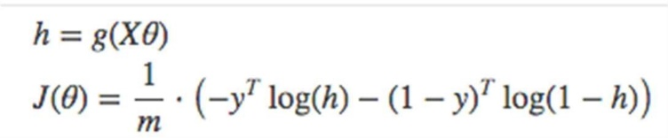

**For Multiclass -** Instead of y=0,1 we will expand our definition so that y=0,1...n. Basically we re-run binary classification multiple times, once for each class.

**Procedure -**

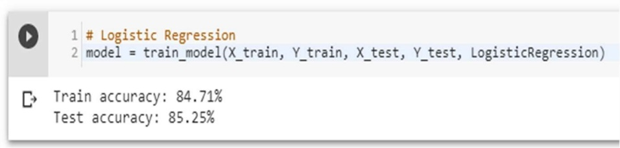

1. Divide the problem into n+1 binary classification problem (+1 because the index starts at 0).
2. For each class…
3. Predict the probability the observations are in that single class.
4. prediction = <math>max (probability of the classes)

**Accuracy score of Logistic Regression is: 85.25%**

**Confusion Matrix**

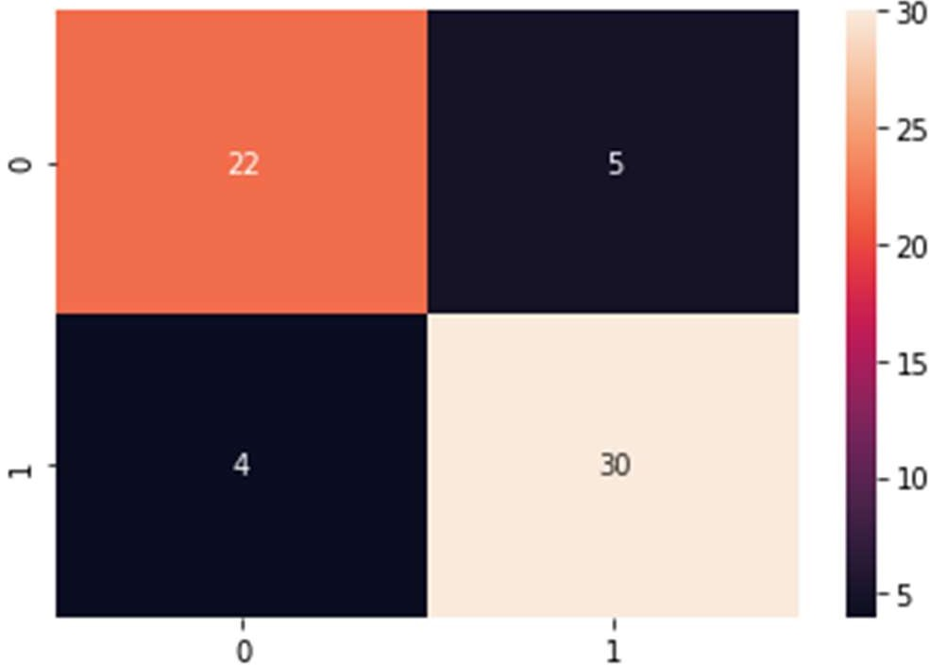

Figure 23 logistic regression confusion matrix

**Precision score**

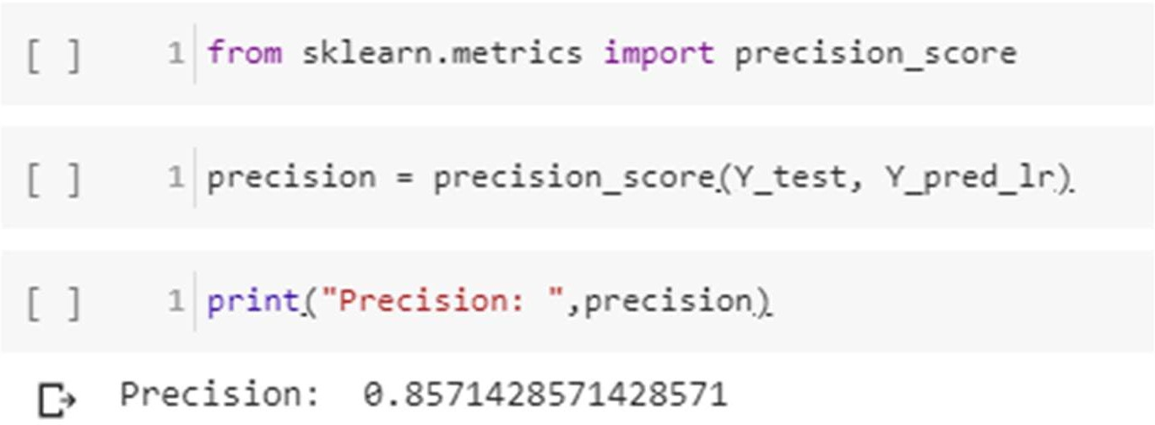

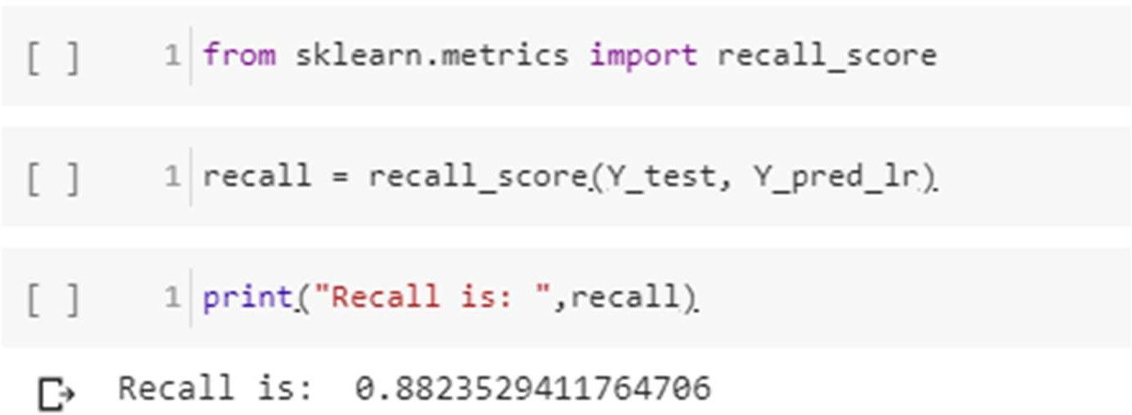**Recall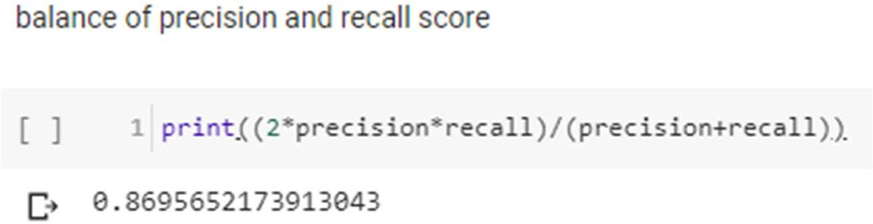F-Score**

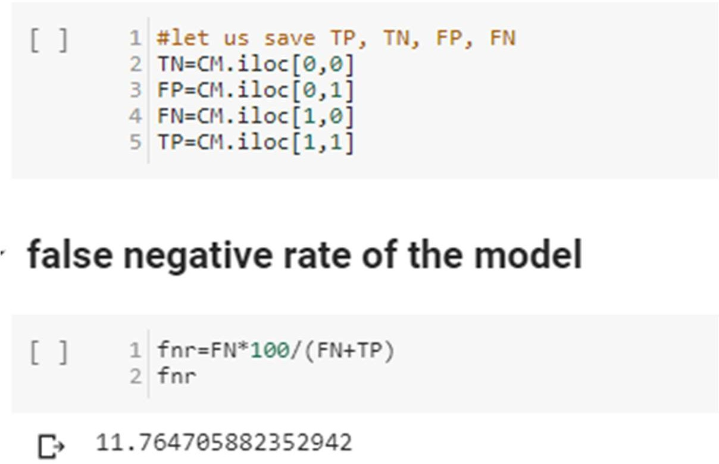**false negative**

* 1. **Random Forest**

Random Forest is a supervised learning algorithm. Random forest can be used for both classification and regression problems, by using random forest regressor we can use random forest on regression problems. But we have used random forest on classification in this project so we will only consider the classification part.

**Random Forest pseudocode**

1. Randomly select **“k”** features from total **“m”** features.

Where **k << m**

1. Among the **“k”** features, calculate the node **“d”** using the best split point.
2. Split the node into **daughter nodes** using the **best split**.
3. Repeat **1 to 3** steps until “l” number of nodes has been reached.
4. Build forest by repeating steps **1 to 4** for “n” number times to create **“n” number of trees**.

**Random forest prediction pseudocode**

1. Takes the **test features** and use the rules of each randomly created decision tree to predict the outcome and stores the predicted outcome (target)
2. Calculate the **votes** for each predicted target.
3. Consider the **high voted** predicted target as the **final prediction** from the random forest algorithm.

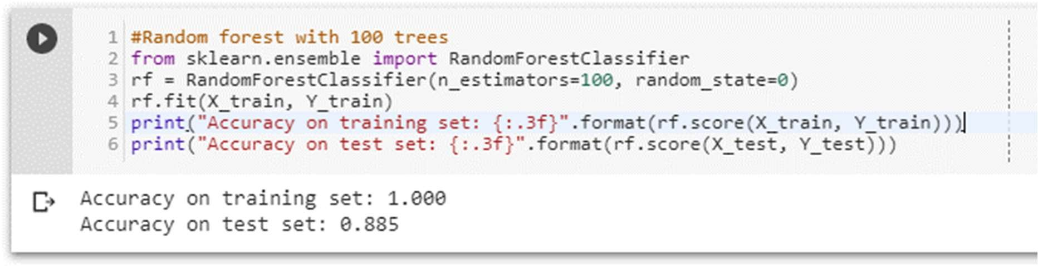

**Pruning the depth of the trees**

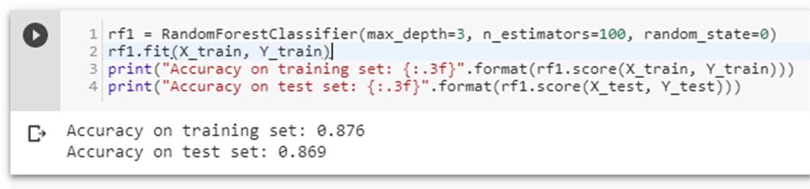

Accuracy score of Random Forest is 86.9%

**Confusion Matrix**

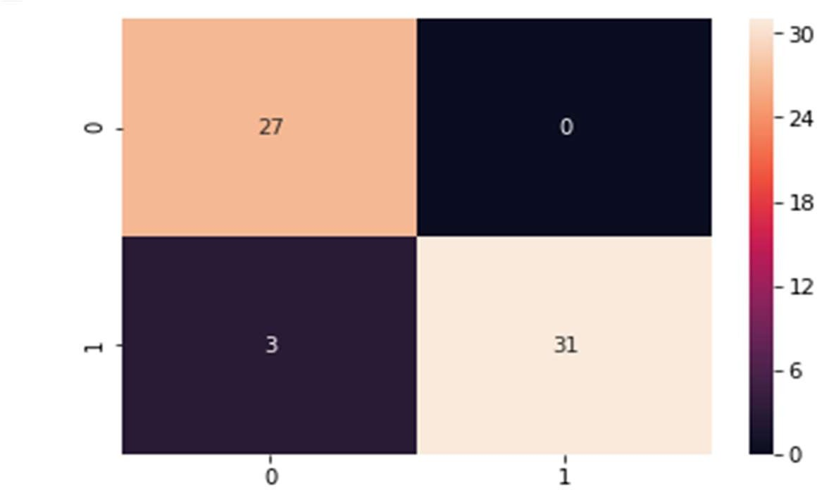

Figure 24 Random forest confusion matrix

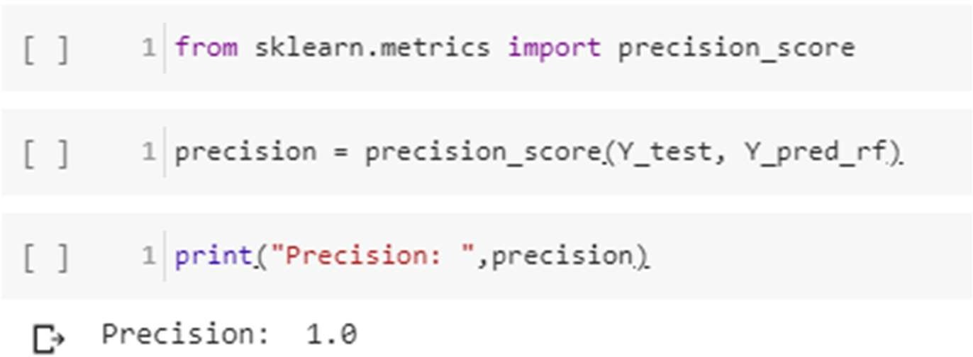**Precision score**

**Recall**

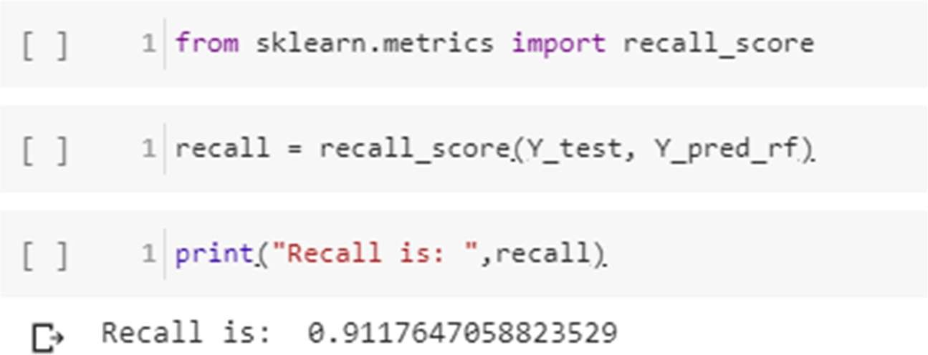

**F-Score**

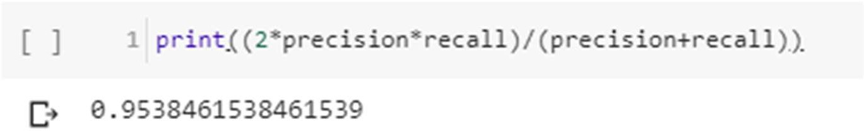

**False negative rate**

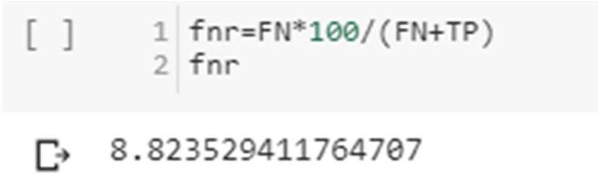

* 1. **Naïve Bayes**

**Bayes’ Theorem** is stated as:

***P(h|d) = (P(d|h) * P(h)) / P(d)***

* + - 1. **P(h|d)** is the probability of hypothesis h given the data d. This is called the posterior probability.
      2. **P(d|h)** is the probability of data d given that the hypothesis h was true.
      3. **P(h)** is the probability of hypothesis h being true (regardless of the data). This is called the prior probability of h.
      4. **P(d)** is the probability of the data (regardless of the hypothesis).

we are interested in calculating the posterior probability of P(h|d) from the prior probability p(h) with P(D) and P(d|h). After calculating the posterior probability for a number of different hypotheses, we will select the hypothesis with the highest probability. This is the maximum probable hypothesis and may formally be called the (MAP) hypothesis.

This can be written as:

***MAP(h) = max(P(h|d)) or***

***MAP(h) = max((P(d|h) * P(h)) / P(d)) or***

***MAP(h) = max(P(d|h) * P(h))***

The P(d) is a normalizing term which allows us to calculate the probability. We can drop it when we are interested in the most probable hypothesis as it is constant and only used to normalize. Back to classification, if we have an even number of instances in each class in our training data, then the probability of each class (e.g. P(h)) will be equal. Again, this would be a constant term in our equation, and we could drop it so that we end up with:

***MAP(h) = max(P(d|h))***

Naive Bayes is a classification algorithm for binary (two-class) and multi-class classification problems. The technique is easiest to understand when described using binary or categorical input values. It is called *naive Bayes* or *idiot Bayes* because the calculation of the probabilities for each hypothesis are simplified to make their calculation tractable. Rather than attempting to calculate the values of each attribute value P (d1, d2, d3|h), they are assumed to be conditionally independent given the target value and calculated as P(d1|h) * P(d2|H) and so on. This is a very strong assumption that is most unlikely in real data, i.e. that the attributes do not interact. Nevertheless, the approach performs surprisingly well on data where this assumption does not hold.

***MAP(h) = max(P(d|h) * P(h))***

**Gaussian Naïve Bayes**

***mean(x) = 1/n * sum(x)***

Where n is the number of instances and x are the values for an input variable in your training data. We can calculate the standard deviation using the following equation:

***standard deviation(x) = sqrt (1/n * sum(xi-mean(x)^2))***

This is the square root of the average squared difference of each value of x from the mean value of x, where n is the number of instances, sqrt() is the square root function, sum() is the sum function, xi is a specific

value of the x variable for the i’th instance and mean(x) is described above, and ^2 is the square. Gaussian PDF with a new input for the variable, and in

return the Gaussian PDF will provide an estimate of the probability of that new input value for that class.

***pdf (x, mean, sd) = (1 / (sqrt (2 * PI) * sd)) * exp (-((x-mean^2)/(2*sd^2)))***

Where pdf(x) is the Gaussian Probability Density Function (PDF), sqrt () is the square root, mean and sd are the mean and standard deviation calculated above, Pi is the numerical constant, exp () is the numerical constant e or Euler’s number raised to power and x is the input value for the input variable.

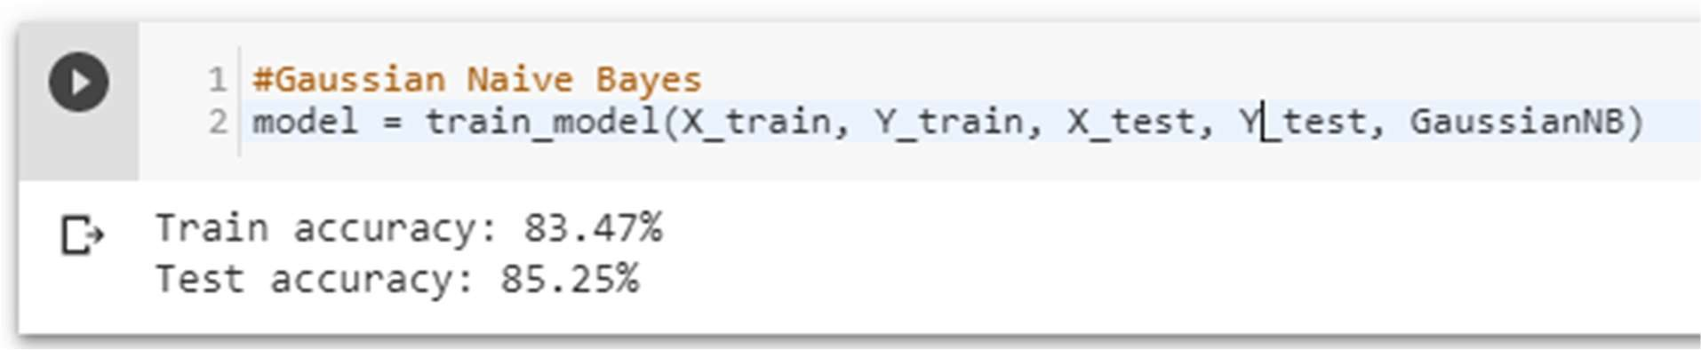

**Confusion matrix**

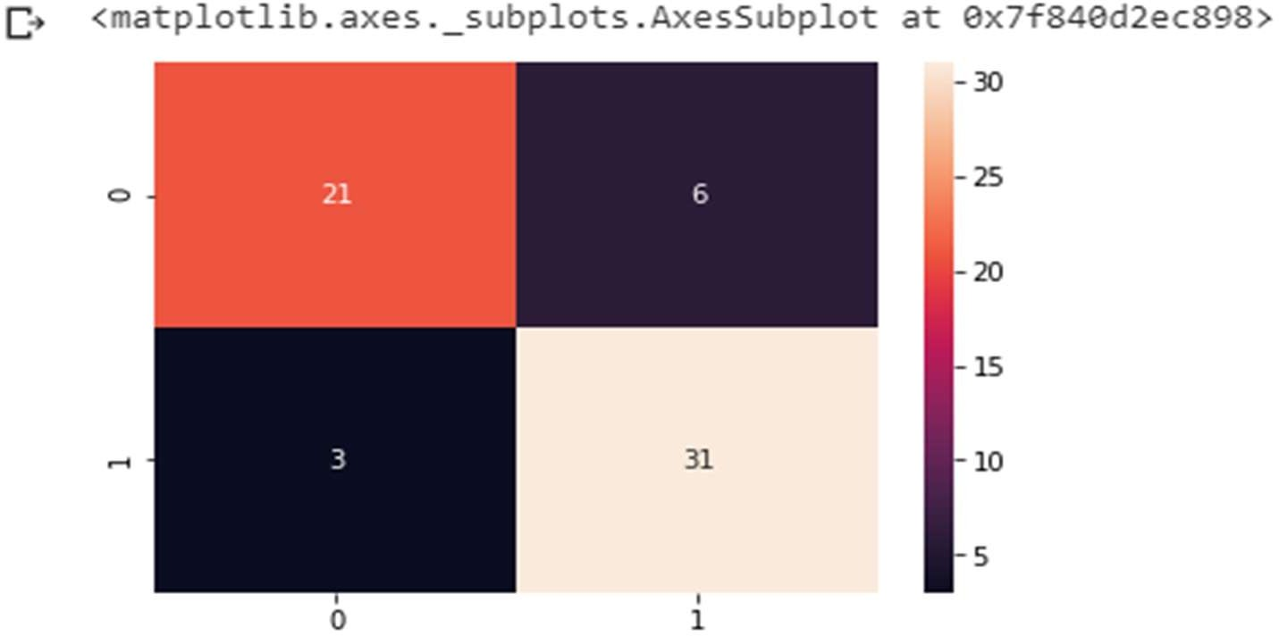

Figure 25 Naive Bayes confusion matrix

**Precision score**

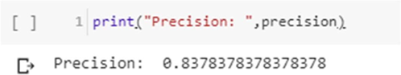

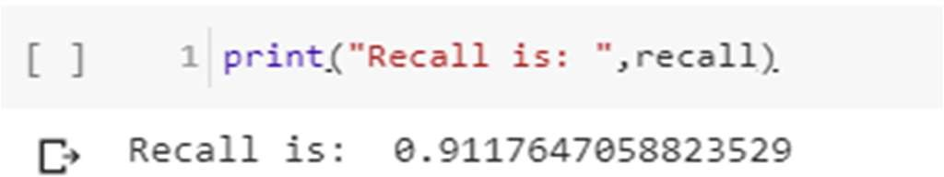**Recall**

**F-Score**

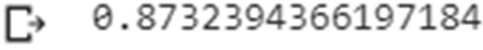

**False negative**

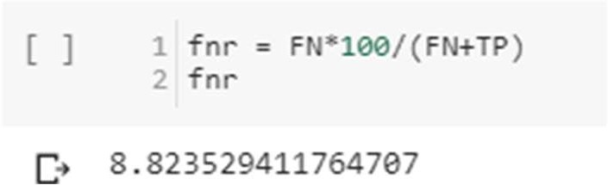

* 1. **K-Nearest Neighbor**

We can implement a KNN model by following the below steps:

1. Load the data
2. Initialize the value of k
3. For getting the predicted class, iterate from 1 to total number of training data points

* Calculate the distance between test data and each row of training data. Here we will use Euclidean distance as our distance metric since it’s the most popular method. The other metrics that can be used are Chebyshev, cosine, etc.
* Sort the calculated distances in ascending order based on distance values
* Get top k rows from the sorted array
* Get the most frequent class of these rows
* Return the predicted class

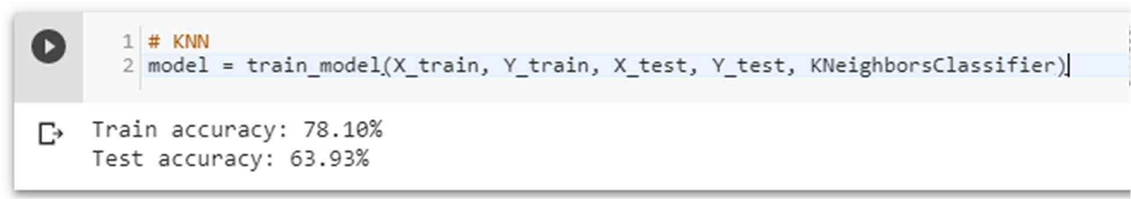

**Using different inputs –**

It turns out that the value of n = 8 is optimal

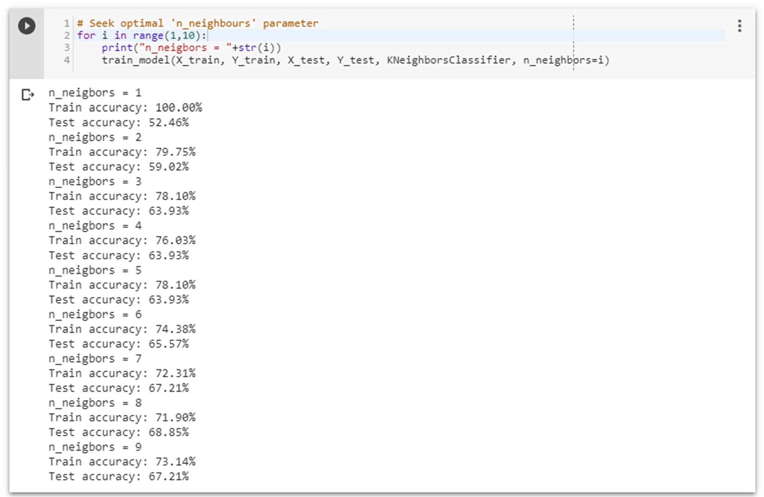

**Confusion matrix**

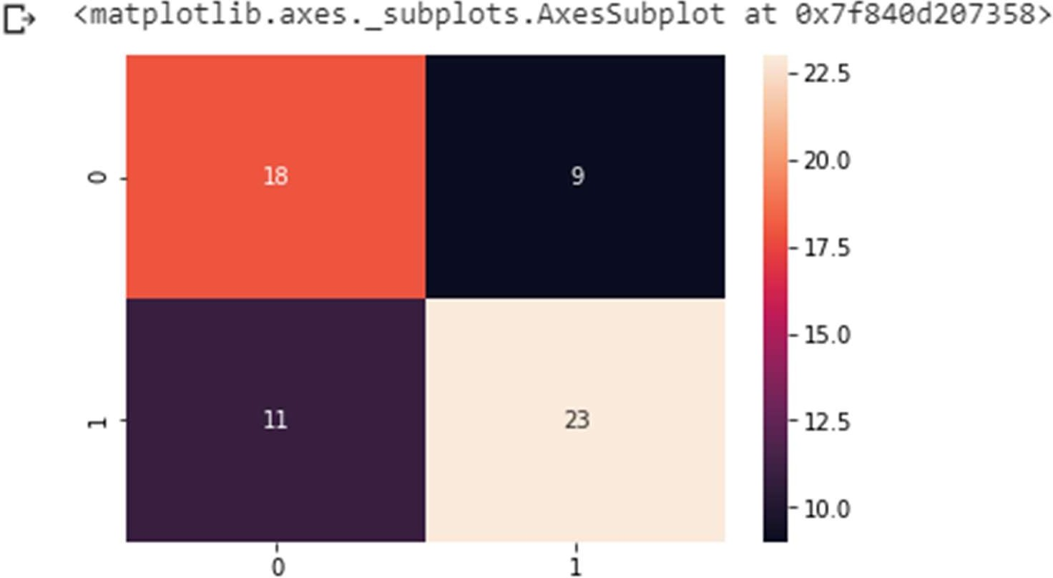

Figure 26 KNN confusion matrix

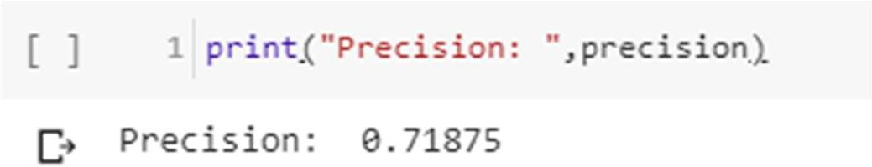**Precision score**

**Recall**

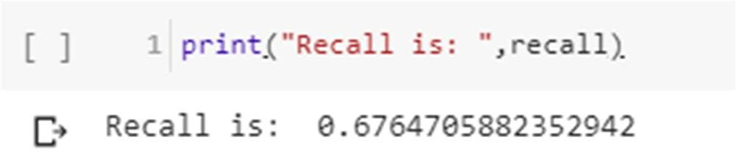

**F-Score**



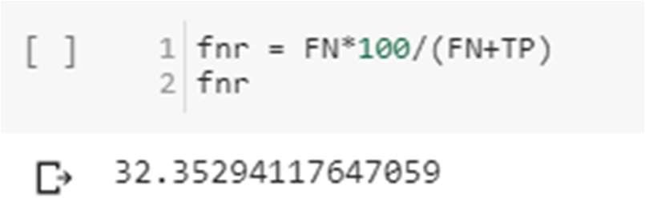**False-negative**

* 1. **Decision Tree Pseudocode**

1. Place the best attribute of the dataset at the **root** of the tree.
2. Split the training set into **subsets**. Subsets should be made in such a way that each subset contains data with the same value for an attribute.
3. Repeat steps 1 and step 2 on each subset until you find **leaf nodes** in all the branches of the tree.

**Assumptions while Creating Decision Tree**

At the beginning, the whole training set is considered as the **root.**

Feature values are preferred to be categorical. If the values are continuous then they are discretized before building the model.

Records are **distributed recursively** based on attribute values.

Order to place attributes as root or internal node of the tree is done by using some statistical approach.

**The popular attribute selection measures**

Information gain

Gini index

**Attribute selection method -** A dataset consists of **“n”** attributes then deciding which attribute to place at the root or different levels of the tree as internal nodes is a complicated step. Just randomly selecting any node to be the root can’t solve the issue. If we follow a random approach, it may give us bad results with low accuracy. For solving this attribute selection problem, researchers worked and devised some solutions. They suggested using some *criteria* like **information gain, Gini index,** etc. These criteria will calculate values for every attribute. The values are sorted, and attributes are placed in the tree by following the order i.e., the attribute with a high value (in case of information gain) is placed at the root. While using information Gain as a criterion, we assume attributes to be categorical, and for the Gini index, attributes are assumed to be continuous.[132]

**Gini Index -** Gini Index is a metric to measure how often a randomly chosen element would be incorrectly identified. It means an attribute with a lower Gini index should be preferred.

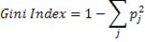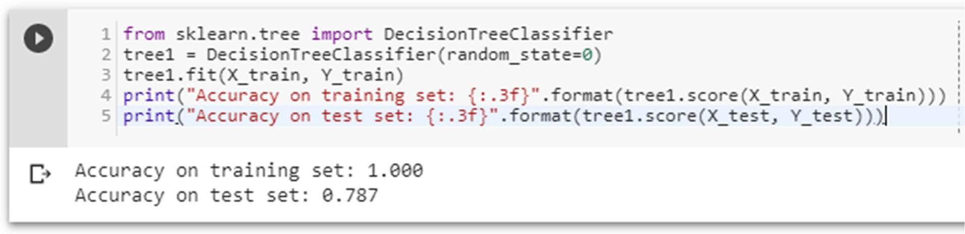

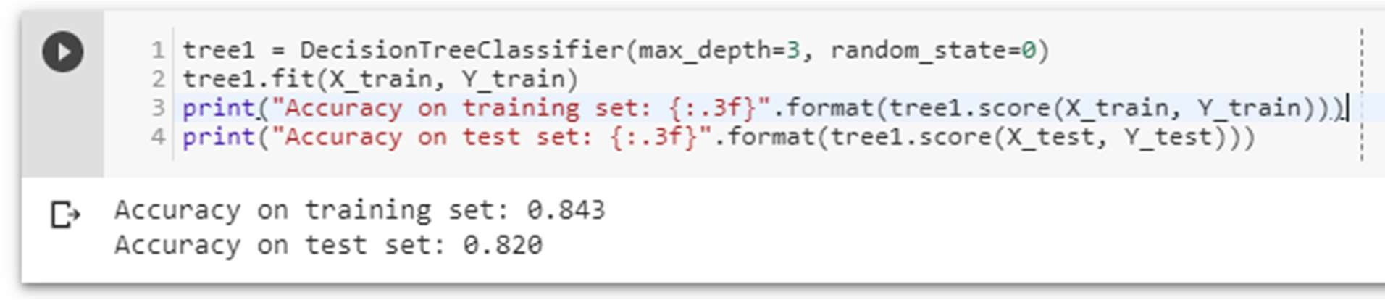The accuracy on the training set is 100%, while the test set accuracy is much worse. This is indicative that the tree is overfitting and not generalizing well to new data. Therefore, we need to apply pre-pruning to the tree. We set max depth=3, limiting the depth of the tree decreases overfitting. This leads to a lower accuracy on the training set, but an improvement on the test set.

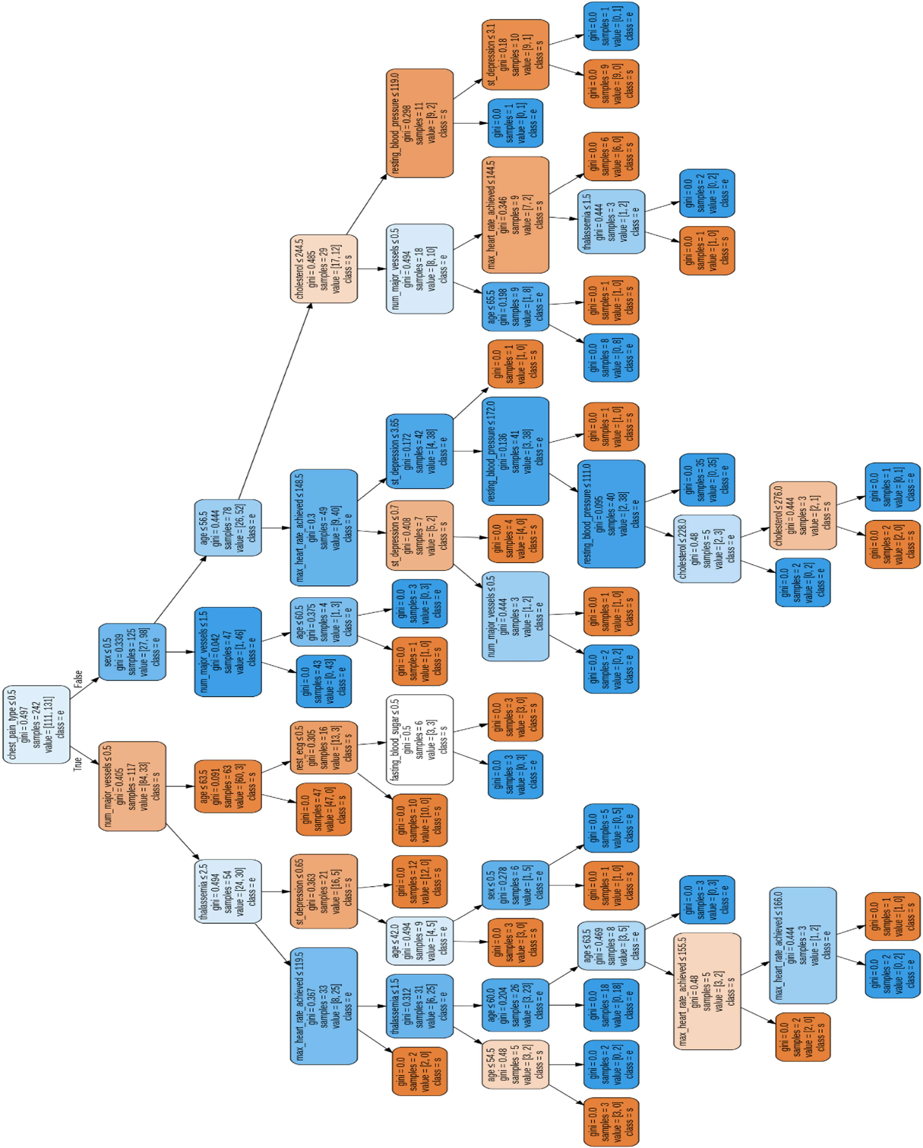

Figure 27 Decision tree visualization

**Confusion matrix**

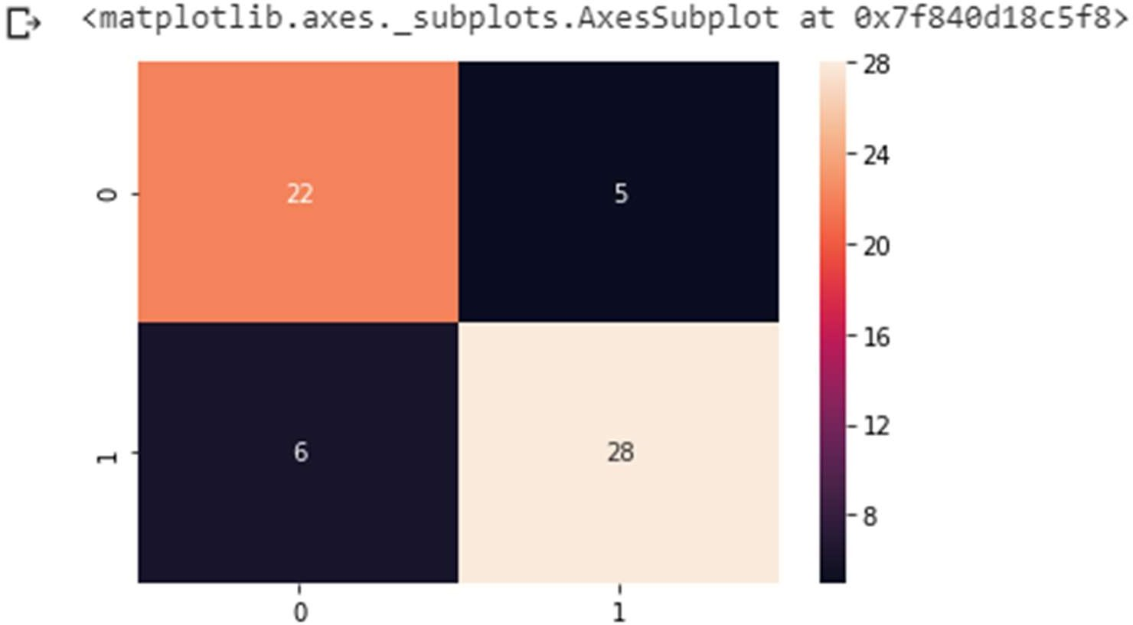

Figure 28 Decision tree confusion matrix

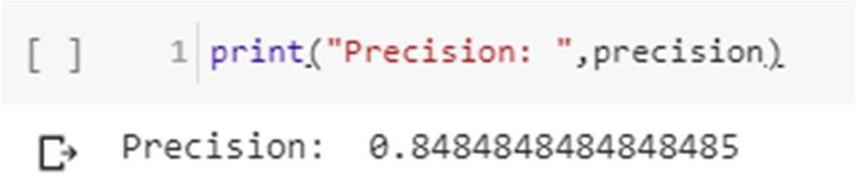**Precision score**

**Recall**

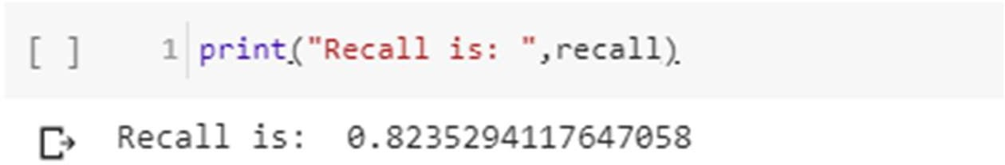

**F-Score**

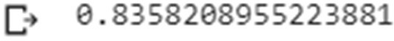

**False negative rate**

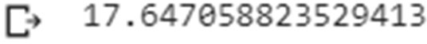

* 1. **Result**

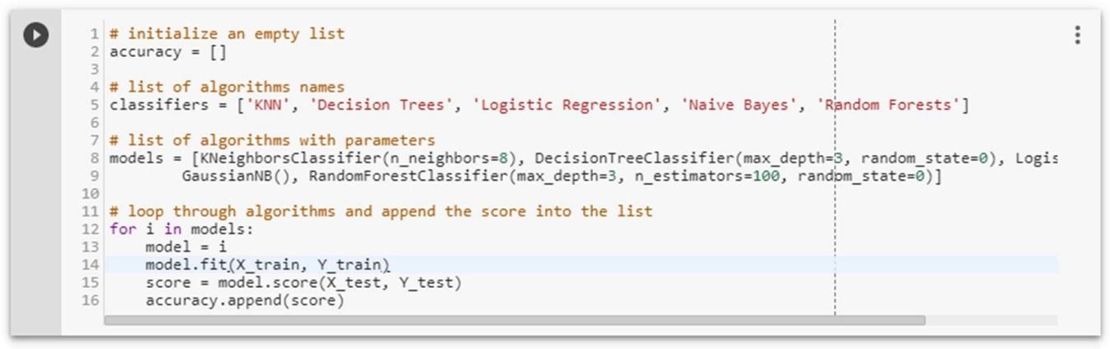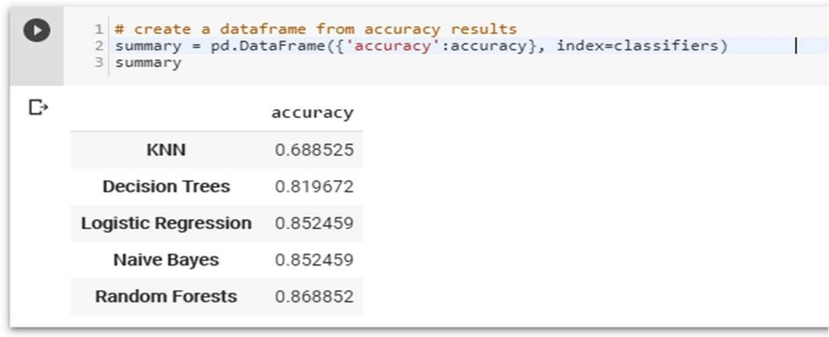

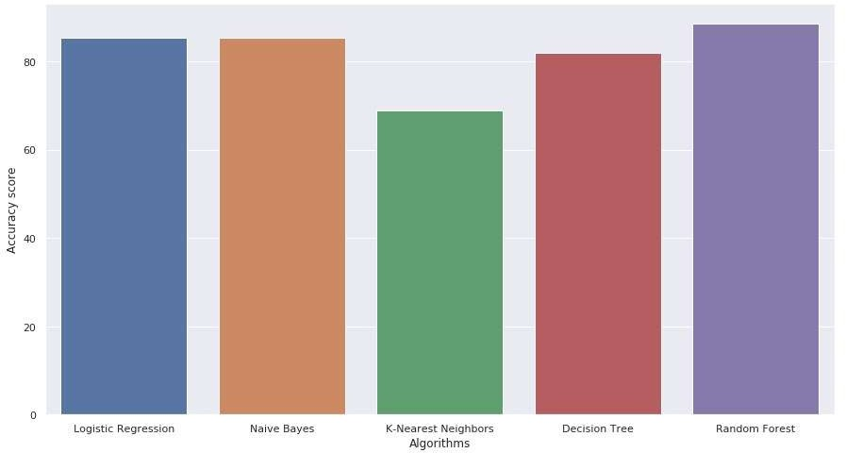

Figure 29 Accuracy Scores of all Algorithms

**Final score**

Logistic Regression

0.869

Random Forest

0.885

Naive Bayes

0.873

KNN

0.707

Decision Tree

0.830

So the Random Forest algorithm is the best here and Naive Bayes is the 2nd Best

And here KNN is the worst algorithm

**CHAPTER NO 5 CONCLUSION AND FUTURE ENHANCEMENT**

**5.1 Conclusion**

The overall objective of our project is to predict accurately with less number of tests and attributes the presence of heart disease. In this project, fourteen attributes are considered which form the primary basis for tests and give accurate results more or less. Many more input attributes can be taken but our goal is to predict with less number of attributes and faster efficiency to predict the risk of having heart disease at a particular age span. Five data mining classification techniques were applied namely K-Nearest Neighbor, Naive Bayes, Decision Tree, Random Forest & Logistic Regression. It is shown that Random Forest has better accuracy than the other techniques.

This is the most effective model to predict patients with heart disease. This project could answer complex queries, each with its strength with respect to ease of model interpretation, access to detailed information, and accuracy.

This project can be further enhanced and expanded. For example, it can incorporate other medical attributes besides the 14 attributes we used. It can also incorporate other data mining techniques, e.g., Time Series, Clustering, and Association Rules. Continuous data can also be used instead of just categorical data. Another area is to use Text Mining to mine the vast amount of unstructured data available.

This project is presented using data mining techniques. From logistic regression, KNN, Naive Bayes, Decision Tree, and Random forest are used to develop the system. Random Forest proves better results and assists the domain experts and even the person related to the medical field to plan for a better and early diagnosis for the patient. This system performs realistically well even without retraining

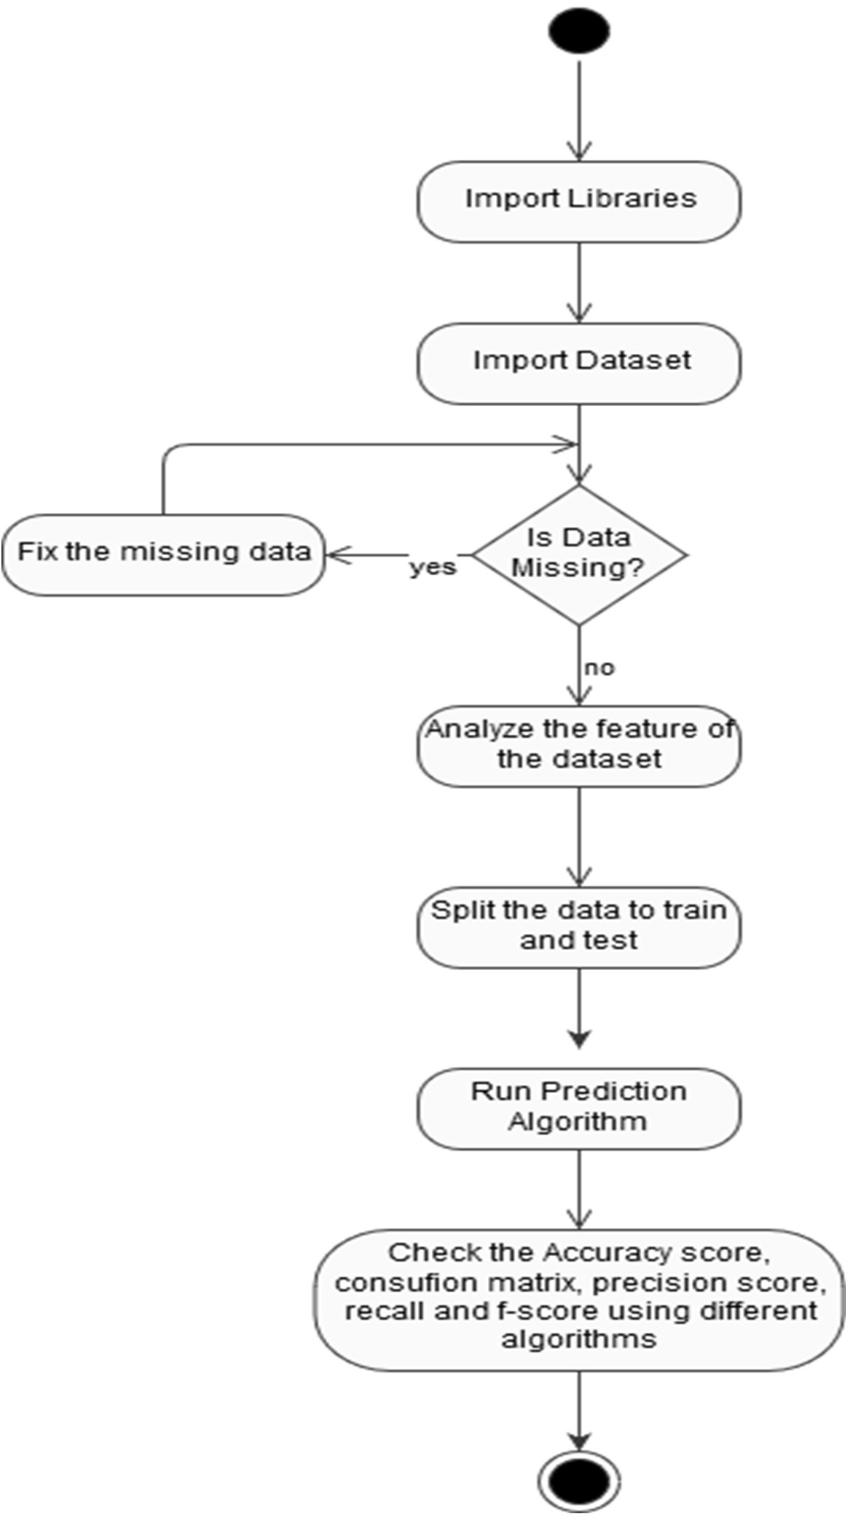

Figure 30 Work flow diagram

* 1. **Drawbacks**

The Algorithms used in our project do not give 100% accuracy, so the prediction is not 100% feasible. Clinical diagnosis and diagnosis using our project may differ slightly because the prediction is not 100% accurate. Medical diagnosis is considered a significant yet intricate task that needs to be carried out precisely and efficiently. The automation of the same would be highly beneficial. Clinical decisions are often made based on a doctor’s intuition and experience rather than on the knowledge-rich data collected from the dataset.

* 1. **Future Scope**

We are planning to introduce an efficient disease prediction system to predict heart disease with better accuracy using Support Vector Machine (SVM). Our project aims to provide a web platform to predict the occurrences of disease based on various symptoms. The user can select various symptoms and can find the diseases with their probabilistic figures.

Our project can be improved by implementing medical suggestion to the patient along with the results. We can implement feedback from experienced doctors who can give their views and opinions about certain medicines /practices done by the doctor on the patient. We can implement a live chat option where the patient can chat with a doctor available regarding medication for the respective result for their symptoms. Our project could be used as a training tool for Nurses and Doctors who are freshly introduced in the field related to heart diseases. The patient can have a choice in choosing the medicines he/she should take in order to have a healthier life. Moreover, if implemented on a large scale it can be used in medical facilities like hospital, clinics where a patient wouldn’t have to wait in long queues for treatment if he is feeling symptoms related to heart disease.

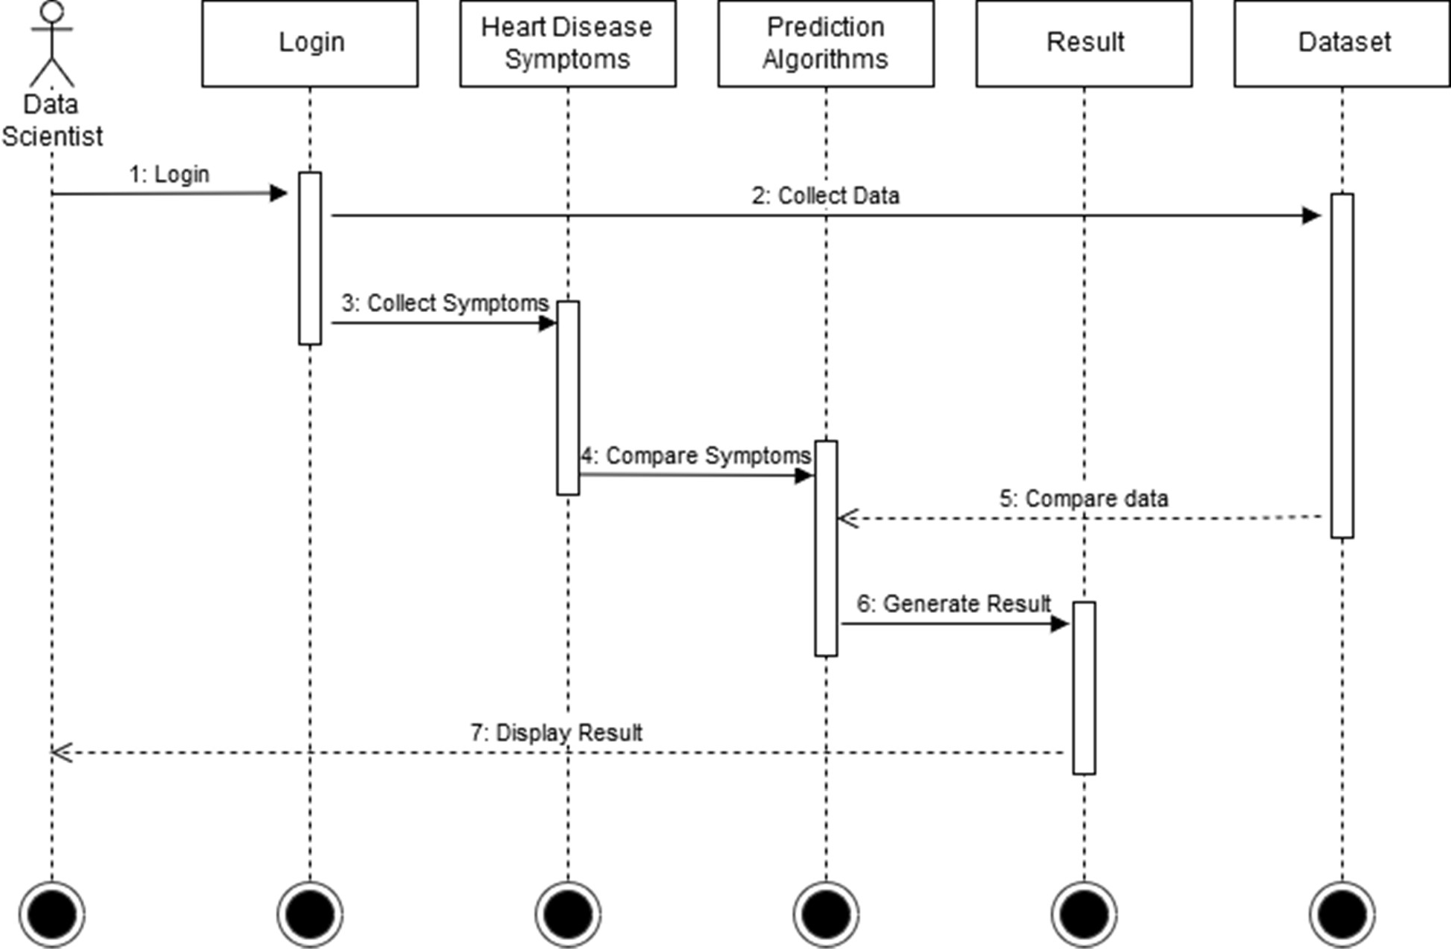

Figure 31 work flow diagram

**5.4 References**

1. M. K. Awang and F. Siraj, “Utilization of an artificial neural network in the prediction of heart disease,” *Int. J. Bio-Science Bio-Technology*, vol. 5, no. 4, pp. 159–165, 2013.
2. P. Selvakumar and S. P. Rajagopalan, “A survey on neural network models for heart disease prediction,” *J. Theor. Appl. Inf. Technol.*, vol. 67, no. 2, pp. 485–497, 2014.
3. A. Methaila, P. Kansal, H. Arya, and P. Kumar, “Early Heart Disease Prediction Using Data Mining Techniques,” vol. 6956, no. October, pp. 53–59, 2014.
4. I. S. F. Dessai, “Intelligent Heart Disease Prediction System Using Probabilistic Neural Network,” no. 5, pp. 38–44, 2013.
5. V. L. Roger *et al.*, “Heart disease and stroke statistics-2011 update: A report from the American Heart Association,” *Circulation*, 2011.
6. L. Mosca, H. Mochari-Greenberger, R. J. Dolor, L. K. Newby, and K. J. Robb, “Twelve-year follow-up of American women’s awareness of cardiovascular disease risk and barriers to heart health,” *Circ. Cardiovasc. Qual. Outcomes*, 2010.
7. R. B. Jaffe, “Explaining the decrease in U.S. deaths from coronary disease, 1980-2000: Commentary,” *Obstetrical and Gynecological Survey*. 2007.
8. T. Karayilan and Ö. Kiliç, “Prediction of Heart disease using neural network,” in *2nd International Conference on Computer Science and Engineering, UBMK 2017*, 2017, pp. 719–723.
9. M. Mardiyono, R. Suryanita, and A. Adnan, “Intelligent Monitoring System on Prediction of Building Damage Index using Neural-Network,” *TELKOMNIKA (Telecommunication Comput. Electron. Control.*, vol. 10, no. 1, p. 155, 2015.
10. N. Guru, A. Dahiya, and N. Rajpal, “Decision support system for heart disease diagnosis using Neural Network,” 2007.
11. [1] Soni J, Ansari U, Sharma D & Soni S (2011). Predictive data mining for medical diagnosis: an overview of heart disease prediction. International Journal of Computer Applications, 17(8), 43- 8
12. overview of heart disease prediction. International Journal of Computer Applications, 17(8), 43-
13. J. S. Singh Navdeep, “No Title,” *Intell. Hear. Dis. Predict. Syst. using CANFIS Genet. Algorithm, Int. J. Biol. Med. Sci.*, no. International Journal of Advance Research, Ideas and Innovations in Technology© 2018, [www.IJARIIT.comAll](http://www.IJARIIT.comAll/) Rights, p. Reserved Page | 987, 2008.
14. U. N. Dulhare and M. Ayesha, “Extraction of action rules for chronic kidney disease using Naïve bayes classifier,” in *2016 IEEE International Conference on Computational Intelligence and Computing Research, ICCIC 2016*, 2017.
15. T. J. Peter and K. Somasundaram, “Study and Development of Novel Feature Selection Framework for Heart Disease Prediction,” *Int. J. Sci. Res. Publ.*, 2012.
16. B. Xue, M. Zhang, and W. N. Browne, “Particle swarm optimization for feature selection in classification: A multi-objective approach,” *IEEE Trans. Cybern.*, 2013.
17. R. G. S. Rajkumar Asha, “No Title,” *Diagnosis Hear. Dis. Using Datamining Algorithm*, vol. Issue 10 V, no. Global Journal of Computer Science and Technology, p. Page 38, 2010.
18. Ks. BKavihta Rani AGovrdhan Associate Professor, P. of CSE, and N. Karimnagar Jagtial, “Applications of Data Mining Techniques in Healthcare and Prediction of Heart Attacks,” 2010.
19. N. A. Setiawan, P. A. Venkatachalam, and A. F. M. H, “Rule Selection for Coronary Artery Disease Diagnosis Based on Rough Set,” *Int. J. Recent Trends Eng. Technol.*, 2009.
20. Shantakumar B. Patil and Y.S. Kumaraswamy, “‘Intelligent and Effective Heart Attack Prediction System using Data Mining and Artificial Neural Network’,” *Eur. J. Sci. Res.*, vol. Vol. 31, no. No. 4, p. pp. 642-656, 2009.
21. F. Thabtah, “A review of associative classification mining,” *Knowledge Engineering Review*. 2007.
22. F. Tao, F. Murtagh, and M. Farid, “Weighted Association Rule Mining using weighted

support and significance framework,” 2004.

1. M. Stensmo and T. J. Sejnowski, “Automated Medical Diagnosis based on Decision Theory and Learning from Cases,” *World Congr. Neural Networks*, 1996.
2. G. Roglic *et al.*, “The burden of mortality attributable to diabetes: realistic estimates for the year 2000.,” *Diabetes Care*, 2005.
3. M. Joel M. Gore, “Typical Angina vs. Atypical Chest Pain,” *NEJM J. Watch*, vol. 2010, Jul. 2010.
4. Wenmin Li, Jiawei Han, and Jian Pei, “CMAR: accurate and efficient classification based on multiple class-association rules,” 2002.
5. B. Unal, J. A. Critchley, and S. Capewell, “Modelling the decline in coronary heart disease deaths in England and Wales, 1981-2000: comparing contributions from primary prevention and secondary prevention,” *BMJ*, vol. 331, no. 7517, p. 614, Sep. 2005.